



PROJECT PROPOSAL (SYNOPSIS) (BCSP-064) of
BACHELOR OF COMPUTER APPLICATIONS
(BCA)
on

To
Project Co-Ordinator (BCA)
Indira Gandhi National Open University
SCHOOL OF COMPUTER AND INFORMATION SCIENCES
IGNOU, MAIDAN GARHI, NEW DELHI – 110068

Submitted By: Abhishek Kumar Under Guidance
Enrollment No: 2350139471 _____________

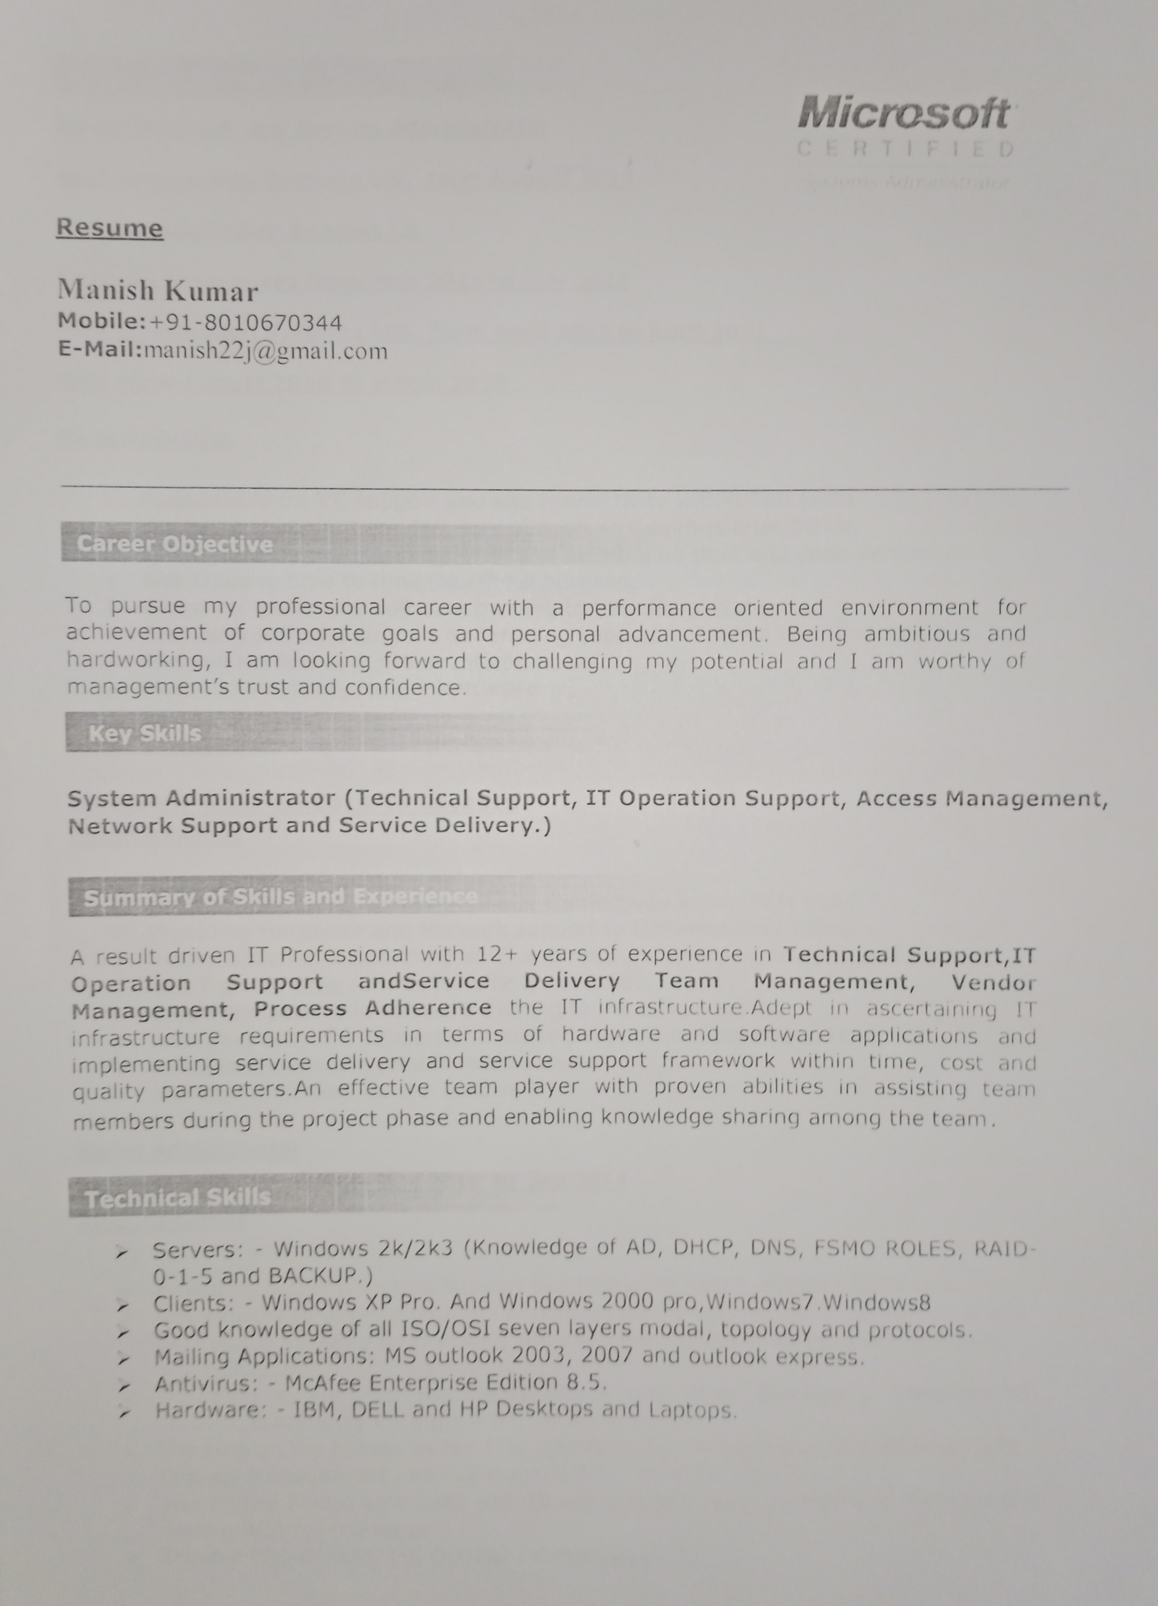
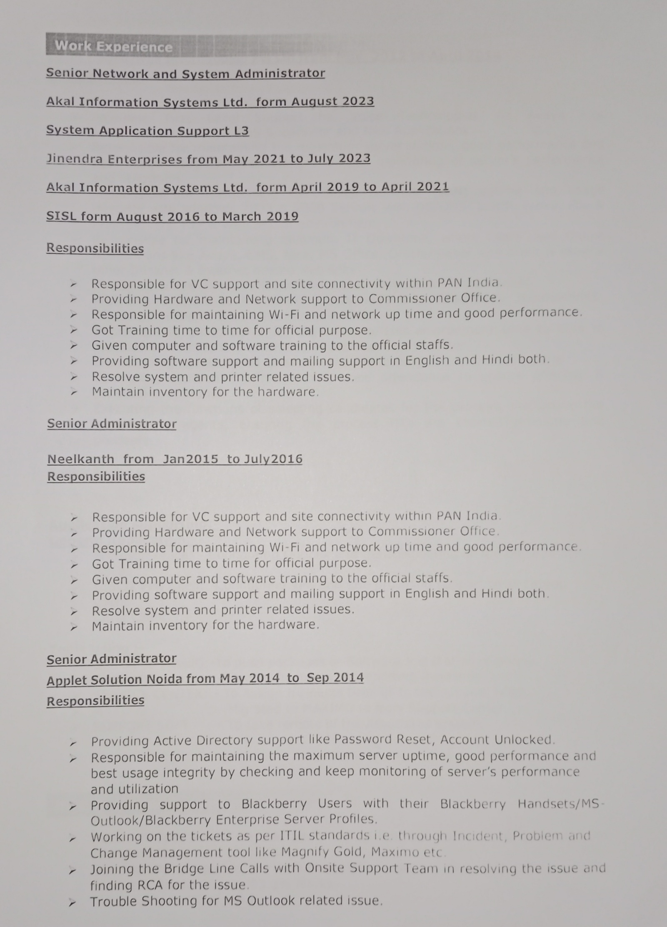
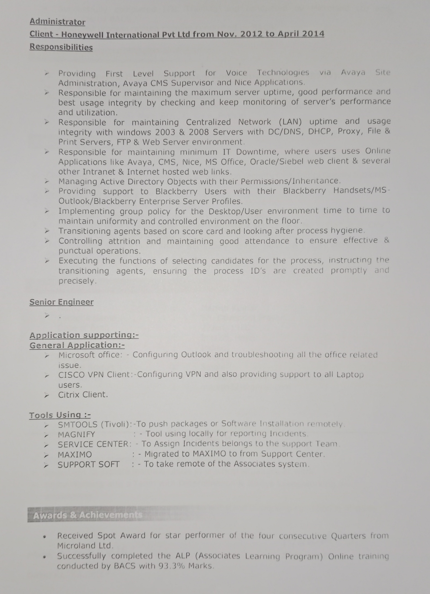
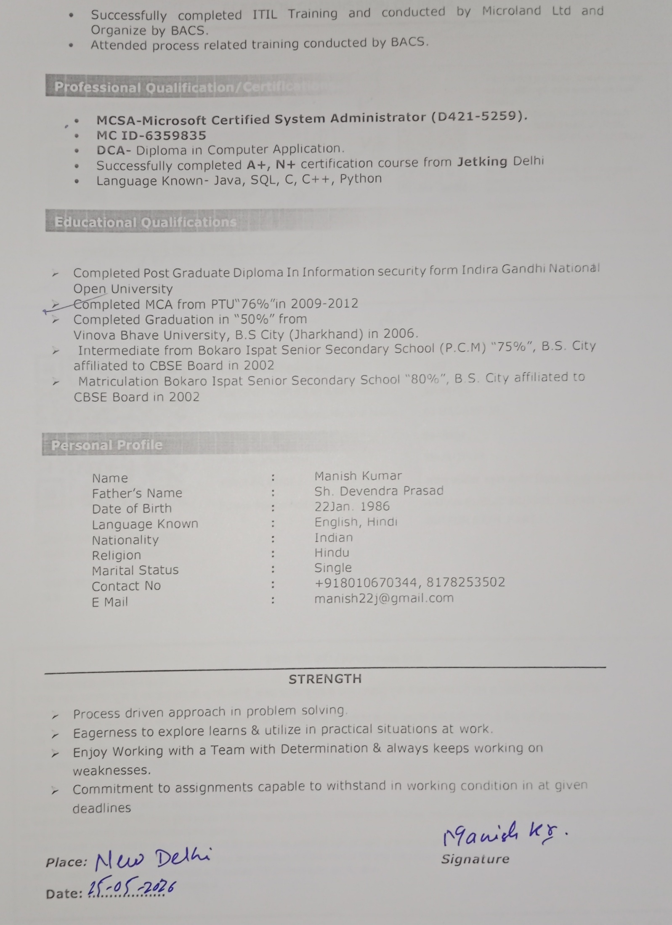
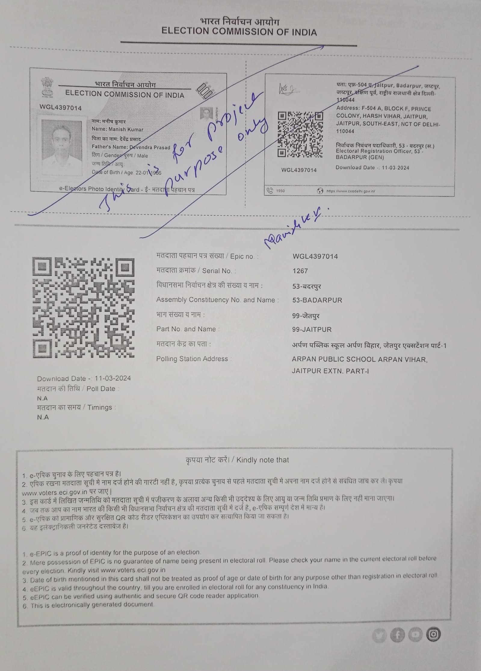

TABLE OF CONTENTS
S. No. | Topic | Page No.
1 | Certificate of Originality | 11
2 | Acknowledgement | 12
3 | Synopsis | 13-42
4 | Project Report | 43
5 | CHAPTER 1: INTRODUCTION | 44-48
 | 1.1: Introduction and Project Profile
 | 1.2: Project Scope and Proposed System
6 | CHAPTER 2: OBJECTIVES | 49
 | 2.1: Project Objectives
7 | CHAPTER 3: TOOLS / ENVIRONMENT USED | 50-52
 | 3.1: Hardware Requirements
 | 3.2: Software Requirements
 | 3.3: Development Environment
 | 3.4: Frontend Technologies
 | 3.5: Backend Technologies
 | 3.6: Database Technology
 | 3.7: Development and Testing
8 | CHAPTER 4: ANALYSIS DOCUMENT | 53-82
 | 4.1: Existing System and Drawbacks
 | 4.2: Project Category and SRS Overview
 | 4.3: Feasibility Study
 | 4.4: Functional Requirements
 | 4.5: Non-Functional Requirements
 | 4.6: Data Flow Diagram (DFD)
 | 4.6.1: DFD Level 0
 | 4.6.2: DFD Level 1
 | 4.6.3: DFD Level 2
 | 4.7: Data Dictionary and Main Database Relationships
9 | CHAPTER 5: DESIGN DOCUMENT | 83-127
 | 5.1: System Design Overview
 | 5.2: Database Design and Table Structure
 | 5.3: Procedural Logic / Flowcharts
 | 5.4: Entity Relationship Diagram (ERD)
 | 5.5: Object Class Diagram
 | 5.6: Use Case Diagram
 | 5.7: User Interface Design
 | 5.8: Module Structure and Description
 | 5.9: Final Website Page List
 | 5.10: API Architecture and Implementation
 | 5.11: Deployment Architecture
 | 5.12: Gantt Chart
10 | CHAPTER 6: TESTING | 128-138
 | 6.1: Testing Types and Strategies
 | 6.2: Error Handling Strategy
11 | CHAPTER 7: IMPLEMENTATION OF SECURITY | 139-145
 | 7.1: Security Mechanism
12 | CHAPTER 8: LIMITATIONS OF THE PROJECT | 146-152
 | 8.1: Assumptions and Constraints
 | 8.2: Project Limitations
13 | CHAPTER 9: CONCLUSION | 153-158
 | 9.1: Summary of the Project
 | 9.2: Future Scope and Potential Enhancements
 | 9.3: Conclusion
14 | CHAPTER 10: BIBLIOGRAPHY | 159-160
 | 10.1: Reference Books
 | 10.2: Websites and Documentation Links
15 | CHAPTER 11: CODING | 161-215
 | 11.1: Complete Source Code
 | 11.2: Database SQL Script
16 | CHAPTER 12: INPUT / OUTPUT SCREENSHOTS | 216
 | 12.1: Sample Screenshots / Project Results
 | 12.2: Additional Screenshots

CERTIFICATE OF ORIGINALITY

This is to certify that the project report entitled SMART LEARNING WEB APP Submitted to Indira Gandhi National Open University in partial fulfilment of the requirement for the award of the degree of BACHELOR OF COMPUTER APPLICATIONS (BCA), is an original work carried out by Mr. ABHISHEK KUMAR Enrolment No: 2350139471 under the guidance of Mr. MANISH KUMAR.

The matter embodied in this project is a genuine work done by the student and has not been submitted whether to this University or to any other University / Institute for the fulfilment of the requirement of any course of study.

Signature of the Student
Name and Address of the student:
ABHISHEK KUMAR
H NO G-178 STREET NO 7 MOHAN BABA NAGAR NEW DELHI SOUTH
Enrolment No: 2350139471
ACKNOWLEDGEMENT
Signature of the Guide
Name, Designation and Address of the Guide

I would like to express my profound gratitude and sincere thanks to my project guide, Manish Kumar, for his invaluable guidance, continuous support, and constant encouragement throughout the development of this project. His deep technical knowledge, constructive feedback, and expert supervision played a vital role in shaping this project from its initial conception to its final implementation. Working under his mentorship has been an enriching experience that significantly enhanced my technical skills and understanding of full-stack web development.
I take this opportunity to express my sincere appreciation to the coordinator and faculty members of My IGNOU Study Center Mohyal Educational & Research Institute of Technology (MERIT), for providing me with the necessary administrative support, academic resources, and infrastructural facilities required during the course of my Bachelor of Computer Applications (BCA) program. Their cooperation and guidance have been instrumental in helping me complete this academic milestone successfully.
Words cannot express my heartfelt gratitude to my beloved family for their unconditional love, endless patience, and constant emotional support throughout my academic journey. Their unwavering belief in my abilities, words of encouragement, and constant motivation gave me the strength to overcome challenges and complete this project. This achievement would not have been possible without their sacrifices and blessings.
Finally, I thank all my friends and well-wishers who directly or indirectly helped and inspired me during the course of this project work.

ABHISHEK KUMAR
Enrollment No: 2350139471
Program: Bachelor of Computer Applications (BCA)
Study Center: Mohyal Educational & Research Institute of Technology (MERIT)
Institution: Indira Gandhi National Open University (IGNOU)

SYNOPSIS

Table of Content
S. No. | Topic | Page No.
 | Introduction | 4-5
 | Objectives | 6
 | Project Category | 7-9
 | Drawback of existing system | 10
 | H/W & S/W Requirements | 11-12
 | Data Flow Diagram (DFD) | 13-18
 | Entity Relationship Diagram (ERD) | 19
 | Process Flow Diagram/Flowchart | 20
 | Database Table Architecture | 21-26
 | Object Class Diagram | 27
 | Use Case Diagram | 28
 | Modules & their description | 29-30
 | GANTT Chart | 31
 | Testing Types and Strategies | 32-33
 | Security Mechanism | 34-35
 | Limitations of Project | 36
 | Future Scope of Project | 37
 | Bibliography and References | 38

1. Introduction:
The Smart Learning Web App is developed as a modern solution to improve how students and educational institutions manage learning activities in a digital environment. As education continues to shift toward online and hybrid models, traditional methods of handling student records, assessments, and communication are no longer efficient. This application aims to simplify and organize these processes by providing a single, user-friendly platform where both students and teachers can interact, learn, and manage academic tasks effectively.
At its core, the system focuses on making student management easier and more accessible. Instead of relying on manual records or scattered tools, institutions can use this web application to handle everything in one place. Students can register themselves, create and update their profiles, and securely manage their login credentials. This reduces paperwork and saves time for both students and administrators. It also ensures that all data is stored in a structured and reliable manner, making it easy to access whenever required.
One of the key features of the Smart Learning Web App is its online test and quiz module. This module allows teachers to create and manage question banks, design tests, and conduct examinations directly through the platform. Students can attempt these tests in real time, and the system automatically evaluates their performance. The results are calculated instantly and stored for future reference, which helps in maintaining transparency and accuracy in the evaluation process. Students can also view their test history, analyse their performance, and identify areas where they need improvement.
The platform is not limited to testing; it also supports continuous learning. Teachers can upload study materials such as notes, documents, or other learning resources, making them easily accessible to students at any time. This creates a flexible learning environment where students can study at their own pace. In addition, the system encourages better communication between teachers and students by providing a structured interface for sharing information and updates.
Another important aspect of the system is security and user control. Features like password management and secure login ensure that user data is protected. Each
user, whether a student or a teacher, has a defined role and access level, which helps maintain privacy and proper system usage. The system is designed to be simple and intuitive so that users with basic computer knowledge can easily navigate and use its features without difficulty.
This document presents the Software Requirement Specification (SRS) for the Smart Learning Web App. It clearly defines the system’s purpose, scope, and functionalities. The SRS acts as a guide for developers, designers, and stakeholders by describing how the system should behave and what features it must include. It covers both functional requirements, such as registration, test management, and result processing, and non-functional requirements, such as performance, usability, and security.
Overall, the Smart Learning Web App aims to create a reliable, efficient, and user-friendly digital learning environment. It bridges the gap between traditional education methods and modern technology by providing tools that enhance both teaching and learning experiences. By integrating multiple academic functions into a single platform, the system not only improves efficiency but also supports better decision-making and performance tracking. This makes it a valuable solution for institutions looking to adopt a smarter and more organized approach to education.

2. Objective:
With the help of this proposed project we can able to full fill the following objectives:
- This is very cost-effective Student management system.
- It reduces the efforts and problem over manual approach.
- It allows a large no of Students to participate simultaneously with Institutes/university.
- Students can also share their feedback with Institute/university.
- Institute/University can also send information to the respective Institute/Students via mail or SMS.
- It provides more secure platform with user friendly environment.
- It is beneficial for every Institutes/university.
- It is very effective medium for quick management.
- User can use some features of this system via Online
3. Project Category
“SMART LEARNING WEB APP” is an OOPS and RDBMS based system.
Relational Database Management System (RDBMS): This is an RDBMS based project which is currently using MySQL DB for all the transaction statements. MySQL is an opensource RDBMS System.
ABOUT RDBMS
RDBMS expanded as Relational Database Management System is a type of database that stores data in a well-organized composite arrangement, comprising of rows and columns, which makes it effortless for the processing of data such as fetching, viewing, updating, deleting and manipulating the contents of the tables, as all the data in each and every table will be holding a relationship with the contents of other tables in the system and all the tables in the database system will be associated to the tables with similar properties.

HOW RDBMS WORKS?
- Relational Database Management System stores data in the form of tables.
- It contains N number of tables, and each table has its own unique primary key.
- Table consist of row and column.
- The row is known as a Record or horizontal entity. The record holds information about the individual entry.
- The column is known as a field or vertical entity. The field holds information about a specific field.
- When the user fires a query, it shows results as for specific queries. Before creating any table or data in the database, it checks constraints.

ADVANTAGES OF RDBMS

1. Maintainability: It allows database admins to maintain, control, update data into the database easily. With RDBMS, backing up of data becomes easy.

2. Flexibility: This feature of RDBMS saves a lot of time as updating data in one place is enough.

3. Data Structure: As RDBMS stores data in a table format, it is easily understood by the users.

4. Privileges: Administrators can give specific access to a user rather than giving all Access.
The Project is Base on Three Tier Architecture

Application Client
Application Server
User
Client
Internet
Database System
Server
Fig : 3 - Tier Architecture

4. Drawback of existing system
The existing traditional education and student management system has several limitations that reduce efficiency and create difficulties for both students and institutions. Some major drawbacks are:
- The existing system mainly depends on manual processes, which require more time and effort to manage records and academic activities.
- Student information, attendance, and academic records are often maintained in separate files or registers, making data management difficult.
- Manual examination and result processing can lead to delays and human errors.
- Communication between teachers and students is not well organized, which may cause delays in sharing important information and updates.
- Study materials are often distributed through multiple sources, creating confusion and difficulty in accessing learning resources.
- Tracking student performance and academic progress becomes difficult due to the lack of centralized data management.
- Existing systems may not provide proper security and role-based access control, which can create privacy and data protection issues.
- Traditional systems are less flexible and difficult to access remotely, especially for online and distance learning environments.
- Managing a large number of students simultaneously becomes challenging and may reduce overall system efficiency.
- Lack of automation increases paperwork and administrative workload for institutions.
This proposed Smart Learning Web App aims to overcome these limitations by providing an integrated, secure, and user-friendly digital platform.

5. Tools / Platform, Hardware and Software Requirement Specifications
For setting this e-commerce Web App, it requires certain technical requirements to be met for the store to operate properly.
First, to make the e-commerce store publicly available on the web. We need Domain names and hosting services which can easily be purchased for an affordable price.
Minimum Hardware Requirements
- Processor (CPU): Intel Core i3 or AMD Ryzen 3
- RAM: 4 GB
- Storage: 256 GB SSD / HDD
- Display: 1366 × 768 Resolution Monitor
- Internet Connection: Broadband Connection for Web Access
- Input Devices: Keyboard and Mouse
For preparing this proposed project (i.e. “SMART LEARNING WEB APP” there are so many technologies available in the current market. But after lots of survey &
discussion we found that following platform is suitable for this proposed project:
The software & Techs which was used for developing the application areas under :-
Software & Technologies Used
- Operating System: Windows 10/11
- Frontend: HTML5, CSS3, JavaScript (ES2023), Bootstrap 5.3.7
- Backend: Node.js 24.16.0 LTS, Express.js 5.x
- Database: MySQL 9.3
- IDE: Visual Studio Code 1.101
- Version Control (optional): Git 2.49, GitHub (Latest Cloud Version)
- API Testing: Postman 11.x
- Documentation: MS Word 2024
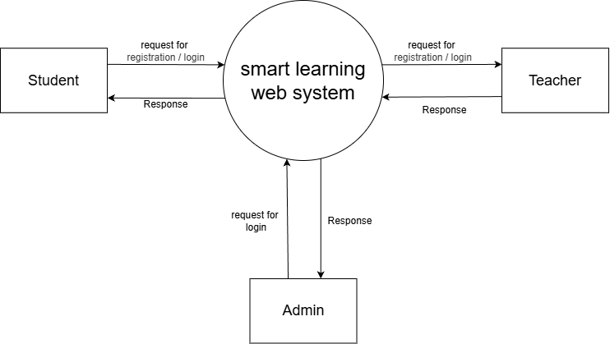
6. Data Flow Diagram
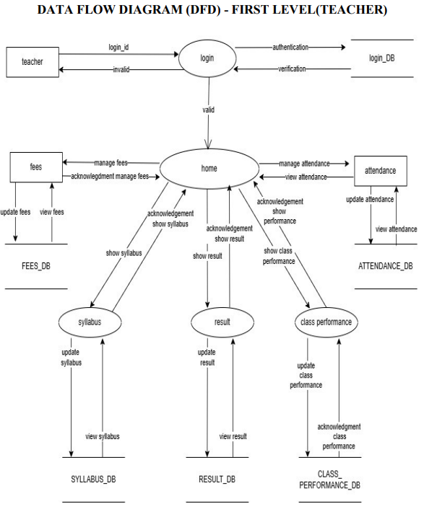

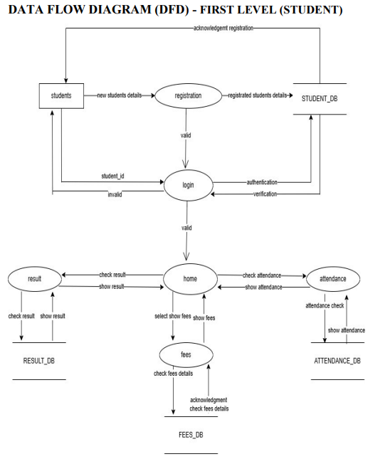

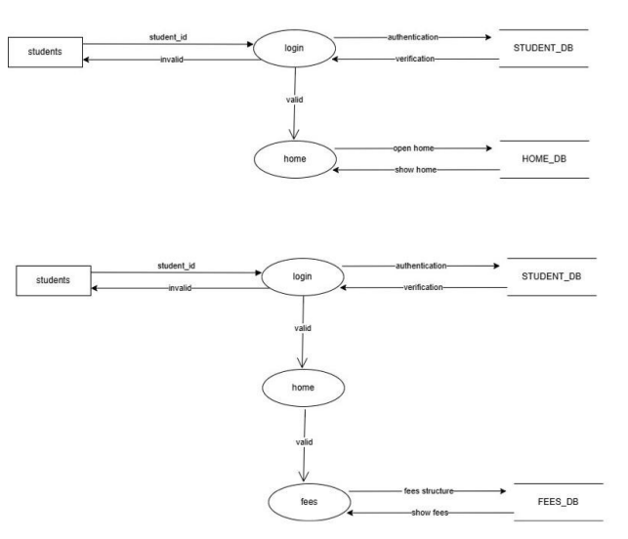
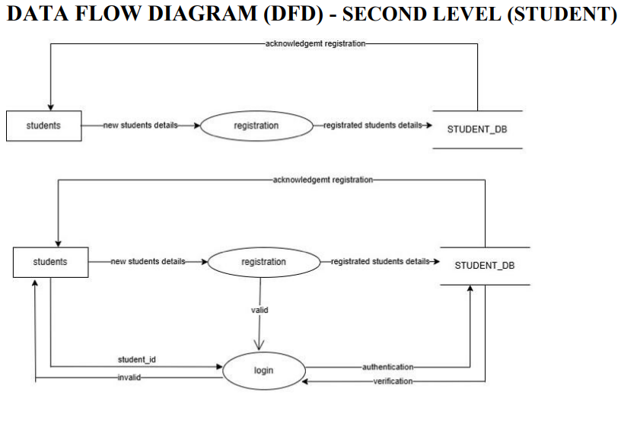
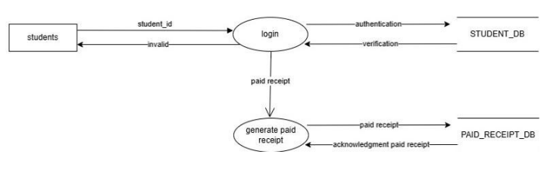
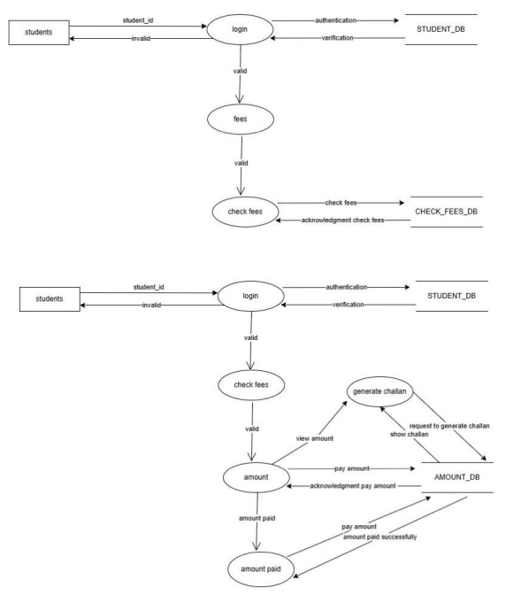
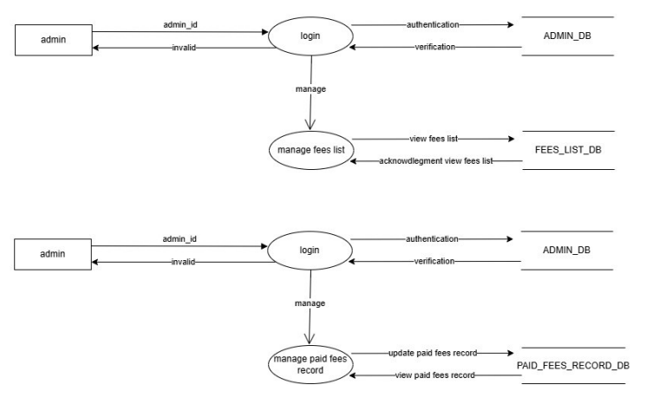
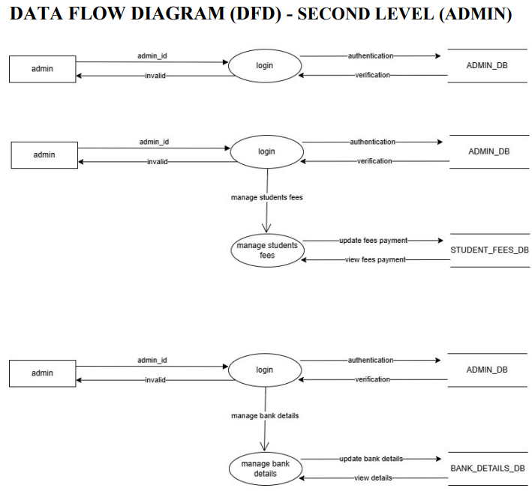
7. Entity Relationship Diagram
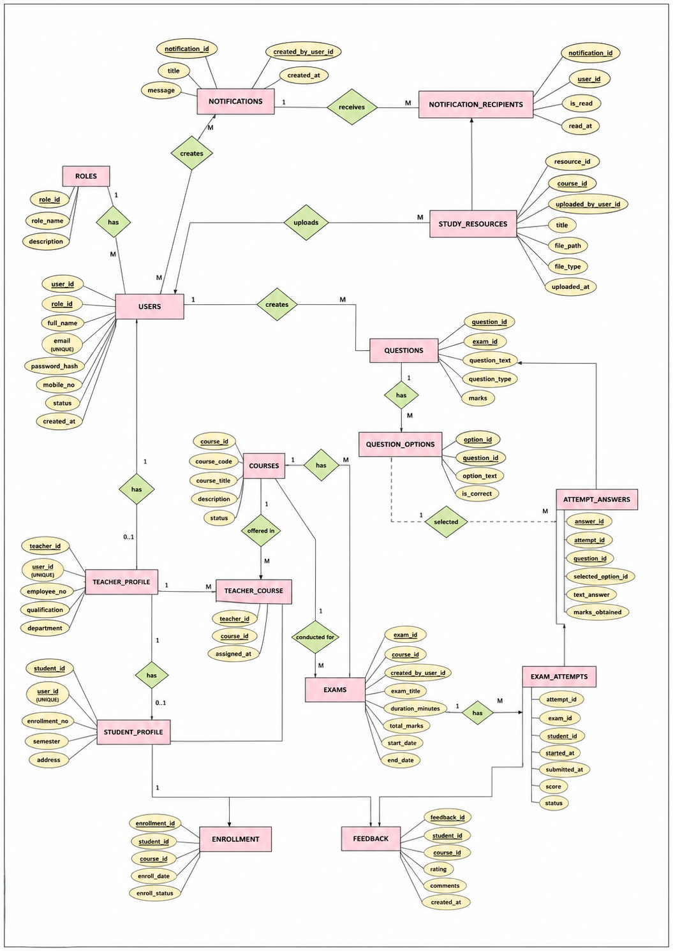
8. Process Flow Diagram/Flowchart
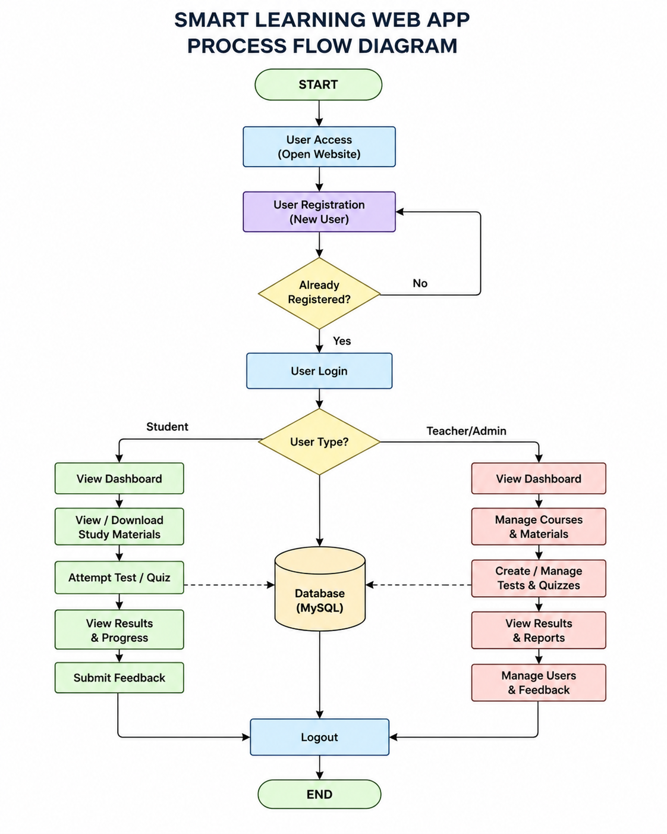
9. Database Table Structure
- ROLES
Field Name | Data Type | Key | Description
role_id | INT | PK | Unique role ID
role_name | VARCHAR (50) | NOT NULL | Role name
description | TEXT | NOT NULL | Role details

- USERS
Field Name | Data Type | Key | Description
user_id | INT | PK | Unique user ID
role_id | INT | FK | References roles(role_id)
full_name | VARCHAR (100) | NOT NULL | User full name
email | VARCHAR (100) | UNIQUE | User email
password_hash | VARCHAR (255) | NOT NULL | Encrypted password
mobile_no | VARCHAR (15) | NOT NULL | Mobile number
status | VARCHAR (20) | NOT NULL | Active/Inactive
created_at | DATETIME | NOT NULL | Account creation date

- TEACHER_PROFILE
Field Name | Data Type | Key | Description
teacher_id | INT | PK | Unique teacher ID
user_id | INT | FK, UNIQUE | References users(user_id)
employee_no | VARCHAR (50) | NOT NULL | Employee number
qualification | VARCHAR(100) | NOT NULL | Teacher qualification
department | VARCHAR (100) | NOT NULL | Department name

- STUDENT_PROFILE
Field Name | Data Type | Key | Description
student_id | INT | PK | Unique student ID
user_id | INT | FK, UNIQUE | References users(user_id)
enrollment_no | VARCHAR (50) | NOT NULL | Student enrollment number
semester | VARCHAR (20) | NOT NULL | Current semester
address | TEXT | NOT NULL | Student address

- COURSES
Field Name | Data Type | Key | Description
course_id | INT | PK | Unique course ID
course_code | VARCHAR (50) | NOT NULL | Course code
course_title | VARCHAR (150) | NOT NULL | Course title
description | TEXT | NOT NULL | Course description
status | VARCHAR (20) | NOT NULL | Active/Inactive

- TEACHER_COURSE
Field Name | Data Type | Key | Description
teacher_id | INT | FK | References teacher_profile(teacher_id)
course_id | INT | FK | References courses(course_id)
assigned_at | DATETIME | NOT NULL | Course assigned date

- ENROLLMENT
Field Name | Data Type | Key | Description
enrollment_id | INT | PK | Unique enrollment ID
student_id | INT | FK | References student_profile(student_id)
course_id | INT | FK | References courses(course_id)
enroll_date | DATE | NOT NULL | Enrollment date
enroll_status | VARCHAR (20) | NOT NULL | Active/Completed/Dropped

- EXAMS
Field Name | Data Type | Key | Description
exam_id | INT | PK | Unique exam ID
course_id | INT | FK | References courses(course_id)
created_by_user_id | INT | FK | References users(user_id)
exam_title | VARCHAR (150) | NOT NULL | Exam title
duration_minutes | INT | NOT NULL | Exam duration
total_marks | INT | NOT NULL | Total marks
start_date | DATETIME | NOT NULL | Exam start date
end_date | DATETIME | NOT NULL | Exam end date

- QUESTIONS
Field Name | Data Type | Key | Description
question_id | INT | PK | Unique question ID
exam_id | INT | FK | References exams(exam_id)
question_text | TEXT | NOT NULL | Question
question_type | VARCHAR (50) | NOT NULL | MCQ/Text
marks | INT | NOT NULL | Question marks

- QUESTION_OPTIONS
Field Name | Data Type | Key | Description
option_id | INT | PK | Unique option ID
question_id | INT | FK | References questions(question_id)
option_text | TEXT | NOT NULL | Option text
is_correct | BOOLEAN | NOT NULL | Correct option status

- EXAM_ATTEMPTS
Field Name | Data Type | Key | Description
attempt_id | INT | PK | Unique attempt ID
exam_id | INT | FK | References exams(exam_id)
student_id | INT | FK | References student_profile(student_id)
started_at | DATETIME | NOT NULL | Exam start time
submitted_at | DATETIME | NOT NULL | Exam submit time
score | INT | NOT NULL | Obtained score
status | VARCHAR (20) | NOT NULL | Started/Submitted

- ATTEMPT_ANSWERS
Field Name | Data Type | Key | Description
answer_id | INT | PK | Unique answer ID
attempt_id | INT | FK | References exam_attempts(attempt_id)
question_id | INT | FK | References questions(question_id)
selected_option_id | INT | FK | References question_options(option_id)
text_answer | TEXT | NOT NULL | Written answer
marks_obtained | INT | NOT NULL | Marks obtained

- STUDY_RESOURCES
Field Name | Data Type | Key | Description
resource_id | INT | PK | Unique resource ID
course_id | INT | FK | References courses(course_id)
uploaded_by_user_id | INT | FK | References users(user_id)
title | VARCHAR (150) | NOT NULL | Resource title
file_path | VARCHAR (255) | NOT NULL | File location
file_type | VARCHAR (50) | NOT NULL | PDF/DOC/Image/Video
uploaded_at | DATETIME | NOT NULL | Upload date

- NOTIFICATIONS
Field Name | Data Type | Key | Description
notification_id | INT | PK | Unique notification ID
title | VARCHAR (150) | NOT NULL | Notification title
message | TEXT | NOT NULL | Notification message
created_by_user_id | INT | FK | References users(user_id)
created_at | DATETIME |  | Notification date

- NOTIFICATION_RECIPIENTS
Field Name | Data Type | Key | Description
notification_id | INT | FK | References notifications(notification_id)
user_id | INT | FK | References users(user_id)
is_read | BOOLEAN | NOT NULL | Read status
read_at | DATETIME | NOT NULL | Read time

- FEEDBACK
Field Name | Data Type | Key | Description
feedback_id | INT | PK | Unique feedback ID
student_id | INT | FK | References student_profile(student_id)
course_id | INT | FK | References courses(course_id)
rating | INT | NOT NULL | Rating value
comments | TEXT | NOT NULL | Feedback comment
created_at | DATETIME | NOT NULL | Feedback date
10. Object Class Diagram
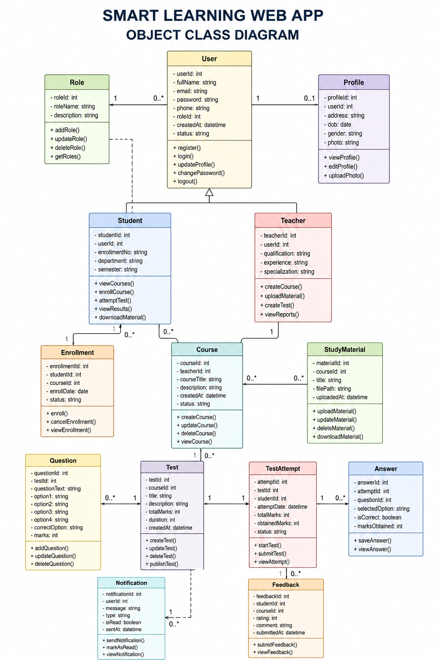
11. Use Case Diagram
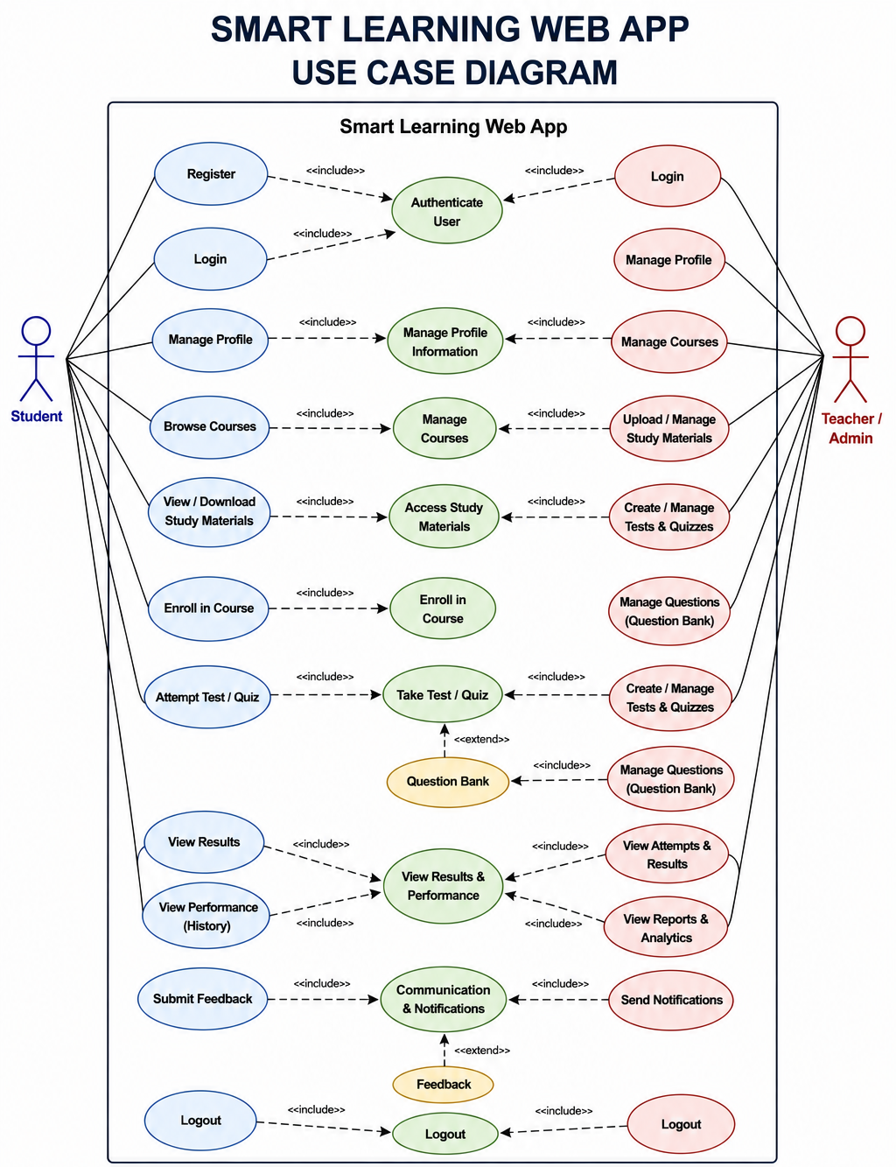
12. Modules & their Details
“SMART LEARNING WEB APP” is a web-based platform by which Institute/universities are able to manage their students effectively using web-based medium. It is designed on the basis of following groups/Module/department:
1. Registration Module
Allows new users to create an account by entering basic details like name, email, and password.
It ensures all information is valid and stores user data securely.
2. Login Module
Provides secure access to users using their login credentials.
It also supports features like password change and recovery.
3. Management Module
Handles overall system operations including courses, users, messages, and resources.
It helps admins and teachers manage data efficiently in one place.
a. Course Management
Allows creation, update, and management of courses and subjects.
Students can view and enroll in available courses.
b. Notification and Message Management
Enables sending important updates, alerts, and messages to users.
Keeps students informed about activities and announcements.
c. Profile Management
Allows users to view and update their personal details.
Ensures information remains accurate and up to date.
d. Accounts Management
Manages user accounts including activation or removal.
Helps maintain control and security of the system.
e. Library Management
Stores and manages study materials like notes and documents.
Students can easily access and download learning resources.
f. Admin Management
Gives full control to the admin overall system activities.
Ensures smooth functioning and monitoring of the platform.

4. Exam Module
Conducts online tests and quizzes for students.
Automatically evaluates answers and shows results instantly.
5. Upload & Download Module
Allows users to upload and share files like notes and assignments.
Students can download materials anytime for learning.
- Administrator Module (Top level Manager/Director)
13. GANTT Chart

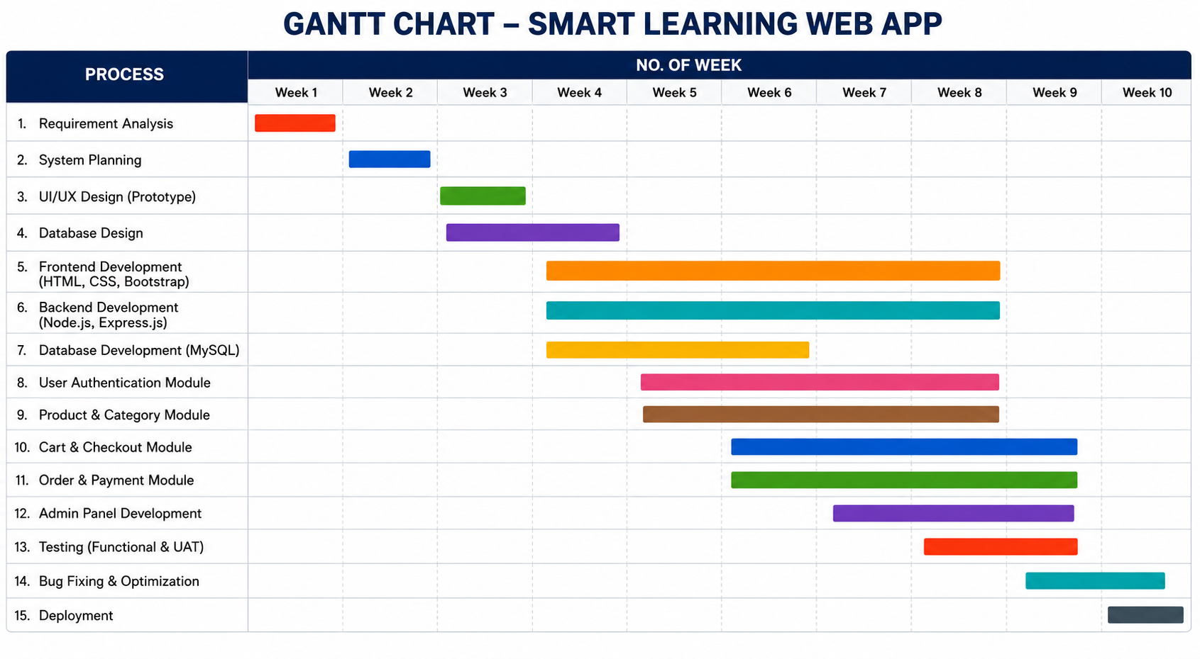
14. Types of Testing Strategies
Testing is the necessary part of any project for successful implementation and working. In “SMART LEARNING WEB APP” we can use various test models as per requirement. But right now, it is on process. So, after proposal & development we do proper testing work to make this system successful.

Software Testing can be majorly classified into two categories: -

- White Box Testing: It is a software testing method in which the internal structure/design/implementation of the item being tested is known to the tester.
- Black Box Testing: It is a software testing method in which the internal structure/design/implementation of the item being tested is not known to the tester.
Levels of Testing
- Unit Testing: It is done at the level of each individual program.
- Module Testing: Testing a complete module, a collection
of related program units to check if the module is working properly as a whole and producing the desired output is known as module testing.
- Integration Testing: In integration testing, the main purpose is to detect problems in interfaces between modules.
- System Testing: In system testing, we test the system as a whole with all parts integrated together in an operational environment.
15. Security Mechanism
Website security is the process of protecting a web application, user data, and server resources from unauthorized access, cyberattacks, and data theft. In the Smart Learning Web App, security is very important because the system stores sensitive information such as student details, passwords, exam records, and study materials.
The following security techniques are used in the proposed system:
1. User Authentication
Authentication ensures that only authorized users can access the system.
Users must log in using their email ID and password. The system verifies credentials before providing access.
2. Password Encryption
Passwords are stored in encrypted form using hashing techniques.
This prevents hackers from reading user passwords directly from the database.
3. Role-Based Access Control
Different users have different permissions:
Admin can manage the entire system
Teachers can upload materials and conduct exams
Students can access courses and attempt quizzes
This prevents unauthorized activities.

4. Secure Database Management
The MySQL database is protected from unauthorized access using:
Strong database passwords
Limited access permissions, Regular backups
5. Input Validation
All user inputs are validated before processing.
This protects the system from SQL Injection and malicious data entry.
6. HTTPS and Secure Communication
The website uses secure communication protocols to protect data transfer between user and server.
7. Session Management
User sessions automatically expire after logout or inactivity, reducing the risk of unauthorized access.
8. Regular Backup and Recovery
Database backups are maintained regularly to recover important data in case of system failure.
Advantages of Website Security
Protects user information
Prevents hacking and cyberattacks
Builds trust among users
Maintains data integrity
Ensures smooth system performance
16. Limitations of Project

8.1 Assumptions and Constraints
The SMART LEARNING WEB APP (SLWA) has been designed as a web-based educational management and learning platform for Administrators, Teachers, and Students. During the analysis, design, development, and testing of the system, certain assumptions and constraints are considered. These conditions define the operating environment and boundaries of the project.
8.1.1 Assumptions
The following assumptions are made for the successful operation of SLWA:
- Availability of Internet:
It is assumed that users have a stable network connection while accessing the web application.
- Supported Web Browser:
It is assumed that users access SLWA through a modern web browser capable of supporting HTML5, CSS3, JavaScript, and the features used by the application.
- Valid User Information:
It is assumed that users provide correct and valid information during registration and other data-entry operations.
- Authorized User Access:
It is assumed that each user accesses the application using their own authorized account and does not share authentication credentials with other users.
- Defined User Roles:
It is assumed that every authenticated account is assigned an appropriate role such as Administrator, Teacher, or Student.
- Reliable Database Service:
The system assumes that the MySQL database service is available when database-dependent operations are performed.
- Server Availability:
It is assumed that the application server and required backend services are available during normal system operation.
- Teacher-Provided Academic Content:
It is assumed that Teachers or authorized users provide accurate and appropriate courses, study resources, examinations, and questions.
- Administrative Management:
It is assumed that Administrators are responsible for maintaining users, courses, academic records, notifications, and other administrative information.
- Appropriate User Behaviour:
It is assumed that users use the system according to the intended academic and administrative procedures.
- Regular Data Management:
It is assumed that appropriate backup and maintenance procedures are followed to protect important application and database information.
- Required Software Availability:
It is assumed that the required runtime environment, database service, browser, and supporting software are properly installed and configured.
8.1.2 Technical Constraints
The project has several technical constraints that influence its implementation.
The application depends on the selected technology stack, including HTML5, CSS3, JavaScript (ES2023), Bootstrap 5.3.7, Node.js 24.16.0 LTS, Express.js 5.x, and MySQL 9.3. Changes in these technologies or their versions may require compatibility testing and possible modifications.
The system also depends on the availability of a suitable server environment for running the Node.js application and MySQL database.
8.1.3 Operational Constraints
SLWA requires appropriate operational management after deployment. User accounts, courses, study resources, examination information, notifications, and other records must be maintained correctly.
The system's effectiveness also depends on:
- Correct user data.
- Proper role assignment.
- Availability of the application server.
- Availability of the database.
- Network connectivity.
- Proper administration.
- Regular backup and maintenance.
- Correct academic information supplied by authorized users.
8.1.4 Security Constraints
Security mechanisms reduce risks but cannot guarantee complete protection against every possible threat. The application therefore depends on proper configuration and maintenance of authentication, authorization, password protection, HTTPS, database security, session management, input validation, logging, and backup mechanisms.
The security level of the deployed system may also depend on the hosting environment, server configuration, network security, and operational practices.
8.1.5 Data Constraints
SLWA depends on structured and consistent data stored in the relational database. Incorrect, incomplete, duplicated, or outdated information may affect the accuracy of displayed results.
Therefore, authorized users are expected to maintain data carefully and perform appropriate administrative checks.
17. Future Scope of Project Although the current SLWA implementation provides the major functionality defined for the project, several enhancements can be considered for future development. These enhancements can increase the usability, accessibility, scalability, and educational capabilities of the system.
9.2.1 Native Mobile Applications
Dedicated Android and iOS applications could be developed in the future. Mobile applications could provide convenient access to courses, learning resources, examinations, notifications, and results from smartphones and tablets.
9.2.2 AI-Based Personalized Learning
An AI-based learning system could be integrated to analyse student performance and provide personalized learning recommendations. Future versions could suggest suitable learning resources, practice activities, or revision areas based on a student's academic activity.
9.2.3 AI-Assisted Evaluation
Advanced automated evaluation could be introduced for additional question types. In particular, future versions could investigate AI-assisted evaluation of descriptive or essay-based answers while maintaining suitable teacher review and academic controls.
9.2.4 Live Online Classes
A future version could integrate video-conferencing and live classroom facilities. Teachers could conduct real-time classes, interact with students, and provide live demonstrations without requiring a separate platform.
9.2.5 Advanced Analytics
The system could provide detailed academic analytics and dashboards showing:
- Student performance trends.
- Course participation.
- Examination performance.
- Resource usage.
- Enrollment statistics.
- Question-wise performance.
- Teacher activity.
- Overall academic progress.
Such analytics could help authorized users understand learning activity and identify areas requiring attention.
9.2.6 University ERP Integration
Future versions could provide integration with university or institutional ERP systems where suitable APIs and authorization mechanisms are available. This could reduce duplicate data entry and support exchange of academic information.
9.2.7 Advanced Notification System
The notification system could be expanded to support additional notification channels and configurable reminders for examinations, course activities, new resources, and important academic events.
9.2.8 Enhanced Accessibility
Future development could further improve accessibility for users with different learning and interaction requirements. Accessibility enhancements could include improved keyboard navigation, screen-reader support, adjustable text size, improved contrast controls, and additional interface customization.
9.2.9 Biometric Authentication
Biometric authentication could be considered as an optional additional authentication mechanism in future versions, subject to suitable hardware, privacy requirements, security controls, and institutional policies.
9.2.10 Blockchain-Based Academic Credentials
Blockchain-based credential verification could be investigated for future academic certificate or achievement verification. Such a system could provide an additional mechanism for verifying academic credentials where technically and institutionally appropriate.
9.2.11 Advanced Learning Resource Management
Future versions could support additional learning-resource formats and improved organization of educational materials. Resources could be categorized by course, topic, difficulty, academic level, and learning objective.
9.2.12 Improved Scalability
As the number of users and academic records increases, the system could be enhanced through additional scalability techniques such as improved database optimization, caching, load balancing, distributed deployment, and cloud-based infrastructure where required.

18. Bibliography and References
- IGNOU Project Guide Booklet
IGNOU Official Website
- IGNOU Study Material
eGyanKosh IGNOU Study Material
- Node.js Official Documentation
Node.js Documentation
- MySQL Official Documentation
MySQL Documentation
- Web Development Tutorials
W3Schools Tutorials
- Express.js Official Documentation
Express.js Documentation
- Bootstrap Official Documentation
Bootstrap Documentation
- GitHub Documentation
GitHub Docs
- API Testing Reference
Postman Learning Centre
- Books and Study Resources for Synopsis Preparation
- Web Technologies by Uttam K. Roy
- Node.js Web Development by David Herron
- Learning MySQL by Seyed M.M. Tahaghoghi and Hugh Williams
- Beginning Bootstrap by Jake Spurlock
- HTML & CSS: Design and Build Websites by Jon Duckett
- Software Engineering by Ian Sommerville
- Database System Concepts by Abraham Silberschatz
- Modern Web Development by Dino Esposito
- System Analysis and Design by Elias M. Awad
- Project Management for Information Systems by Kathy Schwalbe

project
report

CHAPTER 1: INTRODUCTION

1.1 Introduction and Project Profile
The rapid growth of Information Technology and the Internet has significantly transformed the education sector. Educational institutions increasingly depend on digital platforms for managing students, teachers, courses, learning materials, examinations, results, and communication. Traditional academic management methods often involve physical records, separate files, manual examination processes, distributed study materials, and non-centralized communication. Such methods can become difficult to manage as the number of students, teachers, courses, examinations, and academic records increases. A centralized web-based learning platform can therefore provide an organized and efficient environment for managing these activities.
The proposed project, “Smart Learning Web App (SLWA)”, is a web-based educational management and learning platform designed to bring major academic and administrative activities into a centralized digital environment. The system provides different functionalities for three primary categories of users: Administrator, Teacher, and Student. Each user is provided with role-based access to the functions relevant to their responsibilities. The system is designed to provide a secure, user-friendly, responsive, and maintainable environment for managing learning and academic activities through a web browser.
The Smart Learning Web App integrates several important academic functions, including student registration, authentication, user and profile management, course management, course enrollment, study-resource distribution, online examinations and quizzes, question management, examination attempts, result processing, notifications, feedback, and administrative management. By integrating these activities into a common platform, the system reduces dependence on separate manual processes and provides a consistent method for storing, accessing, and managing academic information.
The Student Module provides students with access to their academic activities through a role-based dashboard. Students can access available courses, enroll in courses, view or download learning resources, participate in online examinations, submit answers, view examination results, receive notifications, manage their profiles, and provide feedback where applicable. The system maintains examination attempts and related answer information so that academic performance and examination history can be managed systematically.
The Teacher Module supports teachers in performing academic activities associated with their assigned courses. Teachers can access assigned courses, manage or provide learning resources, conduct examinations, manage examination questions and question options, receive notifications, and maintain their profiles. The system applies authorization rules to ensure that teacher operations are performed only within the responsibilities and permissions assigned to them.
The Administrator Module provides centralized control over the overall application. Administrators can manage users, courses, academic information, notifications, resources, examinations, and other system-level activities according to their authorization. Administrative functions are protected through role-based access control so that sensitive operations are not available to unauthorized users.
The project uses a Three-Tier Architecture consisting of the Presentation Layer, Application Layer, and Database Layer. The Presentation Layer provides the browser-based user interface through which students, teachers, and administrators interact with the application. The Application Layer contains the application logic and REST-based backend services implemented using Node.js and Express.js. It processes user requests, performs validation and authorization, executes business operations, and communicates with the database. The Database Layer uses MySQL to provide persistent relational storage for user, academic, examination, notification, feedback, and other application information.
The technology stack specified for the project includes HTML5, CSS3, JavaScript (ES2023), Bootstrap 5.3.7, Node.js 24.16.0 LTS, Express.js 5.x, and MySQL 9.3. Visual Studio Code is used as the development environment, while Postman can be used for API development and testing. These technologies provide the required foundation for developing a responsive web interface, implementing server-side application logic, exposing backend services, and managing relational data.
The database component is an important part of the project because most major operations depend upon persistent data. The relational database includes entities such as roles, users, teacher profiles, student profiles, courses, teacher-course assignments, enrollments, examinations, questions, question options, examination attempts, attempt answers, study resources, notifications, notification recipients, and feedback. Relationships between these entities allow the application to maintain consistent information and connect users with their academic activities.
Security is treated as an integral part of the Smart Learning Web App. Since the application manages user accounts, personal information, learning resources, examination information, and academic records, unauthorized access and improper data manipulation must be controlled. The proposed system therefore includes secure authentication, password hashing, role-based authorization, input validation, parameterized database operations, secure session or token handling, HTTPS support, secure cookies where applicable, protection against common web attacks, rate limiting, security headers, audit logging, controlled database privileges, and regular backup and recovery procedures.
The system is also designed with usability and responsiveness in mind. The application should be accessible through modern desktop, laptop, tablet, and mobile browsers. The interface should provide consistent navigation, readable content, appropriate form validation, clear status messages, and responsive layouts. These characteristics are intended to make common activities such as login, course access, examination participation, result viewing, resource access, and profile management straightforward for users with basic computer knowledge.
The Smart Learning Web App is therefore a web-based, database-driven educational management system that combines learning and administrative functions into one integrated application. Instead of maintaining student information, courses, resources, examinations, results, notifications, and feedback through separate processes, the proposed system connects these activities through a common application and relational database.
The project provides a practical implementation of modern web-development concepts, including client-server communication, REST-based backend services, relational database management, authentication, authorization, validation, responsive interface development, modular application design, and software testing. Its modular structure also provides a foundation for future expansion into additional educational services and institutional use cases.
In conclusion, the Smart Learning Web App is intended to provide a centralized, secure, maintainable, and user-friendly digital learning environment. It aims to improve the organization and accessibility of academic activities while reducing manual effort and providing reliable storage and retrieval of educational information. The project demonstrates the practical application of modern web technologies to develop an integrated platform for students, teachers, and administrators.

1.2 Project Scope and Proposed System
The scope of the Smart Learning Web App defines the functional, technical, operational, and security boundaries of the proposed web-based educational management platform. The system is designed to provide a centralized environment through which students, teachers, and administrators can perform academic and administrative activities using a web browser.
The proposed system covers the complete basic workflow from user registration and authentication to academic activities such as course enrollment, learning-resource access, examination participation, result processing, notifications, and feedback. It also includes administrative functions required to maintain the application and its underlying academic information.
1.2.1 User Registration and Authentication
The system provides registration and authentication facilities for authorized users. Users can access the application through a secure login mechanism. Authentication ensures that only registered users can access protected functionality. Passwords are intended to be stored using secure hashing rather than plain-text storage.
After successful authentication, the application identifies the user's role and provides an appropriate role-based interface. The three principal roles are Administrator, Teacher, and Student.
1.2.2 Role-Based Access Control
Role-Based Access Control is an important part of the proposed system. Different users require different levels of access according to their responsibilities.
The system provides the following general separation:
- Administrator – responsible for system-level and administrative operations.
- Teacher – responsible for assigned academic and teaching-related operations.
- Student – responsible for learning activities, enrollment, examinations, results, resources, notifications, and feedback.
Authorization is intended to be enforced at the backend/API level and not only through the user interface. This prevents unauthorized users from directly accessing restricted operations.
1.2.3 Student Management
The proposed system provides facilities for managing student accounts and profiles. Student information can be maintained in the database and associated with the authenticated user account.
Students can access their dashboard, profile, courses, enrolled courses, learning resources, examinations, results, notifications, and feedback functionality according to their permissions.
This centralized student information reduces dependence on separate records and provides a consistent source of academic information.
1.2.4 Teacher Management
Teacher-related functionality allows authorized teachers to maintain their profiles and perform academic operations associated with assigned courses. Teachers can access assigned courses, learning resources, examinations, questions, notifications, and other permitted functions.
The system maintains the relationship between teachers and courses so that academic responsibilities can be managed in an organized manner.
1.2.5 Course Management and Enrollment
Course management is one of the core functions of the proposed system. Authorized users can manage course information according to their roles, while students can view available courses and enroll in applicable courses.
Course enrollment creates a relationship between students and courses. This relationship allows the system to determine which academic content and activities are available to a particular student.
1.2.6 Learning Resource Management
The proposed system provides facilities for distributing and accessing study resources. Teachers or authorized users can manage learning resources associated with courses, while students can access or download resources for their academic activities.
This functionality provides a centralized location for learning materials and reduces dependence on separate physical or informal methods of distributing study material.
1.2.7 Online Examination and Quiz Management
The system includes an online examination module for creating and managing examinations. Authorized users can manage examinations and questions according to their roles.
The examination functionality includes:
- Examination management.
- Question management.
- Question-option management.
- Examination attempts.
- Answer submission.
- Result processing.
- Examination history.
Students can participate in examinations through the web interface and submit their answers. The system records examination attempts and related answer information in the database. Supported questions can be evaluated automatically, allowing results to be processed systematically.
1.2.8 Result and Performance Management
The proposed system maintains examination results and related academic information. After an examination attempt is processed, students can access their results according to the application's authorization rules.
Maintaining examination attempts and results in a centralized database provides a structured record of student performance and reduces the need for separate manual result records.
1.2.9 Notification and Communication
The system includes notification functionality for communicating relevant information to users. Notifications can be associated with recipients so that messages can be delivered to appropriate students, teachers, or other authorized users.
This provides a centralized communication mechanism within the application and can be used for academic or administrative announcements.
1.2.10 Feedback Management
The proposed system includes a feedback facility through which students can submit feedback where applicable. Feedback information is stored in the database and can be accessed or managed according to the defined authorization rules.
This functionality provides a structured method for collecting user responses regarding courses and learning activities.
1.2.11 Profile and Account Management
Authenticated users can access their profiles and update permitted information. Common account functions include viewing profile information, editing permitted profile details, changing passwords, viewing notifications, and logging out of the system.
Account-related operations are controlled according to the user's role and authorization.
1.2.12 Search, Filtering and Data Management
The system scope also includes appropriate search, filtering, and pagination facilities where required by the application modules. These facilities help users locate academic and administrative information efficiently when the volume of stored data increases.
The application uses structured relational data to maintain consistency between users, courses, enrollments, examinations, resources, notifications, and feedback.
1.2.13 Security Scope
Security is incorporated throughout the proposed system. The security scope includes authentication, password hashing, role-based authorization, input validation, parameterized SQL queries, secure database management, HTTPS, session or token management, secure cookie configuration where applicable, CSRF protection where applicable, XSS protection, rate limiting, security headers, audit logging, controlled database privileges, and backup protection.
These mechanisms are intended to reduce the risk of unauthorized access, injection attacks, cross-site scripting, session-related attacks, and inappropriate access to academic information.
1.2.14 Technical and Deployment Scope
The application is designed around a three-tier deployment model consisting of:
Presentation Layer → Application/API Layer → MySQL Database Layer
The presentation layer provides the user interface through a web browser. The application layer uses Node.js and Express.js to process requests and implement business logic. The database layer uses MySQL for persistent storage.
The proposed production environment may include a web server or reverse proxy, Node.js application server, MySQL database server, HTTPS/TLS, environment-based configuration, database migrations, logging, monitoring, automated backups, and recovery procedures.
1.2.15 Testing and Quality Scope
Testing is included within the project scope to verify that the proposed system operates correctly and reliably. Testing activities include unit testing, module testing, integration testing, API testing, database testing, system testing, end-to-end testing, security testing, performance testing, compatibility testing, regression testing, and user acceptance testing.
The purpose of these activities is to verify functionality, data integrity, security, usability, reliability, and compatibility before deployment.
1.2.16 Proposed System
The proposed Smart Learning Web App replaces fragmented academic-management activities with an integrated web-based system. Instead of maintaining student records, course information, learning resources, examination information, results, notifications, and feedback through separate processes, the proposed system stores and manages these activities through a common application and relational database.
The proposed system provides the following major benefits:
- Centralized management of academic information.
- Reduced dependence on manual record keeping.
- Secure authentication and authorization.
- Role-specific functionality for administrators, teachers, and students.
- Organized course and enrollment management.
- Centralized distribution of learning resources.
- Online examination and quiz facilities.
- Systematic examination-attempt and result management.
- Centralized notifications and communication.
- Structured student feedback.
- Reliable relational database storage.
- Responsive web-based access.
- Modular and maintainable application architecture.
- Support for testing, security, backup, and recovery procedures.
The initial proposed system is focused on the core educational and academic-management requirements defined for the project. Advanced facilities such as full video-conferencing infrastructure, native Android or iOS applications, artificial-intelligence-based personalized tutoring, automated generative-AI essay grading, live classroom streaming, online payment processing, third-party university ERP integration, biometric authentication, and blockchain-based academic certificates are outside the core initial scope unless they are specifically added in a later phase.
Therefore, the project scope is deliberately limited to providing a complete and workable web-based learning and academic-management environment covering authentication, user management, student and teacher profiles, course management, enrollment, learning resources, online examinations, examination attempts, results, notifications, feedback, administration, security, testing, and data management.
The proposed system provides a structured technical foundation that can subsequently be extended according to institutional requirements. Its modular design, relational database structure, role-based authorization, and three-tier architecture support maintainability and provide opportunities for future enhancement without changing the fundamental purpose of the application.

CHAPTER 2: OBJECTIVES

2.1 Project Objectives
The main objective of the Smart Learning Web App (SLWA) is to develop a centralized, secure, user-friendly, and database-driven web application that integrates important academic and learning activities into a single platform. The system is intended to reduce manual work, improve accessibility of academic information, and provide an organized environment for students, teachers, and administrators.
The major objectives of the project are as follows:
- To centralize academic activities:
To provide a common platform for managing students, teachers, courses, enrollments, learning resources, examinations, results, notifications, and feedback.
- To provide secure user authentication:
To implement secure registration and login facilities and protect user accounts through password hashing and appropriate authentication mechanisms.
- To implement role-based access control:
To provide separate and controlled functionalities for Administrators, Teachers, and Students according to their respective responsibilities and permissions.
- To improve student management:
To maintain student profiles and academic information in a structured database and provide students with convenient access to their learning activities.
- To support teacher activities:
To provide teachers with facilities for managing assigned courses, learning resources, examinations, questions, notifications, and profile information.
- To provide course and enrollment management:
To allow authorized users to manage courses and enable students to enroll in applicable courses through the web application.
- To provide online learning resources:
To provide a centralized facility for teachers to upload or manage study resources and for students to access or download relevant learning material.
- To conduct online examinations and quizzes:
To provide facilities for examination management, question management, question options, examination attempts, answer submission, and result processing.
- To automate supported result evaluation:
To process examination results systematically and maintain examination attempts, answers, and result information in the database.
- To improve academic communication:
To provide a notification mechanism for communicating relevant academic and administrative information to students and teachers.
- To provide feedback facilities:
To allow students to submit feedback and maintain feedback information in a structured manner.
- To ensure data accuracy and integrity:
To use a relational database with appropriate relationships, constraints, validation, and controlled database operations for maintaining consistent information.
- To protect application and academic information:
To implement security measures such as input validation, parameterized database queries, authorization controls, secure session or token management, HTTPS, security headers, and controlled database privileges.
- To provide a responsive and user-friendly interface:
To develop a web interface that can be accessed through modern desktop, laptop, tablet, and mobile browsers with consistent navigation and readable content.
- To develop a maintainable and scalable architecture:
To use a modular three-tier architecture consisting of the Presentation Layer, Application Layer, and Database Layer so that the application can be maintained and extended in the future.
- To ensure reliable system operation:
To perform appropriate testing of application modules, APIs, database operations, security, performance, compatibility, and complete user workflows before deployment.
Overall, the project aims to provide a centralized, secure, efficient, and maintainable digital learning environment that simplifies academic management and improves the accessibility and organization of learning-related activities for students, teachers, and administrators.

CHAPTER 3: TOOLS / ENVIRONMENT USED
The development of the Smart Learning Web App (SLWA) requires an appropriate combination of hardware, software, development tools, frontend technologies, backend technologies, and database technology. The selected environment supports the development of a responsive, secure, database-driven web application using a three-tier architecture. The following sections describe the tools and environment used for the development and testing of the proposed system.

3.1 Hardware Requirements
The Smart Learning Web App is a web-based application and does not require specialized hardware for normal development or usage. A standard computer system with sufficient processing capability, memory, storage, and network connectivity is adequate for development, testing, and operation.
The recommended hardware requirements are:
- Processor: Intel Core i3 or equivalent processor and above.
- RAM: Minimum 4 GB; 8 GB or more is recommended for development.
- Storage: Minimum 20 GB of available storage for the operating system, development tools, project files, database, and dependencies.
- Display: Standard monitor or laptop display with a minimum resolution suitable for web development.
- Keyboard and Mouse: Required for development, testing, data entry, and administrative operations.
- Network Connection: Internet or local network connectivity for accessing development resources, package repositories, documentation, and deployment services where required.
- Server Resources: A suitable server environment with adequate CPU, RAM, storage, and network capacity is required for production deployment according to the expected number of users.
The actual hardware requirement may increase depending on the number of concurrent users, database size, uploaded learning resources, and deployment environment.

3.2 Software Requirements
The software environment consists of an operating system, code editor, runtime environment, database server, browser, API testing tool, and supporting development utilities.
The major software requirements are:
- Operating System: Windows, Linux, or another operating system capable of running the specified development tools.
- Visual Studio Code: Used as the primary source-code editor and development environment.
- Node.js 24.16.0 LTS: Used as the JavaScript runtime environment for executing the backend application.
- Express.js 5.x: Used as the server-side web application framework.
- MySQL 9.3: Used as the relational database management system.
- Web Browser: A modern browser such as Google Chrome, Microsoft Edge, Mozilla Firefox, or an equivalent browser for accessing and testing the application.
- Postman: Used for testing and verifying backend APIs and HTTP requests.
- Node Package Manager (npm): Used for installing and managing Node.js and Express.js project dependencies.
These software tools provide the required environment for implementing the frontend, backend, database, API, and testing components of the Smart Learning Web App.

3.3 Development Environment
The Smart Learning Web App follows a web-based three-tier development environment. The development process separates the presentation, application, and database responsibilities so that each layer can be developed and maintained independently while communicating through defined interfaces.
The Presentation Layer is responsible for the user interface displayed in the web browser. It uses HTML5, CSS3, JavaScript, and Bootstrap to create responsive pages and user interactions.
The Application Layer is implemented using Node.js and Express.js. It manages server-side application logic, request processing, authentication, authorization, validation, API operations, and communication with the database.
The Database Layer uses MySQL for storing and managing persistent application information. The database contains information related to users, roles, student and teacher profiles, courses, enrollments, examinations, questions, examination attempts, study resources, notifications, and feedback.
Visual Studio Code provides the main development workspace. The project source code, configuration files, API implementation, database-related code, and other application resources can be managed within the development environment.
The development environment also supports API testing through Postman and browser-based testing through modern web browsers. This combination allows individual components and complete application workflows to be verified during development.

3.4 Frontend Technologies
The frontend of the Smart Learning Web App provides the interface through which students, teachers, and administrators interact with the system. The frontend is designed to be responsive, understandable, and consistent across supported devices.
HTML5
HTML5 is used to create the basic structure of web pages. It defines elements such as headings, forms, buttons, tables, navigation areas, input fields, and other page components required by the application.
CSS3
CSS3 is used for presentation and visual styling. It controls layout, spacing, typography, responsiveness, colors, forms, navigation components, and other visual aspects of the interface.
JavaScript (ES2023)
JavaScript (ES2023) is used to provide client-side functionality and dynamic interaction. It supports form interactions, validation, user-interface behavior, API communication, and other interactive features required by the application.
Bootstrap 5.3.7
Bootstrap 5.3.7 is used to support responsive interface development and consistent UI components. Its responsive layout system helps the application adapt to desktop, laptop, tablet, and mobile screen sizes.
The combination of HTML5, CSS3, JavaScript, and Bootstrap provides the frontend foundation required for developing the Smart Learning Web App.

3.5 Backend Technologies
The backend provides the application logic and acts as an intermediary between the frontend and the MySQL database.
Node.js 24.16.0 LTS
Node.js 24.16.0 LTS is used as the server-side JavaScript runtime. It allows JavaScript code to execute on the server and provides the runtime environment required for the backend application.
Node.js handles incoming requests and supports communication between the frontend, application logic, and database services.
Express.js 5.x
Express.js 5.x is used as the backend web application framework. It provides mechanisms for defining routes, processing HTTP requests, implementing middleware, handling responses, and developing REST-based application services.
Express.js also provides a suitable structure for implementing authentication, authorization, validation, error handling, and API endpoints required by the Smart Learning Web App.
REST-Based API
The backend follows REST-based service principles for communication between the frontend and application server. APIs are used to perform operations such as authentication, user management, course management, enrollment, resource management, examination processing, notification management, and feedback operations.
Backend authorization ensures that API operations cannot be performed by users who do not have the required permissions.

3.6 Database Technology
The Smart Learning Web App uses MySQL 9.3 as its relational database management system.
MySQL is responsible for storing persistent information required by the application. The database design includes entities such as:
- Roles.
- Users.
- Teacher profiles.
- Student profiles.
- Courses.
- Teacher-course assignments.
- Enrollments.
- Examinations.
- Questions.
- Question options.
- Examination attempts.
- Attempt answers.
- Study resources.
- Notifications.
- Notification recipients.
- Feedback.
The relational structure allows related records to be connected using primary keys and foreign keys. Appropriate constraints and validation are intended to maintain data integrity.
Database operations are performed through the backend application rather than allowing direct uncontrolled access from the client. Parameterized queries and appropriate database-access controls are used to reduce security risks and protect stored information.
MySQL also provides the persistent storage required for maintaining user accounts, academic records, examination information, learning resources, notifications, and feedback.

3.7 Development and Testing
Development of the Smart Learning Web App is performed using a modular approach in which individual application components are developed and integrated progressively. The development process includes frontend development, backend/API development, database development, module integration, validation, security implementation, and final system testing.
Visual Studio Code is used for writing and managing the application source code. Node.js and Express.js provide the backend development environment, while MySQL provides the database environment. Modern web browsers are used to test the frontend interface, and Postman is used to test API requests and responses.
Testing is performed at multiple levels to verify the correctness and reliability of the application. The testing activities include:
- Unit Testing: Individual functions and small components are tested to verify their expected behavior.
- Module Testing: Complete modules such as authentication, course management, examination management, and notification management are tested individually.
- Integration Testing: Interactions between frontend, backend, APIs, and database components are tested.
- API Testing: Backend endpoints are tested using appropriate HTTP requests and responses, including validation and authorization scenarios.
- Database Testing: Database operations, relationships, constraints, data insertion, updating, retrieval, and deletion are verified.
- System Testing: The complete application is tested as an integrated system to verify that the defined functional requirements are satisfied.
- Security Testing: Authentication, authorization, input validation, database security, session or token handling, and common web-security controls are checked.
- Performance and Compatibility Testing: The system is evaluated for response behavior and compatibility across supported browsers and device sizes.
- Regression Testing: Previously implemented functionality is retested after changes to ensure that new modifications do not introduce unintended problems.
- User Acceptance Testing: Major workflows are reviewed from the perspective of the intended users to verify usability and functional suitability.
The development and testing environment therefore provides the complete technical foundation required to develop, validate, and prepare the Smart Learning Web App for deployment. The selected technologies support a modular, database-driven, responsive, secure, and maintainable web application consistent with the requirements of the project.

CHAPTER 4: ANALYSIS DOCUMENT

4.1 Existing System and Drawbacks
The Smart Learning Web App (SLWA) is proposed to address the difficulties associated with managing academic and learning activities through conventional or partially manual systems. In a traditional educational environment, activities such as student registration, course management, distribution of study material, examination management, result maintenance, notifications, and feedback may be handled through separate systems, physical records, spreadsheets, or manual communication.
Such an approach creates difficulties for students, teachers, and administrators because academic information is distributed across different sources and important activities are not managed through a single integrated platform. The proposed Smart Learning Web App provides a centralized web-based environment where these activities can be managed through role-specific access.
4.1.1 Existing System
The existing or conventional system generally involves the following activities:
- Student information may be maintained through manual records or separate digital files.
- Teacher information and academic responsibilities may be managed independently.
- Course information may be maintained in separate records.
- Study material may be distributed through physical documents, email, messaging applications, or other independent methods.
- Examinations may require separate examination-management arrangements.
- Question banks and examination questions may not be maintained in a centralized system.
- Examination attempts and answers may require separate record management.
- Results may be calculated and maintained independently.
- Notifications may be communicated through different channels.
- Student feedback may not be stored in a centralized academic database.
- Searching and filtering academic information may require manual effort.
- Access to information may not always be controlled according to user roles.
- Maintaining accurate relationships between students, teachers, courses, examinations, and results can become difficult as the volume of information increases.
4.1.2 Drawbacks of the Existing System
The major drawbacks identified for the existing approach are as follows:
1. Lack of Centralized Management:
Academic information may be distributed across different files, records, and communication channels. This makes centralized monitoring and management difficult.
2. Manual Data Management:
Manual entry and maintenance of student, teacher, course, examination, and result information can increase administrative workload and the possibility of human error.
3. Difficulty in Resource Distribution:
Students may have difficulty locating the latest study materials when resources are distributed through multiple channels.
4. Limited Examination Automation:
Separate examination arrangements can make examination creation, question management, attempts, answer storage, and result processing more difficult to coordinate.
5. Weak Role Separation:
Without proper role-based access control, it becomes difficult to ensure that administrators, teachers, and students access only the functions relevant to their responsibilities.
6. Data Redundancy and Inconsistency:
Repeated storage of similar information can result in duplicate or inconsistent records.
7. Difficult Information Retrieval:
Searching large amounts of academic information manually requires additional time and effort.
8. Limited Real-Time Communication:
When notifications are handled through independent communication methods, important academic information may not reach users in a consistent manner.
9. Difficult Progress and Result Management:
Maintaining examination attempts, submitted answers, marks, and final results manually can increase the possibility of calculation or record-management errors.
10. Limited Accessibility:
A conventional system may not provide convenient access from different devices and locations.
4.1.3 Need for the Proposed System
The above limitations create the need for an integrated web-based learning management environment. SLWA addresses this requirement by combining authentication, role-based access, user management, courses, enrollments, study resources, examinations, results, notifications, feedback, and administration within a common system.
The proposed three-tier architecture separates the presentation, application, and database responsibilities. This improves organization of the application and provides a foundation for maintainability, security, testing, and future enhancement.

4.2 Project Category and SRS Overview
4.2.1 Project Category
The Smart Learning Web App is categorized as an Object-Oriented Programming (OOPS) and Relational Database Management System (RDBMS) based Web Application.
The system is primarily a web-based educational management and online learning application. It combines application-level modular and object-oriented development concepts with a relational database architecture for storing and managing academic information.
The major categories of the project are:
- Web-Based Application
- Educational Management System
- Online Learning Support System
- Object-Oriented Application
- Relational Database Management System
- REST/API-Based Application
- Multi-Role Information System
The application supports three principal user roles:
- Administrator
- Teacher
- Student
Each role receives different permissions according to its responsibilities.
4.2.2 Object-Oriented Application Characteristics
The object-oriented approach provides logical separation of application responsibilities. Major entities such as users, students, teachers, courses, examinations, questions, resources, notifications, and feedback can be represented through application objects and service components.
The approach supports:
- Encapsulation of related data and operations.
- Separation of responsibilities.
- Reusable application components.
- Modular development.
- Easier maintenance.
- Controlled access to application functionality.
- Future extension of individual modules.
4.2.3 RDBMS-Based Application
The system uses MySQL as the relational database management system. The database maintains relationships among major entities such as:
- Roles
- Users
- Teacher Profiles
- Student Profiles
- Courses
- Teacher-Course Assignments
- Enrollments
- Examinations
- Questions
- Question Options
- Examination Attempts
- Attempt Answers
- Study Resources
- Notifications
- Notification Recipients
- Feedback
The relational structure allows the application to maintain data integrity through primary keys, foreign keys, unique constraints, validation rules, and appropriate transaction processing.
4.2.4 Software Requirements Specification Overview
The Software Requirements Specification (SRS) defines what the Smart Learning Web App shall provide and the quality characteristics that the system shall maintain.
The SRS is divided into two major categories:
- Functional Requirements
- Non-Functional Requirements
Functional requirements specify the operations and services provided by the system. Non-functional requirements specify quality characteristics such as performance, security, usability, reliability, scalability, maintainability, compatibility, and data integrity.
4.2.5 SRS Functional Scope
The functional scope of SLWA includes:
- User registration and authentication.
- Role assignment and role-based access control.
- User profile management.
- Student management.
- Teacher management.
- Course creation and management.
- Teacher-course assignment.
- Student course enrollment.
- Study-resource management.
- Examination creation and scheduling.
- Question-bank management.
- MCQ and text-based questions.
- Examination attempts.
- Answer submission.
- Examination evaluation where applicable.
- Result management.
- Notifications.
- Student feedback.
- Search, filtering, and pagination.
- REST/API-based communication.
- Validation and authorization.
- Security controls.
- Error handling and recovery.
- Application logging.
- Functional and system verification.
4.2.6 SRS Non-Functional Scope
The major non-functional areas include:
- Performance
- Security
- Usability
- Accessibility
- Reliability
- Availability
- Scalability
- Maintainability
- Compatibility
- Testability
- Logging
- Data integrity
- Deployment consistency
- Operational support
- Backup and recovery
- Portability
- Overall system quality
4.2.7 System Users
Administrator:
The administrator manages system-level activities, including users, courses, accounts, resources, examinations, notifications, and other administrative functions permitted by the application.
Teacher:
Teachers manage assigned academic activities such as learning resources, examinations, questions, and relevant student academic information.
Student:
Students can view available courses, enroll in courses, access authorized resources, participate in examinations, view results, manage permitted profile information, receive notifications, and submit feedback.
4.2.8 Major System Workflow
The general workflow of the proposed system is:
- The user accesses the web application.
- The user registers or logs into the system.
- The application authenticates the user.
- The system identifies the user's role.
- Role-specific functionality is made available.
- Students can view and enroll in available courses.
- Authorized teachers or administrators can upload study resources.
- Students access resources for authorized courses.
- Authorized users create examinations and questions.
- Eligible students participate in scheduled examinations.
- Examination attempts and answers are stored.
- Supported questions are evaluated and results are processed.
- Notifications are generated and delivered to appropriate users.
- Students can submit feedback.
- Administrators monitor and manage system activities.
4.2.9 SRS Summary
The SRS establishes a common technical and functional understanding of the Smart Learning Web App. It provides the foundation for system design, database design, API development, testing, security implementation, deployment, and future maintenance.
The SRS therefore acts as a reference document throughout the development life cycle and helps ensure that the implemented application remains consistent with the defined requirements.

4.3 Feasibility Study
The feasibility study determines whether the proposed Smart Learning Web App is practical to develop and operate using the selected technologies and resources.
4.3.1 Technical Feasibility
The project is technically feasible because it uses established web technologies including HTML5, CSS3, JavaScript ES2023, Bootstrap 5.3.7, Node.js 24.16.0 LTS, Express.js 5.x, and MySQL 9.3. These technologies provide the required capabilities for developing a responsive web application, REST APIs, and relational database.
4.3.2 Economic Feasibility
The system is economically feasible because the development environment primarily uses widely available software technologies and development tools. The application can be developed using existing computing infrastructure without requiring specialized hardware.
4.3.3 Operational Feasibility
The proposed system is operationally feasible because students, teachers, and administrators can access the system through standard web browsers. Role-based functionality provides users with interfaces relevant to their responsibilities.
4.3.4 Schedule Feasibility
The project can be developed using a structured software-development process covering requirements analysis, design, implementation, database development, testing, and deployment.
Therefore, based on technical, economic, operational, and schedule considerations, the proposed system is feasible for implementation.

4.4 Functional Requirements
Functional requirements describe the operations that the Smart Learning Web App shall perform. The requirements below retain the requirement identifiers defined in the project synopsis and organize them according to major application modules.
4.4.1 Authentication Requirements
User Registration:
The system shall provide user registration functionality where applicable.
Registration Validation:
The system shall validate mandatory registration information before creating an account. Invalid, empty, improperly formatted, or duplicate values shall be rejected.
Unique Email:
The system shall prevent multiple user accounts from being created with the same email address.
Secure Password Storage:
The system shall never store passwords in plain text. Passwords shall be securely hashed before being stored.
User Login:
The system shall authenticate registered users using valid login credentials.
Invalid Login Handling:
The system shall reject incorrect credentials and provide an appropriate user-readable error message without exposing sensitive authentication information.
Account Status:
The system shall maintain user account status and prevent inactive or disabled accounts from accessing protected functionality.
Password Recovery:
The system shall provide a supported mechanism for password recovery or reset.
Session Management:
The system shall maintain an authenticated session for successfully logged-in users and terminate or invalidate it when the user logs out or the configured expiration condition is reached.
4.4.2 Role-Based Access Control Requirements
Role Assignment:
The system shall assign an appropriate role to each user through the role-management structure.
Role-Based Access:
The system shall enforce role-based access control for Administrator, Teacher, and Student users.
Administrator Permissions:
Administrators shall have access to system-level management functions permitted by the system design.
Teacher Permissions:
Teachers shall be permitted to manage assigned academic activities including course-related resources, examinations, questions, and relevant student academic information.
Student Permissions:
Students shall be permitted to view courses, enroll in courses, access authorized resources, participate in examinations, view results, manage permitted profiles, and submit feedback.
Unauthorized Access Prevention:
The system shall reject requests made by authenticated users who do not possess the required permission.
4.4.3 User and Profile Management
User Profile Management:
Authorized users shall be able to view their profile information.
Profile Update:
Authorized users shall be able to update permitted profile information while system-controlled identifiers and relationships remain protected.
Student Profile:
The system shall maintain student-specific information such as enrollment number, semester, and address.
Teacher Profile:
The system shall maintain teacher-specific information such as employee number, qualification, and department.
Account Management:
Authorized administrators shall be able to activate, deactivate, or remove user accounts according to their permissions.
4.4.4 Course Management
Course Creation:
Authorized users shall be able to create courses using course code, title, description, and status.
Course Modification:
Authorized users shall be able to update permitted course information.
Course Status:
The system shall maintain course status and use it when determining whether courses can be displayed or used for new academic activities.
Course Listing:
The system shall provide access to available course information according to user permissions.
Teacher-Course Assignment:
The system shall associate teachers with courses through the teacher-course relationship.
Course Authorization:
The system shall verify that a teacher is authorized to perform teacher-level operations for the relevant course.
4.4.5 Course Enrollment
Course Enrollment:
The system shall allow an eligible student to enroll in an available course.
Enrollment Record:
Each successful enrollment shall create an enrollment record containing the student, course, enrollment date, and enrollment status.
Enrollment Status:
The system shall support enrollment statuses including Active, Completed, and Dropped.
Duplicate Enrollment Prevention:
The system shall prevent an active student from creating duplicate enrollment records for the same course where duplicate enrollment is not permitted.
Enrollment Authorization:
The system shall verify student identity and eligibility before creating an enrollment record.
4.4.6 Study Resource Management
Study Resource Upload:
Authorized teachers or administrators shall be able to upload study resources associated with a course.
Resource Metadata:
The system shall maintain resource title, file path, file type, associated course, uploading user, and upload date.
Supported Resource Types:
The system shall support the resource categories specified by the project, including PDF, DOC, image, and video resources.
Resource Access:
Students shall be able to view or download resources for courses to which they are authorized to access.
Resource Authorization:
The system shall verify permissions before allowing access to protected resources.
Resource Management:
Authorized users shall be able to manage resources according to assigned permissions.
4.4.7 Examination Management
Examination Creation:
Authorized users shall be able to create an examination for a course.
Examination Details:
The system shall store examination title, associated course, creator, duration, total marks, start date, and end date.
Examination Scheduling:
The system shall use configured start and end dates to determine examination availability.
Examination Duration:
The system shall enforce the configured examination duration for an active attempt.
Question Creation:
Authorized users shall be able to create questions associated with an examination.
Question Information:
Each question shall contain question text, question type, and marks.
Question Types:
The system shall support the question types defined by the project, including MCQ and text-based questions.
MCQ Options:
The system shall allow multiple options to be associated with an MCQ question.
Correct Option:
The system shall maintain the correctness status of each question option through the appropriate data field.
Student Examination Access:
The system shall allow an eligible student to start an examination only when it is available and the student is authorized.
Examination Attempt:
When a student starts an examination, the system shall create an examination-attempt record containing the examination, student, start time, and attempt status.
4.4.8 Examination Attempt and Answer Management
The system shall maintain examination attempts for students participating in available examinations. The attempt shall maintain the required association between the student and examination.
The system shall:
- Validate the student's examination eligibility.
- Verify examination availability.
- Create an examination-attempt record.
- Maintain attempt status.
- Store submitted answers.
- Associate answers with the appropriate questions.
- Preserve the relationship between an attempt and its answers.
- Prevent unauthorized access to another student's attempt.
- Validate final submission.
- Maintain the final submission information.
- Calculate supported examination scores according to the defined evaluation rules.
- Preserve examination data integrity during submission.
4.4.9 Result Management
The system shall support examination result management by maintaining the relationship between examination attempts, answers, marks, and final scores.
The system shall:
- Store examination attempt information.
- Store submitted answers.
- Evaluate supported question types.
- Calculate applicable marks.
- Maintain final examination status.
- Store the final submission information.
- Allow authorized users to access examination results.
- Allow students to view their permitted results.
- Prevent unauthorized modification of academic result information.
- Preserve consistency between attempts, answers, marks, and results.
4.4.10 Notification Management
Notification Management:
The system shall support notifications for communication of relevant academic or administrative information.
The notification functionality shall support:
- Notification creation.
- Association of notifications with the creating user.
- Recipient mapping.
- Delivery to appropriate users.
- Notification read/unread status where implemented.
- Authorization for notification-related operations.
- Appropriate storage of notification records.
Administrators and other authorized users shall be able to create notifications according to their assigned permissions.
4.4.11 Feedback Management
Student Feedback:
The system shall allow students to submit feedback through the supported feedback functionality.
The system shall maintain appropriate feedback information and associate feedback with the relevant student and course where applicable.
Authorized users shall be able to access feedback according to their permissions.
4.4.12 Administration Requirements
Administrative Management:
The system shall provide administrators with appropriate management functions for system-level operations.
Administrative functionality may include:
- User management.
- Account activation and deactivation.
- Course management.
- Teacher-course management.
- Examination management.
- Resource management.
- Notification management.
- Academic information management.
- Monitoring of system records.
- Administrative access control.
Administrative operations shall require appropriate authentication and authorization.
4.4.13 Data Management Requirements
Data Integrity:
The system shall preserve relationships among users, profiles, courses, enrollments, examinations, questions, answers, resources, notifications, and feedback.
Referential Integrity:
Foreign-key relationships shall maintain valid references between related records.
Duplicate Prevention:
The system shall prevent duplicate records where business rules require uniqueness.
Required Data:
Mandatory fields shall not accept invalid null values where a value is required.
Transaction Consistency:
Operations involving multiple related database changes shall use appropriate transaction handling to avoid partially completed operations.
4.4.14 Search, Filtering and Pagination
Data Search:
Authorized users shall be able to search relevant records using supported fields.
Filtering:
The system shall provide filtering for applicable records such as courses, users, examinations, and resources.
Pagination:
Large result sets shall use pagination or equivalent controlled retrieval so that all records are not unnecessarily loaded at once.
4.4.15 User Interface Requirements
Responsive Interface:
The system shall provide a responsive web interface for supported desktop, laptop, tablet, and mobile browser environments.
Form Validation:
Client-side validation shall provide immediate feedback, while server-side validation shall independently validate security-sensitive and business-critical input.
User Feedback:
The interface shall provide clear success, warning, validation, and error messages.
Navigation:
The system shall provide role-appropriate navigation so that users can access functions available to their accounts.
4.4.16 API Requirements
API-Based Communication:
The frontend shall communicate with backend application services through defined application interfaces.
Request Validation:
Backend endpoints shall validate request parameters, request-body data, authentication information, and authorization requirements.
Authentication Middleware:
Protected API operations shall require valid authentication.
Authorization Middleware:
Protected operations shall verify user roles and permissions before executing the requested action.
Consistent Responses:
The backend shall return structured success or error information.
Error Status:
API failures shall return appropriate HTTP status codes for authentication failures, authorization failures, invalid input, missing resources, conflicts, or server errors.
Rate Limiting:
Authentication-sensitive and publicly accessible endpoints shall support rate limiting to reduce abuse and excessive request traffic.
4.4.17 Security Requirements
Input Sanitization:
User-supplied input shall be validated and sanitized before processing or storage.
SQL Injection Prevention:
Database operations shall use parameterized queries, prepared statements, or equivalent secure mechanisms.
XSS Protection:
User-generated content shall be handled to prevent malicious scripts from executing in other users' browsers.
CSRF Protection:
State-changing browser requests shall use suitable CSRF protection where required by the selected authentication architecture.
Secure Authentication Tokens:
Where JWT authentication is used, token signature, expiration, and required claims shall be validated.
HTTPS:
Production communication shall use HTTPS to protect credentials, session information, and application data.
Access Logging:
Security-relevant authentication and administrative operations shall be logged sufficiently for monitoring and investigation.
4.4.18 Performance and Logging Requirements
API Response Performance:
Routine API operations should target sub-second server response time under defined deployment capacity, excluding network latency, large file transfers, external services, and intentionally long-running operations.
Concurrent Users:
The application shall support simultaneous access by students, teachers, and administrators without corrupting shared application data.
Database Efficiency:
Frequently queried fields and relationships shall use suitable database indexes where required.
Application Logging:
The backend shall maintain structured logs for significant errors, authentication events, administrative operations, and important failures.
Request Logging:
HTTP request logging shall be supported through the selected logging mechanism.
Error Logging:
Application errors shall be recorded through a centralized logging mechanism.
4.4.19 Error Recovery Requirements
Error Recovery:
If a transactional operation fails, incomplete database changes shall be rolled back wherever transaction semantics apply.
User-Friendly Error Response:
Technical error details, stack traces, passwords, tokens, and sensitive information shall not be exposed directly to users.
Fallback Interface:
The frontend shall provide a controlled error or fallback interface when an unexpected application or network error prevents normal operation.
4.4.20 Testing Requirements
Functional Verification:
Every implemented functional requirement shall be independently testable through appropriate testing techniques.
Authentication Testing:
Registration, login, logout, password recovery, session expiration, and unauthorized-access scenarios shall be tested.
Examination Testing:
Examination creation, scheduling, question handling, attempts, answer submission, evaluation, result calculation, and final submission shall be tested.
Data Integrity Testing:
Database constraints, relationships, duplicate prevention, transaction handling, and concurrent operations shall be tested.
Role Testing:
Administrator, Teacher, and Student permissions shall be tested separately to verify that each role can access only permitted functionality.
4.4.21 Overall Functional Requirement
The Smart Learning Web App shall provide an integrated digital learning-management environment in which users can securely register and authenticate, perform role-specific activities, manage courses and enrollments, access learning resources, conduct and participate in online examinations, store and retrieve examination results, exchange notifications, submit feedback, manage profiles, and perform administrative operations.
All major operations shall maintain data integrity, enforce authorization, provide appropriate validation and error handling, and preserve the relational relationships defined by the project database architecture.

4.5 Non-Functional Requirements
Non-functional requirements define how effectively, securely, reliably, and consistently the Smart Learning Web App shall perform its functions. They establish quality standards for performance, security, usability, reliability, availability, scalability, maintainability, compatibility, testing, logging, data integrity, deployment, and operational support.
4.5.1 Performance Requirements
Normal API Response Time:
For routine application requests under normal operating conditions, the backend should target a response within approximately one second for at least 95% of requests, excluding large file transfers, external-service delays, and intentionally long-running operations.
Page Load Performance:
Commonly accessed pages should be optimized so that the initial user experience becomes usable within approximately two seconds under a normal broadband connection and supported hardware.
Database Query Performance:
Frequently executed database queries should normally complete within approximately 500 milliseconds under the defined production workload, excluding intentionally complex reporting or large data-processing operations.
Concurrent Users:
The application shall support simultaneous access by multiple students, teachers, and administrators without data corruption or unacceptable degradation of core functionality.
Examination Concurrency:
The system shall handle concurrent examination activity while preserving the integrity of examination attempts, answers, scores, and submissions.
Resource Optimization:
The application shall avoid unnecessary database queries, excessive client-side processing, redundant network requests, and unnecessary loading of large resources.
Database Indexing:
Frequently searched, filtered, joined, and uniquely constrained fields shall be appropriately indexed where indexing improves query performance.
4.5.2 Security Requirements
Secure Authentication:
Protected application functions shall require successful authentication unless explicitly identified as public functionality.
Password Security:
Passwords shall be stored using a strong password-hashing mechanism such as bcrypt or an equivalent adaptive hashing mechanism. Plain-text passwords shall never be stored.
Authorization:
Authentication shall not automatically grant access to all operations. Role-based authorization shall be enforced for Administrator, Teacher, and Student functionality.
SQL Injection Protection:
The application shall prevent SQL injection using parameterized queries, prepared statements, or an equivalent secure mechanism.
Cross-Site Scripting Protection:
User-controlled data shall be validated, sanitized, encoded, or safely rendered to reduce XSS risks.
CSRF Protection:
State-changing requests shall be protected against CSRF where the selected authentication architecture is susceptible to it.
JWT Security:
Where JWT authentication is implemented, tokens shall be cryptographically validated and checked for expiration and required claims.
HTTPS:
Production deployment shall use HTTPS for communication between users and the application server.
Secure Session Management:
Sessions or authentication tokens shall have controlled lifetime, secure invalidation, and protection against unauthorized reuse.
Sensitive Information Protection:
Passwords, authentication tokens, private credentials, database credentials, and other secrets shall not be exposed in application responses, URLs, client-side source code, or ordinary logs.
Database Security:
Database access shall be restricted to authorized application services and administrators.
Backup Security:
Backup files containing user, academic, or authentication-related information shall be protected against unauthorized access.
Administrative Protection:
Administrative functions shall require appropriate authentication and authorization and shall not be accessible through ordinary student or teacher privileges.
4.5.3 Usability Requirements
User-Friendly Interface:
The system shall provide a simple, clear, and consistent interface suitable for students, teachers, and administrators with different levels of computer experience.
Consistent Navigation:
Navigation controls, menus, buttons, forms, and interface patterns shall remain consistent throughout the application.
Clear Feedback:
The application shall provide understandable confirmation, validation, warning, and error messages.
Form Usability:
Forms shall clearly identify required fields, acceptable input formats, validation errors, and successful submission states.
Error Understandability:
User-facing errors shall explain what went wrong and, where practical, what action the user can take to resolve the problem.
Minimal Complexity:
Frequently performed operations such as login, course access, resource access, examination participation, and profile management should require a reasonable number of user interactions.
Responsive Interface:
The interface shall adapt to supported desktop, laptop, tablet, and mobile screen sizes.
Accessibility:
The interface should follow applicable accessibility principles, including readable typography, sufficient contrast, keyboard accessibility, meaningful labels, logical focus order, and understandable interaction feedback.
4.5.4 Reliability Requirements
The system shall provide reliable operation during normal usage and shall protect persistent academic data from unnecessary corruption.
Reliability requirements include:
- Correct handling of recoverable failures.
- Protection against incomplete database operations.
- Appropriate transaction handling.
- Preservation of examination data.
- Controlled handling of API failures.
- Graceful failure when dependent services are temporarily unavailable.
- Recovery from supported failure scenarios.
- Prevention of inconsistent records.
- Maintenance of valid relationships between database entities.
Error Recovery:
Recoverable application failures shall be handled without causing unnecessary loss or corruption of persistent data.
Graceful Failure:
When a service or operation becomes temporarily unavailable, the application shall provide a controlled error response rather than exposing raw server errors or stack traces.
4.5.5 Availability Requirements
Availability:
The production system should target minimum monthly application availability of 99.5%, excluding planned maintenance periods.
Planned Maintenance:
Planned maintenance shall be performed in a controlled manner with appropriate notification and service-restoration procedures.
Service Recovery:
Following an application or infrastructure failure, the system should be capable of being restarted and restored using documented deployment and recovery procedures.
Monitoring:
Production deployment should provide sufficient application, server, database, and error monitoring to identify service failures and performance problems.
4.5.6 Scalability Requirements
User Scalability:
The application architecture shall allow the number of registered students, teachers, and administrators to increase without requiring a fundamental redesign of the core application.
Data Scalability:
The database shall support increasing numbers of users, courses, enrollments, resources, examinations, questions, attempts, answers, notifications, and feedback records.
Application Scalability:
The three-tier architecture shall allow application services to be scaled independently from presentation and database layers where required.
Concurrent Examination Scalability:
Increasing numbers of students participating in examinations shall not result in duplicate attempts, inconsistent answers, or incorrect scores.
Storage Scalability:
Learning-resource storage shall allow capacity to be expanded as the number and size of uploaded resources increases.
4.5.7 Maintainability Requirements
Modular Architecture:
The application shall use a modular structure so that authentication, users, courses, resources, examinations, notifications, feedback, and administration can be maintained independently where practical.
Maintainable Code:
Source code shall follow consistent naming conventions, modular design, appropriate comments, and separation of concerns.
Separation of Layers:
Presentation, application/business logic, and database/data-access responsibilities shall remain clearly separated according to the three-tier architecture.
Configuration Management:
Environment-specific configuration such as database credentials, JWT secrets, API keys, and deployment settings shall be stored outside source code where practical.
Dependency Management:
Third-party dependencies shall be explicitly managed and reviewed periodically for security and compatibility.
Documentation:
Important application modules, database structures, APIs, deployment procedures, and operational processes shall be sufficiently documented.
Version Control:
Where Git/GitHub is adopted, source-code changes shall be tracked through version control.
4.5.8 Testability Requirements
The system shall be designed so that individual modules and major business operations can be tested independently.
The system shall support:
- Unit testing.
- Integration testing.
- System testing.
- Black-box testing.
- White-box testing.
- Regression testing.
- API testing.
- Database testing.
- Security testing.
- Role-based testing.
- Examination workflow testing.
Testability:
Individual modules and major business operations shall be independently testable.
Unit Testing:
Critical application logic shall be testable through unit tests.
Integration Testing:
Communication between frontend, backend, database, authentication, examination, and other dependent components shall be testable through integration testing.
System Testing:
The complete application shall be tested as an integrated system against specified functional and non-functional requirements.
Black-Box Testing:
User-facing functionality shall be testable without requiring knowledge of internal implementation details.
White-Box Testing:
Important internal application logic shall be testable through code-level or structural testing techniques.
Regression Testing:
Changes to existing functionality shall be followed by appropriate regression testing.
4.5.9 Logging Requirements
Application Logging:
The backend shall maintain appropriate logs for important application events, errors, authentication events, and administrative actions.
HTTP Request Logging:
The application should use an HTTP request-logging mechanism such as Morgan or an equivalent solution.
Error Logging:
Application and server errors should be recorded through a structured logging mechanism such as Winston or an equivalent framework.
Sensitive Data Exclusion:
Logs shall not contain passwords, authentication tokens, database credentials, or other sensitive secrets.
Log Management:
Production logs should be managed so that excessive log growth does not unnecessarily consume available storage.
4.5.10 Data Integrity Requirements
Data Integrity:
The database shall maintain accurate and consistent relationships among users, profiles, courses, enrollments, examinations, questions, answers, resources, notifications, and feedback.
ACID Transactions:
Critical multi-record database operations shall preserve applicable ACID properties: atomicity, consistency, isolation, and durability.
Referential Integrity:
Foreign-key relationships shall prevent orphaned records where business rules require referential integrity.
Duplicate Prevention:
Unique constraints and appropriate transaction/isolation mechanisms shall prevent unintended duplicate records.
Examination Data Integrity:
Student examination attempts, submitted answers, marks, and final scores shall remain mutually consistent.
Backup Integrity:
Database backups shall be periodically verified to confirm that they are valid and usable for restoration.
4.5.11 Deployment Requirements
Deployment Consistency:
The production environment shall use documented versions of the application's runtime, framework, database, and required dependencies.
Environment Configuration:
Development, testing, and production configurations shall be separated.
Secure Production Configuration:
Debug mode, verbose error reporting, development credentials, and unnecessary services shall be disabled or restricted in production.
Deployment Repeatability:
The application shall have documented deployment procedures so that the production environment can be recreated or updated consistently.
4.5.12 Operational Requirements
Administrative Monitoring:
Authorized administrators should have sufficient operational information to identify major system failures, authentication problems, examination issues, and database or service errors.
Operational Documentation:
Procedures for deployment, backup, recovery, user administration, database maintenance, and common troubleshooting shall be documented.
Incident Handling:
Significant application failures shall be recorded and investigated using available logs and operational information.
Maintenance Window:
System maintenance should be planned to minimize disruption to students, teachers, and administrators.
4.5.13 Compatibility Requirements
Browser Compatibility:
The application shall support current versions of major modern browsers, including Chrome, Edge, Firefox, and Safari, subject to the final compatibility matrix.
Operating System Compatibility:
The web application shall be accessible from supported desktop operating systems, with Windows 10 and Windows 11 identified in the project synopsis as supported environments.
Device Compatibility:
The application shall support desktop and mobile-class devices using compatible modern browsers.
Frontend Technology Compatibility:
The frontend shall remain compatible with HTML5, CSS3, JavaScript ES2023, and Bootstrap 5.3.7.
Backend Compatibility:
The backend shall operate using Node.js 24.16.0 LTS and Express.js 5.x.
Database Compatibility:
The application shall operate with MySQL 9.3.
4.5.14 Portability Requirements
NFR-PORT-002 — Resource Portability:
Learning resources shall be stored using defined file paths or storage references so that storage infrastructure can be changed without unnecessarily changing application business logic.
NFR-PORT-003 — API Portability:
The backend API shall use standardized HTTP communication and structured payloads so that the frontend can be maintained or replaced independently where required.
4.5.15 Overall Non-Functional Requirement
The Smart Learning Web App shall provide a secure, reliable, responsive, maintainable, scalable, and user-friendly web environment.
The system shall protect personal and academic information, preserve database consistency, support multiple simultaneous users, provide acceptable response performance, maintain recoverable data, support role-based access, and remain compatible with the technologies and three-tier architecture specified in the project synopsis.
The measurable thresholds included in this section, such as response-time and availability targets, represent technical requirements defined in the project synopsis for a production-oriented implementation. They should be validated during implementation and testing against the actual deployment environment.

4.6: Data Flow Diagram (DFD)
A Data Flow Diagram (DFD) is a graphical representation of the flow of data through a system. It illustrates how data moves between users, processes, and databases within the application.
The DFD helps in understanding system functionality, data processing, information storage, and interactions between different modules. The proposed smart learning web app website contains multiple modules such as user authentication, product management, cart management, Wishlist management, order processing, payment handling, review management, contact management, and administrative operations.
The DFD is represented in three levels:
- Level 0 (Context Diagram)
- Level 1 (Major System Processes)
- Level 2 (Detailed Process Flow)
These diagrams provide a clear understanding of how information flows throughout the system.

4.6.1: DFD Level 0

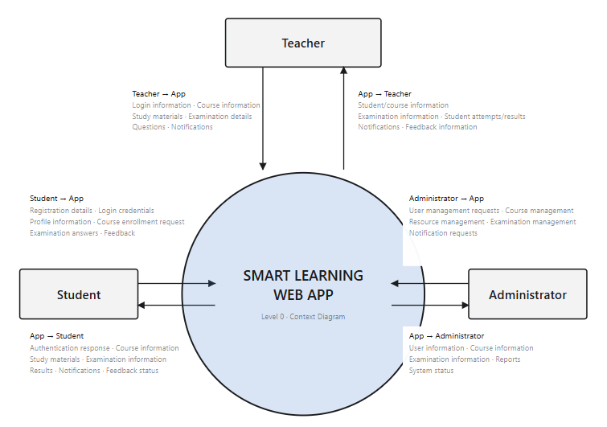

4.6.2: DFD Level 1
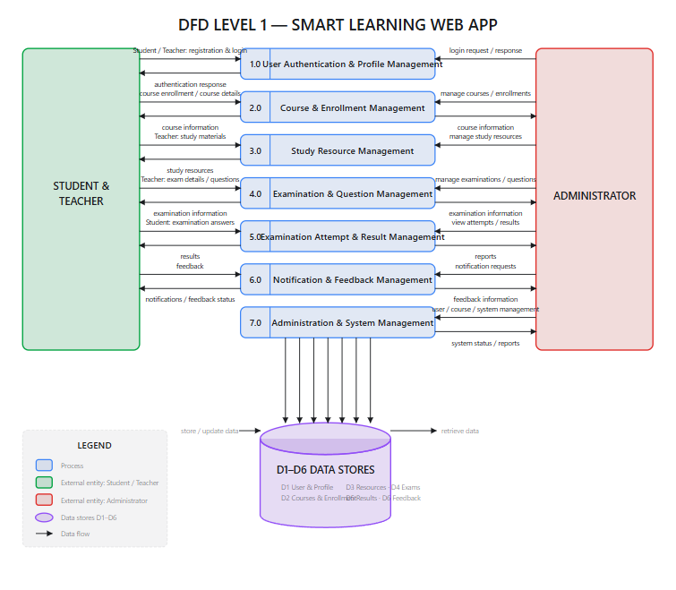

4.6.3: DFD Level 2
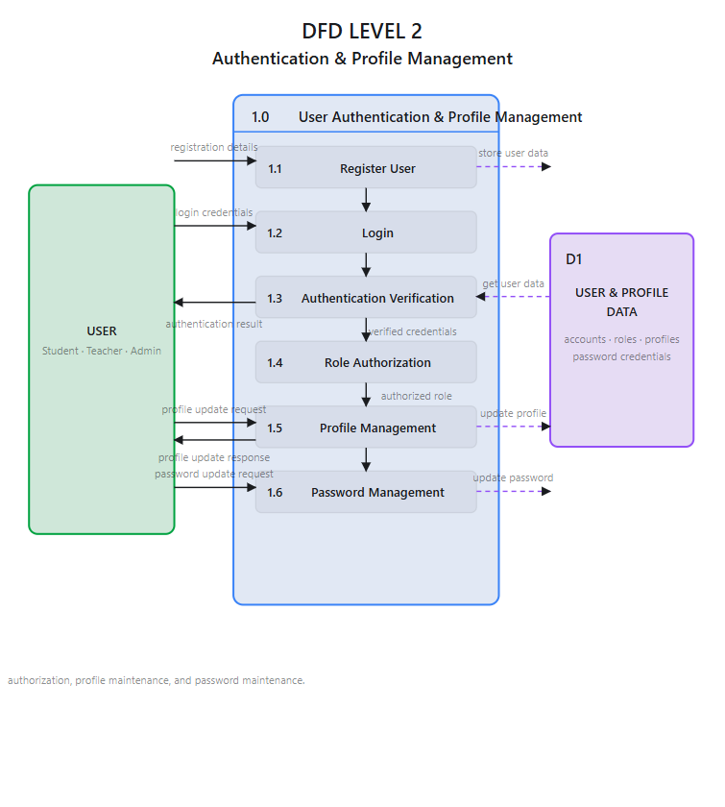

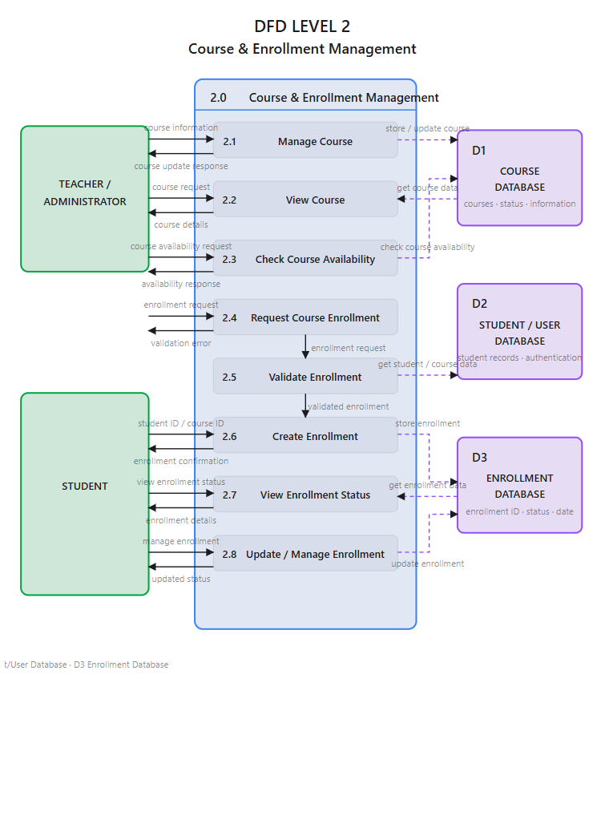

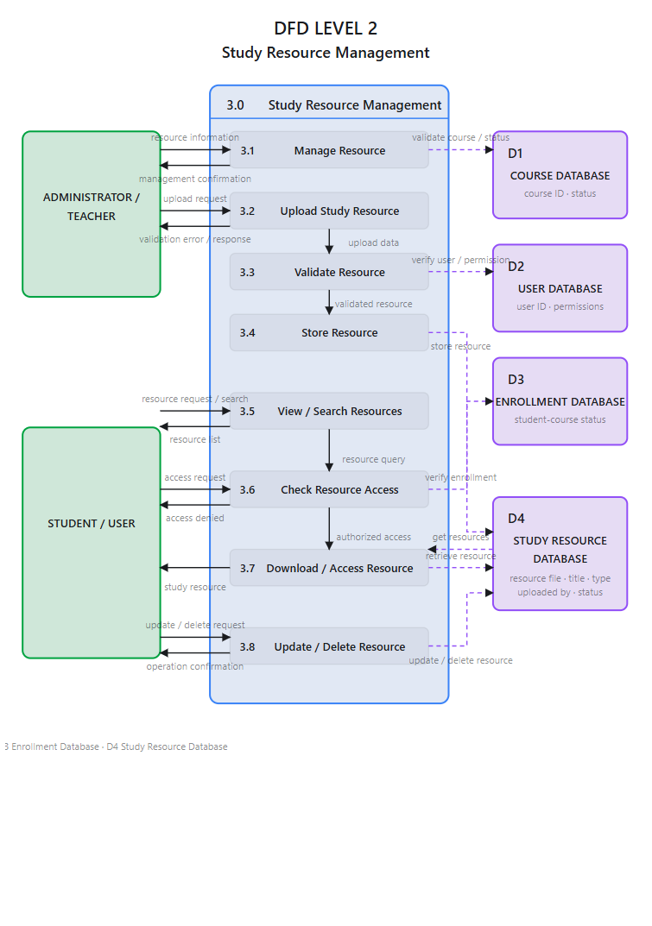

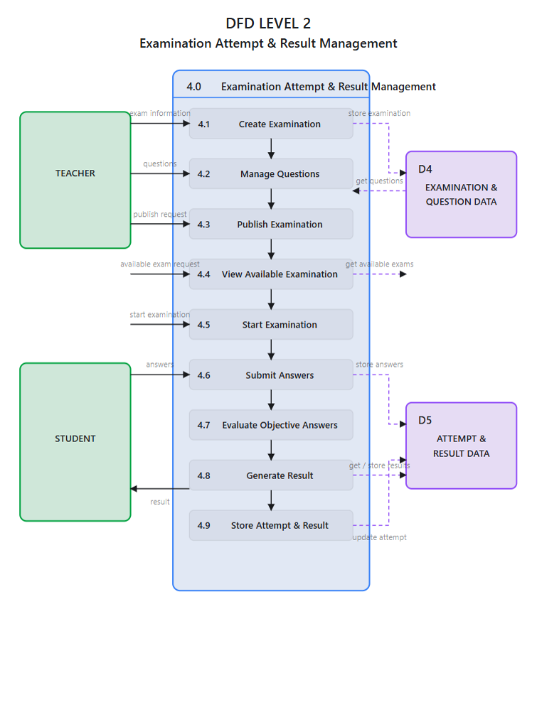

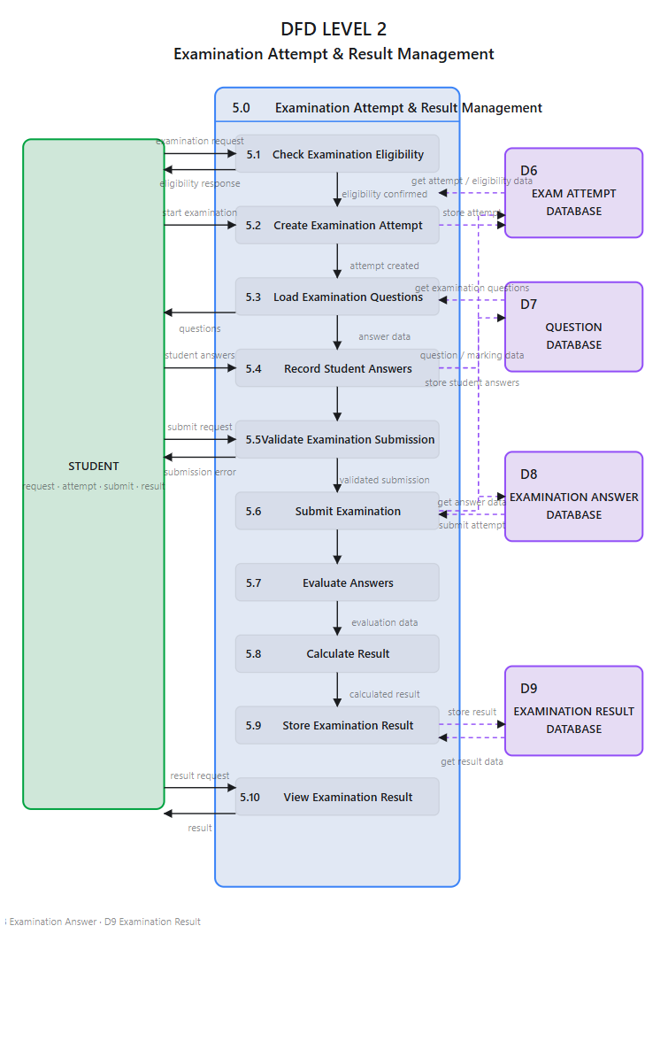
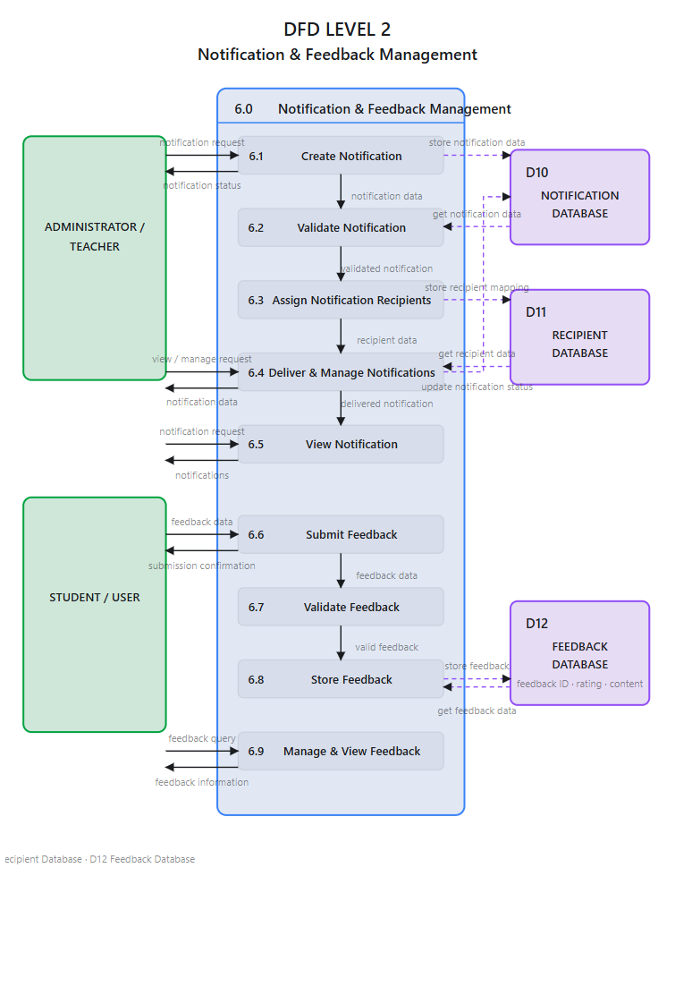

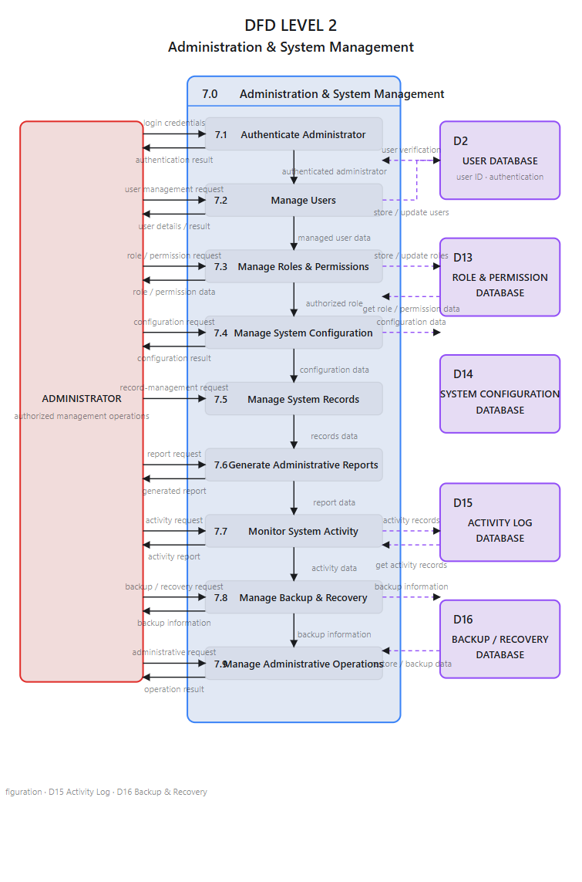

4.7 Data Dictionary and Main Database Relationships
The SMART LEARNING WEB APP (SLWA) uses a relational database approach with MySQL 9.3 for persistent storage of application and academic information. The database is organized into logically related entities so that user information, academic activities, examinations, learning resources, notifications, and feedback can be maintained in a centralized and consistent manner. The database uses primary keys to uniquely identify records and foreign keys to establish relationships between related entities.
4.7.1 Data Dictionary
The ROLES entity stores the different access roles available in the application. The primary identifier is role_id. Roles are associated with users and support role-based access control for Administrator, Teacher, and Student accounts.
The USERS entity stores common user-account and authentication information. Its primary identifier is user_id, while role_id identifies the role associated with the user. This entity provides the common authentication foundation for the different categories of system users.
The TEACHER_PROFILE entity stores teacher-specific information separately from common authentication information. It is associated with the corresponding user through user_id. The profile can maintain information such as employee number, qualification, and department.
The STUDENT_PROFILE entity stores student-specific information separately from the common user account. It is associated with the corresponding user through user_id and can contain information such as enrollment number, semester, and address.
The COURSES entity stores information about courses offered through the system. Each course is uniquely identified by course_id. Courses form a central academic entity because they are associated with teachers, student enrollments, examinations, study resources, and feedback.
The TEACHER_COURSE entity acts as an association entity between teachers and courses. It contains references to the relevant teacher and course and identifies which teachers are assigned to particular courses.
The ENROLLMENTS entity maintains the relationship between students and courses. It identifies the student and the course in which the student is enrolled and provides the basis for controlling access to relevant academic activities.
The EXAMINATIONS entity stores information about examinations associated with courses. An examination references its associated course and provides the foundation for examination management and student participation.
The QUESTIONS entity stores questions belonging to examinations. Each question is associated with an examination and contains the information required for the configured question type and evaluation process.
The QUESTION_OPTIONS entity stores options associated with questions that use selectable answer choices. Each option references an existing question.
The EXAM_ATTEMPTS entity records a student's attempt at an examination. Each examination attempt references both the relevant examination and the participating student.
The ATTEMPT_ANSWERS entity stores answers submitted during an examination attempt. Each answer is associated with an examination attempt and the corresponding question. This structure supports examination submission and result processing.
The STUDY_RESOURCES entity stores learning-resource information associated with courses. A study resource references an existing course and its uploader, allowing learning materials to be managed according to the defined application permissions.
The NOTIFICATIONS entity stores notification information such as the notification content and related communication information. It provides the central record for announcements and other system communication.
The NOTIFICATION_RECIPIENTS entity connects notifications with their intended users. It allows notification content and recipient-specific information, including read/unread status where implemented, to be maintained separately.
The FEEDBACK entity stores student feedback associated with courses. It contains the relationship between the student and course together with feedback information such as rating, comments, and creation date.
4.7.2 Main Database Relationships
The ROLES–USERS relationship connects each user account with an assigned role. One role can be associated with multiple users, while each user is associated with a role. This relationship provides the database foundation for role-based access control.
The USERS–TEACHER_PROFILE relationship connects a teacher profile with its corresponding user account. A user can have zero or one teacher profile, while each teacher profile belongs to one user. This separation allows common authentication information and teacher-specific information to be maintained independently.
The USERS–STUDENT_PROFILE relationship follows a similar structure. A user can have zero or one student profile, while each student profile belongs to one user. Student-specific information is therefore maintained separately from common authentication information.
The TEACHER_PROFILE–TEACHER_COURSE relationship connects teachers with their course assignments. A teacher can have multiple course-assignment records, and each assignment identifies the course associated with that teacher.
The COURSES–TEACHER_COURSE relationship connects courses with their assigned teachers. A course can have multiple teacher assignments, while each teacher-course assignment belongs to a particular course.
The STUDENT_PROFILE–ENROLLMENTS and COURSES–ENROLLMENTS relationships connect students and courses through enrollment. A student can have multiple enrollment records, and a course can have multiple enrolled students. The enrollment entity therefore provides the association between students and courses.
The COURSES–EXAMINATIONS relationship connects examinations with courses. A course can contain multiple examinations, while each examination belongs to a particular course.
The EXAMINATIONS–QUESTIONS relationship connects questions with examinations. An examination can contain multiple questions, while each question belongs to an examination.
The QUESTIONS–QUESTION_OPTIONS relationship connects selectable options with their questions. A question can have multiple options, while each option references an existing question.
The EXAMINATIONS–EXAM_ATTEMPTS relationship records student participation in examinations. An examination can have multiple attempts, while each attempt belongs to one examination and one participating student.
The EXAM_ATTEMPTS–ATTEMPT_ANSWERS relationship connects submitted answers with an examination attempt. An attempt can contain multiple answer records, and each answer references the corresponding question.
The COURSES–STUDY_RESOURCES relationship connects learning resources with courses. A course can have multiple study resources, while each resource references an existing course and uploader.
The NOTIFICATIONS–NOTIFICATION_RECIPIENTS relationship connects notification messages with their recipients. A notification can be distributed to multiple users through recipient records, while each recipient record references an existing notification and user.
The STUDENT_PROFILE–FEEDBACK and COURSES–FEEDBACK relationships connect feedback with both the student providing it and the course to which it relates. A student can submit feedback for courses, while each feedback record references an existing student and course.
4.7.3 Referential Integrity and Consistency
The database relationships are supported through primary keys, foreign keys, unique constraints, validation rules, and appropriate transaction processing. These mechanisms help prevent logically invalid records, such as an examination attempt referencing a non-existent examination or an answer referencing a non-existent question.
Database-level integrity is complemented by application-level validation and authorization. For example, a foreign key can confirm that a course exists, but application logic must additionally determine whether a particular student is permitted to enroll in that course or whether a teacher is authorized to manage its academic activities.
Critical multi-step operations, particularly examination submission and related answer processing, should use appropriate transaction management so that a failure does not leave related records in an incomplete or inconsistent state. Enrollment operations should similarly protect against unintended duplicate records where required by the final business rules.
Overall, the SLWA database establishes a connected structure in which users and roles provide the foundation, profiles represent role-specific information, courses act as a central academic entity, and examinations, resources, enrollments, notifications, and feedback are connected through well-defined relationships. This relational structure supports centralized data management, referential integrity, examination processing, course management, learning-resource management, communication, and feedback within the Smart Learning Web App.

CHAPTER 5: DESIGN DOCUMENT

5.1 System Design Overview
The system design combines the project modules, database structure, procedural flow, diagrams, user interface standards, and final website page structure described in the following sections

5.2 Database Design and Table Structure
The database design of SLWA is based on a relational model implemented using MySQL 9.3. The database is designed to store user information, academic information, examination information, learning resources, notifications, and feedback in a structured manner.
The database uses primary keys to uniquely identify records and foreign keys to establish relationships between related entities.
5.2.1 Roles Table
The Roles table maintains the roles available in the application.
Field Name | Data Type | Key | Description
role_id | INT | PK | Unique role ID
role_name | VARCHAR (50) | NOT NULL | Role name
description | TEXT | NOT NULL | Role details

The role identifier is referenced by the Users table to establish the user's authorization category.
5.2.2 Users Table
The Users table contains the common authentication and account information.
Field Name | Data Type | Key | Description
user_id | INT | PK | Unique user ID
role_id | INT | FK | References roles(role_id)
full_name | VARCHAR (100) | NOT NULL | User full name
email | VARCHAR (100) | UNIQUE | User email
password_hash | VARCHAR (255) | NOT NULL | Encrypted password
mobile_no | VARCHAR (15) | NOT NULL | Mobile number
status | VARCHAR (20) | NOT NULL | Active/Inactive
created_at | DATETIME | NOT NULL | Account creation date
The table acts as the primary user identity table.
5.2.3 Teacher Profiles Table
The Teacher Profiles table stores information specific to teachers.
Field Name | Data Type | Key | Description
teacher_id | INT | PK | Unique teacher ID
user_id | INT | FK, UNIQUE | References users(user_id)
employee_no | VARCHAR (50) | NOT NULL | Employee number
qualification | VARCHAR (100) | NOT NULL | Teacher qualification
department | VARCHAR (100) | NOT NULL | Department name
The user_id establishes the relationship between the teacher profile and the common Users table.
5.2.4 Student Profiles Table
The Student Profiles table maintains information specific to students.
Field Name | Data Type | Key | Description
student_id | INT | PK | Unique student ID
user_id | INT | FK, UNIQUE | References users(user_id)
enrollment_no | VARCHAR (50) | NOT NULL | Student enrollment number
semester | VARCHAR (20) | NOT NULL | Current semester
address | TEXT | NOT NULL | Student address
The profile is associated with the corresponding user account.
5.2.5 Courses Table
The Courses table maintains information about courses available in SLWA.
Field Name | Data Type | Key | Description
course_id | INT | PK | Unique course ID
course_code | VARCHAR (50) | NOT NULL | Course code
course_title | VARCHAR (150) | NOT NULL | Course title
description | TEXT | NOT NULL | Course description
status | VARCHAR (20) | NOT NULL | Active/Inactive
Courses provide the central academic association for enrollments, resources, and examinations.
5.2.6 Teacher-Course Assignments Table
This table establishes the relationship between teachers and courses.
Field Name | Data Type | Key | Description
teacher_id | INT | FK | References teacher_profile(teacher_id)
course_id | INT | FK | References courses(course_id)
assigned_at | DATETIME | NOT NULL | Course assigned date
The table allows a teacher to be associated with an appropriate course.
5.2.7 Enrollments Table
The Enrollments table records students registered for courses.
Field Name | Data Type | Key | Description
enrollment_id | INT | PK | Unique enrollment ID
student_id | INT | FK | References student_profile(student_id)
course_id | INT | FK | References courses(course_id)
enroll_date | DATE | NOT NULL | Enrollment date
enroll_status | VARCHAR (20) | NOT NULL | Active/Completed/Dropped
The table connects students with courses.
5.2.8 Examinations Table
The Examinations table stores examination information.
Field Name | Data Type | Key | Description
enrollment_id | INT | PK | Unique enrollment ID
student_id | INT | FK | References student_profile(student_id)
course_id | INT | FK | References courses(course_id)
enroll_date | DATE | NOT NULL | Enrollment date
enroll_status | VARCHAR (20) | NOT NULL | Active/Completed/Dropped
The table connects an examination to a course and its creator.
5.2.9 Questions Table
The Questions table stores examination questions.
Field Name | Data Type | Key | Description
question_id | INT | PK | Unique question ID
exam_id | INT | FK | References exams(exam_id)
question_text | TEXT | NOT NULL | Question
question_type | VARCHAR (50) | NOT NULL | MCQ/Text
marks | INT | NOT NULL | Question marks
Questions belong to examinations.
5.2.10 Question Options Table
The Question Options table stores options for multiple-choice questions.
Field Name | Data Type | Key | Description
option_id | INT | PK | Unique option ID
question_id | INT | FK | References questions(question_id)
option_text | TEXT | NOT NULL | Option text
is_correct | BOOLEAN | NOT NULL | Correct option status
This table allows an MCQ question to contain multiple possible options.
5.2.11 Exam Attempts Table
The Exam Attempts table stores student examination attempts.
Field Name | Data Type | Key | Description
attempt_id | INT | PK | Unique attempt ID
exam_id | INT | FK | References exams(exam_id)
student_id | INT | FK | References student_profile(student_id)
started_at | DATETIME | NOT NULL | Exam start time
submitted_at | DATETIME | NOT NULL | Exam submit time
score | INT | NOT NULL | Obtained score
status | VARCHAR (20) | NOT NULL | Started/Submitted
The table provides the primary link between a student and an examination attempt.
5.2.12 Attempt Answers Table
This table stores answers submitted during an examination.
Field Name | Data Type | Key | Description
answer_id | INT | PK | Unique answer ID
attempt_id | INT | FK | References exam_attempts(attempt_id)
question_id | INT | FK | References questions(question_id)
selected_option_id | INT | FK | References question_options(option_id)
text_answer | TEXT | NOT NULL | Written answer
marks_obtained | INT | NOT NULL | Marks obtained
The structure allows answers to be associated with both the examination attempt and individual questions.
5.2.13 Study Resources Table
The Study Resources table stores information about learning materials.
Field Name | Data Type | Key | Description
resource_id | INT | PK | Unique resource ID
course_id | INT | FK | References courses(course_id)
uploaded_by_user_id | INT | FK | References users(user_id)
title | VARCHAR (150) | NOT NULL | Resource title
file_path | VARCHAR (255) | NOT NULL | File location
file_type | VARCHAR (50) | NOT NULL | PDF/DOC/Image/Video
uploaded_at | DATETIME | NOT NULL | Upload date
Resources may include supported PDF, DOC, image, and video materials.
5.2.14 Notifications Table
The Notifications table stores notification information.
Field Name | Data Type | Key | Description
notification_id | INT | PK | Unique notification ID
title | VARCHAR (150) | NOT NULL | Notification title
message | TEXT | NOT NULL | Notification message
created_by_user_id | INT | FK | References users(user_id)
created_at | DATETIME |  | Notification date

5.2.15 Notification Recipients Table
This table associates notifications with intended recipients.
Field Name | Data Type | Key | Description
notification_id | INT | FK | References notifications(notification_id)
user_id | INT | FK | References users(user_id)
is_read | BOOLEAN | NOT NULL | Read status
read_at | DATETIME | NOT NULL | Read time
This design allows one notification to be associated with multiple users.
5.2.16 Feedback Table
The Feedback table stores feedback submitted by students.
Field Name | Data Type | Key | Description
feedback_id | INT | PK | Unique feedback ID
student_id | INT | FK | References student_profile(student_id)
course_id | INT | FK | References courses(course_id)
rating | INT | NOT NULL | Rating value
comments | TEXT | NOT NULL | Feedback comment
created_at | DATETIME | NOT NULL | Feedback date

5.2.17 Database Design Principles
The database design follows the following principles:
- Each major entity has a unique identifier.
- Primary keys uniquely identify records.
- Foreign keys maintain relationships between entities.
- Duplicate records are restricted through appropriate constraints.
- Mandatory data is validated before storage.
- Passwords are stored as hashes rather than plain text.
- Parameterized queries are used to reduce SQL-injection risks.
- Related records are protected through referential integrity.
- Database transactions are used where multiple related operations require atomic processing.
- Appropriate indexes are used for frequently searched or joined fields.

5.3: Procedural Logic / Flowcharts

5.4: Entity Relationship Diagram (ERD)

5.5: Object Class Diagram

5.6: Use Case Diagram

5.7 User Interface Design
The User Interface (UI) of the SMART LEARNING WEB APP (SLWA) is designed to provide a simple, responsive, and role-based environment for Administrators, Teachers, and Students. The interface acts as the main point of interaction between users and the application and is designed to make academic and administrative operations easy to understand and perform.
The UI follows a structured approach in which common functions such as authentication, navigation, profile management, notifications, and logout are presented consistently, while role-specific functions are displayed according to the permissions of the logged-in user. The interface is designed using HTML5, CSS3, JavaScript, and Bootstrap so that the application can adapt to different screen sizes and modern web browsers.
5.7.1 General Interface Design
The interface follows a clean and organized layout so that users can locate required functionality without unnecessary navigation. The major interface areas include the header or navigation area, main content area, navigation controls, forms, action buttons, information cards, lists, and feedback messages.
The design maintains consistency in typography, spacing, button usage, form structure, navigation, and page organization. Similar operations use similar interface patterns throughout the application.
The interface also provides appropriate visual feedback after important operations. For example, successful creation, updating, deletion, enrollment, submission, or other actions can provide confirmation to the user, while invalid input or failed operations provide understandable error messages.
5.7.2 Login and Authentication Interface
The login interface provides the entry point for authenticated users. It allows users to enter their required credentials and submit them for authentication.
The interface is designed to keep the authentication process simple while providing appropriate validation messages when credentials are missing or invalid. After successful authentication, the user is directed to the dashboard or appropriate starting page according to the assigned role.
Protected application pages are not intended to be directly accessible to unauthenticated users.
5.7.3 Administrator Interface
The Administrator interface provides access to system-level management functions. The Administrator dashboard acts as a central control area from which administrative operations can be accessed.
The Administrator interface provides access to functions such as user management, student management, teacher management, course management, teacher-course assignment, enrollment management, examination management, question management, result management, notifications, feedback, and other administrative activities defined for the system.
Management pages generally provide appropriate controls for viewing existing records and performing permitted operations such as adding, editing, updating, or deleting information.
The Administrator interface is designed to display only functions available to the Administrator role. Backend authorization is also applied so that access control does not depend only on the visual interface.
5.7.4 Teacher Interface
The Teacher interface is designed around academic management and course-related activities. After authentication, the Teacher can access the functions associated with assigned academic responsibilities.
The Teacher interface supports activities such as viewing assigned courses, managing study resources, creating and managing examinations, managing questions, and accessing relevant student academic information.
Forms are provided where teachers need to enter or modify information. Input fields are accompanied by suitable validation so that incomplete or invalid information can be identified before processing.
The interface is intended to reduce unnecessary navigation by grouping related academic functions within the Teacher's working environment.
5.7.5 Student Interface
The Student interface focuses on learning and academic participation. Students can access available courses, enroll in appropriate courses, access authorized study resources, participate in examinations, view results, receive notifications, manage profile information, and provide feedback.
The Student dashboard provides access to the student's important academic activities. Course-related information is presented in an organized manner so that students can identify available and enrolled courses.
During examinations, the interface is designed to present questions and answer options clearly and provide an appropriate mechanism for submitting responses. After examination processing, students can access their available results through the relevant interface.
5.7.6 Course Management Interface
The course-management interface provides authorized users with facilities for creating, viewing, updating, and managing course information.
Course information is presented in an organized format so that users can understand important details without excessive navigation. Teachers and Administrators receive different levels of access according to their roles.
For Students, course-related screens focus primarily on viewing available course information and performing enrollment-related activities.
5.7.7 Study Resource Interface
The study-resource interface is designed to allow authorized academic users to manage learning resources and allow Students to access resources associated with their courses.
Teachers can add or manage appropriate study resources according to their permissions, while Students can access resources associated with courses in which they are permitted to participate.
The interface should clearly identify resource information and provide suitable actions for viewing or accessing the available material.
5.7.8 Examination Interface
The examination interface provides the interaction area for examination creation, question management, student participation, submission, and result-related activities.
For Teachers and Administrators, the interface provides management functions for examinations and questions. For Students, the interface focuses on attempting available examinations and submitting answers.
Question presentation should remain clear and readable. Where selectable answer options are used, they should be presented in an understandable manner to reduce input errors.
The submission process should provide appropriate confirmation and error handling so that users are informed if an operation cannot be completed successfully.
5.7.9 Result Interface
The result interface provides authorized access to examination results. Students can view their available results after the relevant examination has been processed.
The result interface should present academic information in a clear and understandable manner. Teachers and authorized Administrators can access result-related information according to their permissions.
The interface should prevent unauthorized users from viewing another user's private academic information.
5.7.10 Notification Interface
The notification interface provides a centralized area for displaying important communication to users.
Notifications can be presented in the user's authenticated environment and can provide information about academic or system-related activities. The interface should clearly distinguish available notifications and provide appropriate indication of notification status where implemented.
Administrators and authorized users can manage notifications according to their assigned permissions.
5.7.11 Feedback Interface
The feedback interface allows Students to provide feedback associated with courses. The interface provides appropriate fields for entering feedback information and, where applicable, a rating and comments.
The form validates required information before submission. After successful submission, the user receives appropriate confirmation.
Feedback information is handled according to the application's access-control rules so that only authorized users can access relevant feedback-management functions.
5.7.12 Profile Management Interface
The profile interface allows authenticated users to view and manage permitted personal information.
The common account information is maintained separately from role-specific profile information. Therefore, the interface can present appropriate fields depending on whether the authenticated user is an Administrator, Teacher, or Student.
Profile forms should validate user input and provide confirmation after successful updates.
5.7.13 Navigation Design
Navigation is designed according to the user's role and available permissions. The interface should provide access to the most frequently used functions without requiring unnecessary movement between unrelated pages.
A consistent navigation structure improves usability and helps users understand where they are within the application.
Navigation elements may include dashboard links, course-related options, examination options, notifications, profile management, and logout. Role-specific options are displayed according to the authenticated user's permissions.
5.7.14 Form Design and Validation
Forms are an important part of SLWA because many operations involve entering or modifying information.
The form-design principles include:
- Clear field labels.
- Appropriate input controls.
- Required-field identification.
- Validation of entered information.
- Meaningful validation messages.
- Clear submission controls.
- Confirmation after successful operations.
- Prevention of accidental duplicate submissions where applicable.
Client-side validation improves the user experience, while server-side validation provides the necessary security and reliability.
5.7.15 Responsive Interface Design
SLWA is designed as a responsive web application so that the interface can adapt to desktop, laptop, tablet, and mobile screen sizes.
Responsive design includes appropriate adjustment of navigation, content width, forms, cards, buttons, lists, and other interface components according to the available screen space.
Bootstrap responsive utilities and CSS media-query techniques can be used to maintain consistent usability across different devices.
The objective is to ensure that important information remains readable and that interactive elements remain accessible without requiring unnecessary horizontal scrolling.
5.7.16 Usability and Accessibility Considerations
The interface is designed with usability as an important consideration. Text should remain readable, controls should be understandable, and related functions should be grouped logically.
Important usability considerations include:
- Consistent navigation.
- Readable typography.
- Clear labels.
- Understandable error messages.
- Appropriate button text.
- Logical form ordering.
- Adequate spacing between interactive elements.
- Responsive layouts.
- Keyboard-friendly interaction where applicable.
Accessibility can be further improved through semantic HTML, suitable labels, keyboard navigation, appropriate contrast, alternative text for meaningful images, and compatibility with assistive technologies.
5.7.17 Security Considerations in UI Design
The user interface also follows security-related design principles. Sensitive information should not be unnecessarily displayed, and protected functionality should be available only to authorized users.
For example, a student interface should not provide administrative controls merely because the corresponding page exists in the application. Authorization must also be enforced at the backend level.
Forms should validate input, authentication interfaces should handle credentials securely, and error messages should avoid exposing internal database or server information.
5.7.18 Overall UI Design Approach
The overall UI design of SLWA follows a role-based, responsive, consistent, and task-oriented approach. The interface is structured so that Administrators can manage the system, Teachers can perform academic management activities, and Students can participate in learning and examination activities.
The combination of HTML5, CSS3, JavaScript, and Bootstrap provides the foundation for creating responsive pages and reusable interface components. Consistent navigation, form validation, controlled access, responsive layouts, and clear feedback contribute to a usable and maintainable application interface.
The UI therefore acts as an important connection between the user and the underlying application logic and database. Its design supports the project's objective of providing a centralized and accessible Smart Learning Web App while maintaining the role-based structure defined for the system.

5.8 Module Structure and Description
The Smart Learning Web App is divided into functional modules. Each module has a defined responsibility and interacts with other modules through controlled application services and database relationships.
5.8.1 Authentication Module
The Authentication Module manages user identity and secure access.
Main functions include:
- Registration.
- Login.
- Logout.
- Password management.
- Password hashing.
- Authentication/session management.
- Account-status verification.
- Unauthorized-access prevention.
5.8.2 Role and Access Control Module
This module determines what functions each user can access.
It manages:
- Administrator permissions.
- Teacher permissions.
- Student permissions.
- Role verification.
- Authorization middleware.
- Protected routes.
- Unauthorized-access handling.
5.8.3 User Management Module
The User Management Module manages common account information.
Functions include:
- User creation.
- User listing.
- User profile viewing.
- User profile modification.
- Account status management.
- Administrative account management.
5.8.4 Student Management Module
The Student Module manages student-specific academic information.
Functions include:
- Student profile.
- Enrollment information.
- Course access.
- Study-resource access.
- Examination participation.
- Examination results.
- Notifications.
- Feedback.
5.8.5 Teacher Management Module
The Teacher Module provides academic management functionality for teachers.
Functions include:
- Teacher profile.
- Course assignments.
- Study-resource management.
- Examination creation.
- Question management.
- Examination monitoring.
- Access to relevant student academic information.
5.8.6 Course Management Module
The Course Module manages academic courses.
Functions include:
- Course creation.
- Course modification.
- Course status.
- Course listing.
- Teacher-course association.
- Student course access.
5.8.7 Enrollment Module
The Enrollment Module manages student registration for courses.
Functions include:
- Course enrollment.
- Enrollment status.
- Enrollment date.
- Duplicate-enrollment prevention.
- Course-student relationship management.
5.8.8 Study Resource Module
This module manages learning materials associated with courses.
Functions include:
- Resource upload.
- Resource metadata.
- Resource listing.
- Resource access.
- Resource download.
- Resource management.
Supported resource categories defined by the project include PDF, DOC, image, and video resources.
5.8.9 Examination Module
The Examination Module manages online examinations.
Functions include:
- Examination creation.
- Examination scheduling.
- Examination duration.
- Total marks.
- Question creation.
- Question-type management.
- MCQ option management.
- Examination availability.
- Student examination access.
5.8.10 Question Bank Module
The Question Bank functionality manages examination questions and options.
It supports:
- Question creation.
- Question modification.
- Question deletion where authorized.
- Question type.
- Question marks.
- MCQ options.
- Correct-option management.
- Association with examinations.
5.8.11 Examination Attempt Module
The Examination Attempt Module manages the student's participation in an examination.
Functions include:
- Starting an examination.
- Creating an attempt.
- Maintaining attempt status.
- Recording answers.
- Maintaining start/end times.
- Final submission.
- Preventing unauthorized access to attempts.
5.8.12 Result Management Module
The Result Module processes and displays examination results.
Functions include:
- Answer evaluation where supported.
- Marks calculation.
- Score storage.
- Result retrieval.
- Student result display.
- Authorized teacher/administrator access.
5.8.13 Notification Module
The Notification Module provides centralized communication.
Functions include:
- Creating notifications.
- Assigning recipients.
- Displaying notifications.
- Maintaining read/unread information where implemented.
- Managing notification records.
5.8.14 Feedback Module
The Feedback Module allows students to submit academic feedback.
Functions include:
- Feedback submission.
- Feedback storage.
- Course association where applicable.
- Feedback viewing by authorized users.
- Feedback management.
5.8.15 Search and Filtering Module
This module improves information retrieval.
Functions include:
- Search.
- Filtering.
- Sorting where supported.
- Pagination.
- Controlled retrieval of large datasets.
5.8.16 API Module
The API Module provides communication between the frontend and backend.
Functions include:
- REST-style endpoints.
- Request validation.
- Authentication middleware.
- Authorization middleware.
- CRUD operations.
- Structured responses.
- HTTP status handling.
- Error handling.
5.8.17 Administration Module
The Administration Module provides system-level management.
Functions include:
- User administration.
- Course administration.
- Teacher-course management.
- Examination administration.
- Resource management.
- Notification management.
- System monitoring.
- Administrative access control.
5.8.18 Logging and Error Management Module
This module supports application monitoring and controlled error handling.
Functions include:
- Request logging.
- Application error logging.
- Authentication-event logging.
- Administrative-event logging.
- Structured error responses.
- Prevention of sensitive information exposure.

5.9 Final Website Page List
The final website is organized according to the three major user roles and common public functionality.
5.9.1 Public and Common Pages
- Home Page
- About / Information Page
- Login Page
- Registration Page
- Forgot Password Page
- Reset Password Page
- Unauthorized Access Page
- Error Page
- Profile Page
- Change Password Page
- Notifications Page
5.9.2 Student Pages
- Student Dashboard
- Student Profile
- Available Courses
- Course Details
- My Courses
- Course Enrollment
- My Study Resources
- Resource Details / Access
- Available Examinations
- Examination Instructions
- Examination Attempt Page
- Examination Submission
- Examination Result
- My Results
- Notifications
- Feedback Form
- My Feedback / Feedback Status
- Change Password
- Logout
5.9.3 Teacher Pages
- Teacher Dashboard
- Teacher Profile
- Assigned Courses
- Course Details
- Study Resource Management
- Add Study Resource
- Edit Study Resource
- Examination Management
- Create Examination
- Edit Examination
- Examination Details
- Question Management
- Add Question
- Edit Question
- MCQ Option Management
- Examination Attempts / Academic Monitoring
- Student Academic Information
- Notifications
- Profile Management
- Change Password
- Logout
5.9.4 Administrator Pages
- Administrator Dashboard
- User Management
- Add User
- Edit User
- View User
- Student Management
- Teacher Management
- Course Management
- Add Course
- Edit Course
- Teacher-Course Assignment
- Enrollment Management
- Study Resource Management
- Examination Management
- Question Management
- Examination Result Management
- Notification Management
- Feedback Management
- System Records / Monitoring
- Profile Management
- Change Password
- Logout
5.9.5 Page Design Principles
All pages shall follow a consistent design language.
The interface shall provide:
- Consistent header/navigation.
- Role-specific menus.
- Responsive layouts.
- Clear page titles.
- Form validation.
- Success and error notifications.
- Consistent buttons and controls.
- Appropriate tables for administrative information.
- Search and filtering where required.
- Pagination for large datasets.
- Accessible form labels.
- Controlled access to protected pages.

5.10 API Architecture and Implementation
The Smart Learning Web App uses a REST-oriented backend architecture implemented using Node.js 24.16.0 LTS and Express.js 5.x.
The API layer provides controlled communication between the frontend and application/database services.
5.10.1 API Architecture
The logical API request flow is:
- Client sends HTTP request.
- Express receives the request.
- Request middleware processes the request.
- Authentication is verified when required.
- Authorization is verified.
- Request input is validated.
- Appropriate controller/service logic is executed.
- Database operations are performed where required.
- The result is processed.
- A structured HTTP response is returned to the client.
5.10.2 API Layers
The backend may be logically organized into:
- Routes
- Middleware
- Controllers
- Services/Business Logic
- Data Access/Database Layer
- Validation
- Error Handling
- Logging
This separation improves maintainability and testing.
5.10.3 Authentication API
Authentication-related API operations support:
- Registration.
- Login.
- Logout.
- Password reset/recovery.
- Session or token validation.
Typical logical endpoints include:
Method | Logical Endpoint | Purpose
POST | /api/auth/register | Register user
POST | /api/auth/login | Authenticate user
POST | /api/auth/logout | End authenticated session
POST | /api/auth/forgot-password | Initiate password recovery
POST | /api/auth/reset-password | Reset password
The exact production route naming shall follow the implemented application.
5.10.4 User API
User APIs provide authorized account-management operations.
Method | Logical Endpoint | Purpose
GET | /api/users | Retrieve users
GET | /api/users/:id | Retrieve specific user
POST | /api/users | Create user
PUT/PATCH | /api/users/:id | Update user
DELETE | /api/users/:id | Remove/deactivate user
Administrative authorization shall be applied to protected operations.
5.10.5 Course API
Course APIs manage course information.
Method | Logical Endpoint | Purpose
GET | /api/courses | List courses
GET | /api/courses/:id | View course
POST | /api/courses | Create course
PUT/PATCH | /api/courses/:id | Update course
DELETE | /api/courses/:id | Remove/deactivate course
5.10.6 Enrollment API
The Enrollment API manages student-course relationships.
Method | Logical Endpoint | Purpose
GET | /api/enrollments | Retrieve enrollments
POST | /api/enrollments | Create enrollment
GET | /api/enrollments/:id | View enrollment
PUT/PATCH | /api/enrollments/:id | Update enrollment
DELETE | /api/enrollments/:id | Remove/drop enrollment
The backend shall verify student identity and course eligibility before creating an enrollment.
5.10.7 Resource API
Resource APIs manage study materials.
Method | Logical Endpoint | Purpose
GET | /api/resources | List resources
GET | /api/resources/:id | View resource information
POST | /api/resources | Upload/create resource
PUT/PATCH | /api/resources/:id | Update resource
DELETE | /api/resources/:id | Delete resource
Access shall be restricted according to course and user permissions.
5.10.8 Examination API
Examination APIs manage examinations.
Method | Logical Endpoint | Purpose
GET | /api/exams | List examinations
GET | /api/exams/:id | View examination
POST | /api/exams | Create examination
PUT/PATCH | /api/exams/:id | Update examination
DELETE | /api/exams/:id | Delete/deactivate examination
5.10.9 Question API
Question APIs manage questions and options.
Method | Logical Endpoint | Purpose
GET | /api/exams/:id/questions | Retrieve examination questions
POST | /api/exams/:id/questions | Create question
PUT/PATCH | /api/questions/:id | Update question
DELETE | /api/questions/:id | Delete question
For MCQs, additional operations manage question options.
5.10.10 Examination Attempt API
Method | Logical Endpoint | Purpose
POST | /api/exams/:id/start | Start examination
GET | /api/attempts/:id | Retrieve own attempt
POST | /api/attempts/:id/answers | Submit/store answer
POST | /api/attempts/:id/submit | Submit examination
GET | /api/attempts/:id/result | Retrieve result
The backend shall verify that the authenticated user owns the relevant student attempt.
5.10.11 Notification API
Method | Logical Endpoint | Purpose
GET | /api/notifications | Retrieve notifications
POST | /api/notifications | Create notification
PUT/PATCH | /api/notifications/:id | Update notification
DELETE | /api/notifications/:id | Delete notification
Recipient authorization shall be applied to notification access.
5.10.12 Feedback API
Method | Logical Endpoint | Purpose
POST | /api/feedback | Submit feedback
GET | /api/feedback | Retrieve feedback
GET | /api/feedback/:id | View feedback
PUT/PATCH | /api/feedback/:id | Update where permitted
DELETE | /api/feedback/:id | Delete where authorized
Students shall only be permitted to create or manage feedback according to the defined business rules.
5.10.13 API Validation
Every API endpoint receiving user-controlled input shall validate:
- Required fields.
- Data types.
- String length.
- Email format.
- Numeric ranges.
- Date values.
- Resource identifiers.
- User permissions.
- Business rules.
Client-side validation shall not replace server-side validation.
5.10.14 API Authentication and Authorization
Protected API requests shall pass through authentication middleware.
Authorization shall then verify:
- The identity of the authenticated user.
- The user's role.
- The requested resource.
- The user's relationship with that resource.
- Whether the requested operation is permitted.
This prevents users from accessing or modifying records belonging to other users without authorization.
5.10.15 API Response Structure
Successful API responses should provide structured information containing the requested result and appropriate status information.
Error responses should provide controlled information such as:
- HTTP status code.
- General error message.
- Validation details where appropriate.
- Request or error reference information where implemented.
Production responses shall not expose:
- Database passwords.
- Authentication secrets.
- JWT signing keys.
- SQL statements.
- Stack traces.
- Internal server configuration.
5.10.16 HTTP Status Codes
The API shall use suitable HTTP status codes.
Code | Meaning
200 | Successful request
201 | Resource successfully created
204 | Successful request with no response body
400 | Invalid request
401 | Authentication required/failed
403 | Access forbidden
404 | Resource not found
409 | Resource conflict
422 | Validation/business-rule failure where applicable
429 | Too many requests
500 | Internal server error
5.10.17 API Security
API security shall include:
- Authentication middleware.
- Authorization middleware.
- Input validation.
- Parameterized SQL.
- Rate limiting.
- Secure token/session handling.
- HTTPS.
- CORS configuration where required.
- Controlled error responses.
- Logging.
- Sensitive-data protection.

5.11 Deployment Architecture
The deployment architecture defines how the Smart Learning Web App is prepared and operated in a production environment.
The deployment follows the same logical separation established during system design:
- Client/Presentation environment.
- Application/server environment.
- Database environment.
5.11.1 Client Environment
Users access SLWA through a modern web browser.
Supported user devices may include:
- Desktop computers.
- Laptop computers.
- Tablets.
- Mobile devices.
The client environment executes the HTML5, CSS3, JavaScript, and Bootstrap-based frontend.
5.11.2 Application Server
The backend application is deployed using Node.js and Express.js.
The application server is responsible for:
- Processing API requests.
- Authentication.
- Authorization.
- Business logic.
- Input validation.
- Database communication.
- File/resource operations.
- Error handling.
- Logging.
The application server should be configured so that development settings are not exposed in production.
5.11.3 Database Server
MySQL 9.3 provides persistent data storage.
The database server stores:
- User accounts.
- Roles.
- Student profiles.
- Teacher profiles.
- Courses.
- Enrollments.
- Examinations.
- Questions.
- Question options.
- Attempts.
- Answers.
- Resources.
- Notifications.
- Feedback.
Database access shall be restricted to authorized application services and administrators.
5.11.4 Production Communication
Production communication should use HTTPS.
The logical communication sequence is:
- User opens SLWA in a browser.
- Browser communicates with the application through HTTPS.
- Application server processes the request.
- Application server communicates with MySQL through the configured database connection.
- Database returns the required data.
- Application server prepares the response.
- Response is returned to the browser through HTTPS.
5.11.5 Environment Configuration
Separate configuration should be maintained for:
- Development.
- Testing.
- Production.
Environment-specific information includes:
- Database host.
- Database port.
- Database name.
- Database username.
- Database password.
- Authentication secrets.
- Application port.
- File-storage configuration.
- Allowed origins.
- Logging configuration.
Sensitive configuration values should be maintained through environment variables or an equivalent secure configuration mechanism rather than being hard-coded into source files.
5.11.6 Production Security Configuration
Before production deployment:
- HTTPS shall be enabled.
- Strong database credentials shall be configured.
- Development credentials shall be removed.
- Debug mode shall be disabled.
- Detailed stack traces shall not be returned to users.
- Secure cookies shall be configured where applicable.
- Authentication secrets shall be protected.
- Database privileges shall be restricted.
- API rate limiting shall be configured.
- Logging shall be enabled.
- Backup procedures shall be configured.
- Unnecessary services and ports shall be restricted.
5.11.7 Database Backup
The deployment environment shall include a regular database-backup strategy.
Backups should cover important application data including:
- Users.
- Profiles.
- Courses.
- Enrollments.
- Examination records.
- Questions.
- Attempts.
- Answers.
- Results.
- Resources metadata.
- Notifications.
- Feedback.
Backup files should be stored securely and access should be restricted.
5.11.8 Learning Resource Storage
Study resources uploaded by authorized users require appropriate storage management.
The deployment should maintain:
- Valid resource paths.
- File-type validation.
- File-size restrictions where applicable.
- Access authorization.
- Safe file naming.
- Backup or recovery procedures for important resources.
The exact physical storage mechanism is dependent on the final deployment environment.
5.11.9 Application Logging
The production application should maintain logs for:
- Authentication events.
- API requests.
- Application errors.
- Database-related errors.
- Administrative operations.
- Important security events.
Sensitive values such as passwords, tokens, and database credentials shall not be written to logs.
5.11.10 Monitoring and Maintenance
The deployed application should be monitored for:
- Application availability.
- API response performance.
- Database availability.
- Error frequency.
- Storage usage.
- Resource consumption.
- Authentication failures.
- Examination-related failures.
Regular maintenance should include:
- Dependency updates.
- Security review.
- Database maintenance.
- Backup verification.
- Log management.
- Performance monitoring.
- Error investigation.
5.11.11 Deployment Procedure
A general deployment process consists of the following steps:
- Prepare the production server.
- Install the required Node.js runtime.
- Install the required backend dependencies.
- Configure MySQL.
- Create the application database.
- Execute the database SQL script.
- Configure production environment variables.
- Deploy backend source code.
- Deploy frontend files.
- Configure the application server.
- Configure HTTPS.
- Configure allowed origins and network access.
- Start the Node.js/Express application.
- Verify database connectivity.
- Test authentication.
- Test role-based authorization.
- Test course and enrollment functionality.
- Test learning resources.
- Test examination workflows.
- Test results and notifications.
- Review application logs.
- Perform final system testing.
5.11.12 Deployment Verification
After deployment, the following checks should be performed:
Verification Area | Check
Application | Application starts successfully
Database | Database connection works
Authentication | Login/logout works correctly
Authorization | Role restrictions are enforced
Users | User management functions operate
Courses | Course operations operate
Enrollment | Student enrollment works
Resources | Authorized resources are accessible
Examination | Examination workflow works
Results | Results are correctly generated/displayed
Notifications | Notifications reach intended users
Feedback | Feedback submission works
Security | HTTPS and security controls are active
Logging | Application errors and important events are logged
Backup | Database backup can be created and verified
5.11.13 Deployment Architecture Summary
The deployment design provides a controlled environment in which users interact with the presentation layer, application requests are processed by the Node.js/Express backend, and persistent information is maintained by MySQL.
This architecture provides a suitable foundation for security, maintainability, testing, performance management, backup, and future scalability. The separation of the client, application, and database responsibilities also makes it possible to modify or expand individual layers without unnecessarily redesigning the complete system.
The exact hosting provider, domain name, operating system of the production server, reverse-proxy configuration, and cloud infrastructure are not specified in the project synopsis; therefore, these deployment details should be finalized according to the actual hosting environment selected for the completed project.

5.12: Gantt Chart

CHAPTER 6: TESTING

6.1 Testing Types and Strategies
Software testing is an essential phase in the development of the SMART LEARNING WEB APP (SLWA). The purpose of testing is to verify that the developed system performs according to the specified functional and non-functional requirements and provides reliable services to Administrators, Teachers, and Students. Testing also helps identify defects, incorrect data processing, authorization problems, interface issues, database errors, and unexpected system behaviour before the application is deployed for practical use.
SLWA contains several interconnected modules, including authentication, user management, student and teacher management, course management, course enrollment, study resources, examinations, question-bank management, examination attempts, result management, notifications, feedback, search and filtering, and administrative functions. Therefore, testing is performed at different levels so that individual components as well as the complete application can be verified.
The testing strategy follows a combination of white-box and black-box testing techniques. White-box testing focuses on internal program logic and implementation paths, while black-box testing verifies system behaviour by providing inputs and examining the resulting outputs without depending on internal implementation details.
The major objectives of testing SLWA are:
- To verify that all functional requirements are correctly implemented.
- To ensure that users can authenticate securely.
- To verify role-based access for Administrator, Teacher, and Student users.
- To validate course creation, assignment, enrollment, and management operations.
- To verify that study resources can be created, managed, and accessed according to user permissions.
- To verify examination, question-bank, examination-attempt, and result-management processes.
- To ensure that notifications and feedback functions operate correctly.
- To verify the correctness and integrity of database operations.
- To identify and handle invalid inputs and unexpected conditions.
- To verify the security, performance, compatibility, and reliability of the application.
6.1.1 Testing Approach
The testing approach for SLWA is systematic and module-oriented. Each major module is tested individually before testing the interaction between modules. After successful module testing, integration testing is performed to verify the complete workflow.
The general testing sequence includes:
- Requirement analysis.
- Test-condition identification.
- Test-case preparation.
- Unit/module testing.
- Integration testing.
- API and database testing.
- System testing.
- Security and performance testing.
- Compatibility testing.
- Regression testing.
- User acceptance testing.
- Defect correction and retesting.
This approach reduces the possibility of carrying an error from one development stage to another.
6.1.2 White-Box Testing
White-box testing examines the internal implementation and logical flow of the application. It is useful for verifying program conditions, branches, loops, functions, validation logic, authorization middleware, error-handling paths, and database-processing operations.
In SLWA, white-box testing can be applied to:
- Authentication and password-processing logic.
- Role-based authorization middleware.
- Input-validation functions.
- Course-management functions.
- Enrollment-processing logic.
- Examination and result-processing functions.
- API controllers and services.
- Database interaction functions.
- Error-handling routines.
- Notification-processing functions.
The objective is to ensure that the internal program logic works correctly for valid as well as invalid conditions.
6.1.3 Black-Box Testing
Black-box testing evaluates the behaviour of the system from the user's perspective. The tester provides specified inputs and checks whether the expected output is produced.
For example, during login testing, valid credentials should allow the user to access the appropriate dashboard, while invalid credentials should result in an appropriate authentication error. Similarly, a Student should not be able to access functions reserved for an Administrator or Teacher.
Black-box testing is particularly useful for testing:
- Login and registration.
- Course search and filtering.
- Course enrollment.
- Study-resource access.
- Examination participation.
- Result viewing.
- Feedback submission.
- Notifications.
- Profile management.
- Administrative operations.
6.1.4 Unit Testing
Unit testing verifies individual functions or small program components independently. The purpose is to identify defects at the earliest stage of development.
In SLWA, unit-level testing may include:
Test Area | Example Verification
Authentication | Verify credential validation
Validation | Verify required-field and format validation
Password handling | Verify secure password processing
Course logic | Verify course creation and modification
Enrollment | Verify valid enrollment processing
Question management | Verify question creation and update
Result processing | Verify supported automatic evaluation
Notification | Verify notification creation and delivery logic
Feedback | Verify feedback submission and validation
Database access | Verify correct query execution
Unit testing helps isolate errors and simplifies debugging because the tested component has limited dependencies.
6.1.5 Module Testing
Module testing verifies complete functional modules rather than individual functions. Each module is tested according to its expected workflow and business rules.
Important SLWA modules tested include:
- Authentication Module
- Role and Access Control Module
- User Management Module
- Student Management Module
- Teacher Management Module
- Course Management Module
- Enrollment Module
- Study Resource Module
- Examination Module
- Question Bank Module
- Examination Attempt Module
- Result Management Module
- Notification Module
- Feedback Module
- Search and Filtering Module
- Administration Module
For example, the Examination Module is tested for examination creation, examination details, question availability, student access, submission, evaluation, and result generation.
6.1.6 Integration Testing
Integration testing verifies whether different modules work correctly when connected with each other. Since SLWA uses a three-tier architecture, integration testing covers communication between the presentation layer, application/server layer, and database layer.
Important integrated workflows include:
- Login → Authentication → Dashboard.
- Teacher → Course Creation → Database.
- Course → Enrollment → Student.
- Teacher → Study Resource → Student Access.
- Teacher → Examination → Question Bank.
- Student → Examination Attempt → Answer Submission → Result.
- Administrator → User Management → Database.
- Notification Creation → Notification Recipient → User Notification.
- Feedback Submission → Feedback Management.
Integration testing helps detect errors that may not appear when individual modules are tested separately.
6.1.7 API Testing
The backend of SLWA provides REST-oriented API functionality using Node.js and Express.js. API testing verifies that requests are correctly received, processed, validated, authorized, and returned with appropriate responses.
API testing includes:
- Request validation.
- Authentication verification.
- Authorization verification.
- HTTP method verification.
- Request parameter validation.
- Response-body verification.
- HTTP status-code verification.
- Database interaction.
- Error response verification.
- Unauthorized-access testing.
Typical API outcomes include successful responses for valid requests and appropriate client or server error responses for invalid or failed requests.
Postman can be used during development and testing to send API requests and examine responses.
6.1.8 Database Testing
Database testing verifies the correctness, integrity, consistency, and reliability of data stored in MySQL.
The major database testing activities include:
- Verifying table creation.
- Checking primary-key constraints.
- Checking foreign-key relationships.
- Verifying required fields.
- Testing unique constraints where applicable.
- Testing insertion of valid records.
- Testing rejection of invalid records.
- Testing update operations.
- Testing delete operations.
- Verifying relational consistency.
- Testing parameterized database queries.
- Verifying retrieval and filtering operations.
Database testing is particularly important because SLWA maintains academic information such as users, profiles, courses, enrollments, examinations, questions, attempts, results, resources, notifications, and feedback.
6.1.9 System Testing
System testing evaluates the complete SLWA application as an integrated system. The objective is to determine whether the complete application satisfies its functional and non-functional requirements.
The major system-level workflows include:
- Administrator login and administration.
- Teacher login and course management.
- Student login and course enrollment.
- Study-resource management and access.
- Examination creation and participation.
- Question management and evaluation.
- Result generation and viewing.
- Notification management.
- Feedback management.
- Search and filtering.
- Profile and account management.
System testing provides confidence that individual components operate correctly as part of the complete application.
6.1.10 Security Testing
Security testing verifies that the application protects users and academic information against unauthorized access and common application-level threats.
The security-testing strategy includes:
- Authentication testing.
- Role-based authorization testing.
- Session-management testing.
- Password-security testing.
- Input-validation testing.
- SQL-injection prevention testing.
- Parameterized-query verification.
- Access-control testing.
- Secure-cookie configuration verification.
- CSRF protection where applicable.
- Output-encoding verification.
- Rate-limiting verification.
- Audit and logging verification.
- HTTPS configuration verification.
For example, a Student attempting to access an Administrator function should be denied. Similarly, unauthenticated users should not be permitted to access protected academic resources.
6.1.11 Performance Testing
Performance testing evaluates the responsiveness and stability of SLWA under expected usage conditions.
The major performance areas include:
- API response time.
- Page-loading time.
- Database query performance.
- Search and filtering response.
- Examination data processing.
- Concurrent user handling.
- Resource retrieval.
- Server stability.
The project requirements include performance targets for API responses, page loading, database operations, and concurrent access. Testing should verify these requirements in the actual deployment environment.
Performance testing also helps identify inefficient database queries, excessive processing, unnecessary network requests, and other factors that may reduce application responsiveness.
6.1.12 Compatibility Testing
Compatibility testing verifies whether SLWA functions correctly across supported environments.
Testing should cover:
- Desktop computers.
- Different screen resolutions.
- Modern web browsers.
- Responsive layouts.
- Different operating systems where applicable.
- Keyboard and mouse interaction.
- Network conditions appropriate to the deployment environment.
The responsive interface is particularly important because students and teachers may access the system using different screen sizes.
6.1.13 Regression Testing
Regression testing is performed after modifications, bug fixes, or feature changes. Its purpose is to verify that previously working functionality has not been affected by new changes.
For example, modification of the authentication system should not break course access. Similarly, changes to the examination module should not incorrectly affect result generation or student records.
Regression testing should therefore be repeated after significant changes to:
- Authentication.
- Authorization.
- Database structure.
- API endpoints.
- Course management.
- Examination processing.
- Result processing.
- Notifications.
- User-management functions.
6.1.14 User Acceptance Testing
User Acceptance Testing (UAT) verifies whether the application meets the practical expectations of its intended users.
For SLWA, UAT can be performed according to the three major roles:
Administrator: verifies user management, teacher management, course management, examinations, notifications, feedback, and system administration.
Teacher: verifies assigned courses, learning resources, examinations, questions, student academic information, and related notifications.
Student: verifies course browsing, enrollment, study resources, examinations, result viewing, notifications, profile management, and feedback.
UAT confirms that the system is understandable, usable, and suitable for the intended academic workflow.
6.1.15 Sample Test Cases
The following table presents representative test cases for the major SLWA functions:
Test Case | Input/Condition | Expected Result
TC-01 | Valid login credentials | User is authenticated and redirected to the correct dashboard
TC-02 | Invalid login credentials | Appropriate authentication error is displayed
TC-03 | Student accesses Admin function | Access is denied
TC-04 | Valid course creation data | Course is created successfully
TC-05 | Missing required course information | Validation message is displayed
TC-06 | Valid student enrollment | Enrollment is recorded successfully
TC-07 | Invalid enrollment request | Enrollment is rejected appropriately
TC-08 | Teacher adds study resource | Resource is stored and becomes available according to permissions
TC-09 | Student accesses authorized resource | Resource can be accessed
TC-10 | Teacher creates examination | Examination record is created
TC-11 | Teacher adds valid question | Question is stored successfully
TC-12 | Student submits examination | Attempt is recorded
TC-13 | Supported objective answer submitted | Answer is evaluated according to configured rules
TC-14 | Student views result | Correct result information is displayed
TC-15 | Notification is created | Intended recipient receives notification
TC-16 | Student submits feedback | Feedback is stored successfully
TC-17 | Invalid API request | Appropriate validation/error response is returned
TC-18 | Database constraint violation | Operation fails safely and appropriate error is handled
TC-19 | Unauthorized API request | Request is rejected
TC-20 | Search with valid keyword | Matching records are displayed
6.1.16 Defect Management and Retesting
When a defect is identified, it should be recorded with sufficient information for correction. The defect record may include:
- Defect identification number.
- Module name.
- Description of the problem.
- Steps to reproduce.
- Expected result.
- Actual result.
- Severity.
- Priority.
- Status.
- Corrective action.
- Retesting result.
After correction, the same test case should be executed again. Related functionality should also be checked through regression testing.
A defect is considered resolved only after the corrected functionality produces the expected result and does not introduce a new problem.

6.2 Error Handling Strategy
Error handling is an important part of SLWA because the application processes user input, API requests, database operations, authentication information, examination data, and academic records. An effective error-handling strategy ensures that errors are detected, controlled, logged, and communicated appropriately without exposing sensitive technical information.
The primary objectives of the error-handling strategy are:
- To prevent application crashes.
- To provide meaningful messages to users.
- To maintain database consistency.
- To prevent exposure of sensitive information.
- To identify technical errors through logging.
- To provide suitable HTTP responses through the API.
- To safely handle invalid user input.
- To maintain application availability and reliability.
6.2.1 Types of Errors
SLWA may encounter several categories of errors.
1. User Input Errors:
These occur when users enter incomplete, invalid, or incorrectly formatted information. Examples include missing required fields, invalid email formats, invalid values, and incorrect examination input.
2. Authentication Errors:
These occur when login credentials are incorrect, sessions are invalid, or authentication information is missing.
3. Authorization Errors:
These occur when an authenticated user attempts to perform an operation outside the permissions of the assigned role.
4. Validation Errors:
These occur when submitted information does not satisfy the defined validation rules.
5. Database Errors:
These may occur because of connection failures, constraint violations, invalid queries, unavailable database services, or transaction-related problems.
6. API Errors:
These occur when an API request is malformed, missing required information, unauthorized, or cannot be processed successfully.
7. Server Errors:
These may occur because of unexpected application exceptions, unavailable services, configuration problems, or resource limitations.
8. Resource Errors:
These may occur when a requested learning resource, examination, course, or other record does not exist or is no longer available.
9. Network Errors:
These may occur when communication between the browser and server is interrupted or unavailable.
6.2.2 Client-Side Error Handling
The frontend should validate user input before sending requests to the backend wherever practical. Client-side validation improves usability by identifying common mistakes early.
Examples include:
- Required-field validation.
- Email-format validation.
- Password-field validation.
- Numeric-value validation.
- Input-length validation.
- Selection validation.
- Form-submission validation.
However, client-side validation is not considered a substitute for server-side validation. All important validation rules must also be applied by the backend because client-side checks can be bypassed.
User-facing messages should be simple and understandable. Technical database messages, stack traces, file paths, SQL statements, or internal implementation details should not be displayed directly to users.
6.2.3 Server-Side Error Handling
Server-side error handling provides the main protection against invalid or unexpected requests.
The Express.js application should process errors through centralized error-handling mechanisms. Instead of allowing an exception to terminate normal application processing, the error should be captured, logged where appropriate, and converted into a suitable response.
The server-side process should generally include:
- Receive the request.
- Validate the request.
- Authenticate the user where required.
- Verify authorization.
- Execute business logic.
- Perform database operations.
- Return a successful response.
- If an error occurs, capture the error.
- Log the technical details.
- Return a controlled response to the client.
This approach makes the application easier to maintain and reduces inconsistent error responses.
6.2.4 HTTP Status Code Strategy
The REST-oriented API should use appropriate HTTP status codes to communicate request outcomes.
Status Code | Meaning | SLWA Example
200 | Successful request | Data successfully retrieved
201 | Resource created | New course or resource created
400 | Bad request | Invalid request data
401 | Unauthorized | Authentication required or invalid
403 | Forbidden | User does not have required permission
404 | Not found | Course, resource, or record does not exist
409 | Conflict | Duplicate or conflicting operation
422 | Validation problem | Submitted data fails validation
429 | Too many requests | Rate limit exceeded
500 | Internal server error | Unexpected server-side failure
503 | Service unavailable | Required service temporarily unavailable
Using meaningful status codes allows the frontend and API clients to respond appropriately to different conditions.
6.2.5 Database Error Handling
Database operations are critical because SLWA depends on MySQL for storing academic and administrative information.
Database error handling should include:
- Checking database connection status.
- Validating query parameters.
- Using parameterized SQL queries.
- Handling constraint violations.
- Handling missing records.
- Handling transaction failures where required.
- Avoiding exposure of SQL statements to users.
- Logging technical database errors.
- Returning controlled application responses.
For example, if a course cannot be inserted because a required field is missing, the system should return a suitable validation or database-operation response rather than displaying the raw MySQL error.
6.2.6 Authentication and Authorization Errors
Authentication and authorization errors require careful handling because they involve application security.
If a user provides invalid login information, the system should provide a general authentication failure message without exposing unnecessary information about stored accounts.
If an authenticated user attempts to access a restricted function, the application should return an appropriate authorization response.
The system should distinguish between:
- Unauthenticated user.
- Authenticated user without required role.
- Authenticated user with the required role.
- Invalid or expired session.
Role-based authorization should be applied on the backend and should not depend solely on hiding interface elements.
6.2.7 API Error Response
The API should use a consistent response structure for errors. A controlled error response may contain information such as:
- Success/failure indicator.
- Error code.
- User-safe error message.
- Optional validation details.
- Request or tracking identifier where implemented.
Sensitive implementation details should remain in server-side logs rather than being sent to the browser.
A consistent structure makes error processing easier for the frontend and simplifies API testing and maintenance.
6.2.8 Error Logging
Logging is necessary for identifying and diagnosing application problems.
The logging strategy may record:
- Date and time.
- Request or operation.
- Module.
- Error type.
- Error message.
- Relevant technical context.
- User or session reference where appropriate and safe.
- Severity.
- Resolution status.
Sensitive information such as passwords should never be stored in logs.
Logs should be protected from unauthorized access because they may contain operational and security-related information.
6.2.9 Error Messages and User Experience
Error messages should be clear, concise, and appropriate for the user's role.
For example:
- Instead of displaying a database exception, display: “The requested operation could not be completed. Please try again.”
- For missing required information: “Please complete all required fields.”
- For unauthorized access: “You do not have permission to access this section.”
- For an unavailable record: “The requested information could not be found.”
The objective is to help users understand what action they can take without exposing unnecessary technical information.
6.2.10 Error Handling During Examination
The examination module requires special attention because examination attempts and answers are academic records.
Possible errors include:
- Examination not found.
- Examination no longer available.
- Invalid question identifier.
- Invalid answer submission.
- Duplicate or unexpected submission.
- Database failure during submission.
- Session interruption.
- Result-processing failure.
The system should validate examination availability and user authorization before accepting an attempt. Examination answers should be stored carefully, and database operations should be handled so that an unexpected error does not result in inconsistent academic records.
Where appropriate, transactions or controlled database operations should be used for operations involving multiple related records.
6.2.11 Error Handling During Resource Access
Study resources may become unavailable because of incorrect references, missing files, permission restrictions, or storage problems.
When a resource cannot be accessed, the system should:
- Verify that the resource exists.
- Verify that the user has permission.
- Verify the resource location or reference.
- Handle access failure safely.
- Record technical details in logs where required.
- Display an appropriate user-facing message.
The application should not expose internal storage paths or other sensitive server information.
6.2.12 Error Recovery
Error handling should not only report errors but also support recovery wherever possible.
Recovery mechanisms may include:
- Retry for temporary operations where appropriate.
- Redirecting users to a safe page.
- Allowing users to correct invalid input.
- Maintaining database consistency.
- Returning controlled API responses.
- Re-authentication when a session becomes invalid.
- Repeating a failed operation when appropriate.
- Administrator notification for serious system problems.
Recovery should be designed carefully so that repeated operations do not unintentionally create duplicate records.
6.2.13 Preventive Error Handling
Preventive measures reduce the number of errors reaching production.
The SLWA project incorporates or proposes preventive practices such as:
- Input validation.
- Parameterized SQL queries.
- Authentication.
- Role-based authorization.
- Secure session management.
- Controlled database access.
- API validation.
- Error logging.
- Regular testing.
- Regression testing.
- Backup and recovery procedures.
- Secure configuration management.
These measures complement normal error-handling procedures and improve overall system reliability.
6.2.14 Error Handling and Security
Error handling is directly connected with application security. Poorly handled errors can reveal information about the database, server, source code, file system, or application structure.
Therefore, SLWA should follow these principles:
- Do not display database error messages directly to users.
- Do not display source-code stack traces in production.
- Do not expose passwords or authentication information.
- Do not expose internal file paths.
- Do not expose SQL statements.
- Validate all important inputs.
- Apply authorization on protected operations.
- Log technical information securely.
- Use controlled error responses.
- Protect logs and operational information.
6.2.15 Testing of Error Handling
Error-handling mechanisms themselves should be tested. Representative error tests include:
Error Condition | Expected Handling
Empty required field | Validation message
Invalid email | Validation failure
Incorrect login | Authentication error
Missing authentication | Unauthorized response
Insufficient role permission | Forbidden response
Non-existent record | Not-found response
Invalid API parameter | Bad-request/validation response
Duplicate record | Conflict response where applicable
Database connection failure | Controlled server error
Unexpected server exception | Logged internal error with safe client response
Excessive requests | Rate-limit response where configured
Invalid resource access | Controlled access/resource error
Examination submission failure | Safe error response and consistent record handling
6.2.16 Overall Testing and Error-Handling Strategy
The testing and error-handling approaches of SLWA work together to improve application quality. Testing attempts to identify defects before and after deployment, while error handling ensures that unexpected conditions are controlled during actual operation.
The overall strategy can be summarized as follows:
- Requirements are converted into testable conditions.
- Individual functions are tested.
- Complete modules are tested.
- Module integration is verified.
- APIs and databases are tested.
- Complete system workflows are tested.
- Security and performance are evaluated.
- Compatibility and regression testing are performed.
- Users participate in acceptance testing.
- Detected defects are recorded and corrected.
- Corrected functionality is retested.
- Runtime errors are captured through controlled error-handling mechanisms.
- Technical information is recorded in logs.
- Users receive clear and safe error messages.
- Database integrity and application security are maintained.

CHAPTER 7: IMPLEMENTATION OF SECURITY

7.1 Security Mechanism
Security is an important part of the SMART LEARNING WEB APP (SLWA) because the system stores and processes user accounts, student and teacher information, courses, learning resources, examination data, results, notifications, and feedback. The application therefore requires suitable security mechanisms to protect information from unauthorized access, modification, disclosure, and misuse.
The security implementation of SLWA is based on multiple layers of protection. These include authentication, role-based access control, password protection, input validation, secure database access, session management, API security, HTTPS, controlled error handling, logging, and regular data backup.
The major objectives of the security mechanism are:
- To authenticate users before accessing protected functionality.
- To ensure that users can access only the functions permitted to their roles.
- To protect user credentials and passwords.
- To prevent unauthorized access to academic information.
- To validate user input and API requests.
- To protect the MySQL database from unsafe queries.
- To secure communication between the client and server.
- To protect sessions and authentication information.
- To record important security and operational events.
- To support reliable recovery through regular database backups.
7.1.1 User Authentication
Authentication verifies the identity of a user before access is granted to protected areas of SLWA.
The system provides authentication for the major user roles:
- Administrator
- Teacher
- Student
During login, the user provides the required credentials. The backend validates the submitted information and determines whether the account is valid and active. After successful authentication, the user can access the functionality associated with the account.
Authentication prevents unauthenticated users from directly accessing protected academic and administrative information.
7.1.2 Password Security
User passwords are sensitive information and should not be stored as plain text. SLWA uses password hashing as part of its security mechanism.
The basic password-security principles include:
- Passwords are stored using secure hashing rather than plain text.
- Password verification is performed during authentication.
- Password information is not displayed to users or administrators.
- Passwords should not be included in application logs.
- Password-related operations should be protected from unauthorized access.
- Password changes should require appropriate authentication.
These measures reduce the risk associated with unauthorized access to stored credentials.
7.1.3 Role-Based Access Control
SLWA uses Role-Based Access Control (RBAC) to control access to system functionality.
The three primary roles are:
Administrator: Responsible for system-level management, users, teachers, students, courses, examinations, results, notifications, feedback, and other administrative functions.
Teacher: Responsible for assigned academic activities such as courses, learning resources, examinations, questions, and relevant student academic information.
Student: Responsible for accessing courses, enrolling in available courses, using authorized learning resources, participating in examinations, viewing results, receiving notifications, and submitting feedback.
Authorization checks are performed on protected backend operations. Merely hiding a menu item from the interface is not considered sufficient security.
7.1.4 Session Management
Session management protects authenticated user access after successful login.
The system should ensure that:
- Authentication information is handled securely.
- Protected requests require a valid authenticated session or authentication mechanism.
- Sessions are invalidated when the user logs out.
- Expired or invalid sessions are rejected.
- Secure cookie configuration is used where cookies are employed.
- Session-related information is not unnecessarily exposed to the client.
Proper session management reduces the possibility of unauthorized use of an authenticated account.
7.1.5 Input Validation
Input validation is applied to information received through forms, APIs, and other user-controlled sources.
Validation may include:
- Required-field checking.
- Data-type validation.
- Length validation.
- Format validation.
- Numeric validation.
- Email validation.
- Allowed-value validation.
- Request-parameter validation.
Validation is implemented on the server side even when client-side validation is also provided. This is necessary because client-side validation can be bypassed.
Input validation reduces invalid data and helps protect application functionality from malicious or unexpected input.
7.1.6 Database Security
MySQL is used as the relational database for SLWA. Since the database contains important academic and user information, database access must be controlled carefully.
The database-security mechanism includes:
- Controlled database credentials.
- Restricted database privileges.
- Parameterized SQL queries.
- Input validation.
- Appropriate primary and foreign-key constraints.
- Controlled access from the backend application.
- Regular database backups.
- Protection of database configuration information.
Parameterized queries are particularly important because they reduce the risk of SQL injection caused by unsafe handling of user-provided values.
7.1.7 API Security
SLWA uses a REST-oriented backend implemented using Node.js and Express.js. API security ensures that requests are authenticated, authorized, validated, and safely processed.
API security includes:
- Authentication verification.
- Role-based authorization.
- Request validation.
- Parameter validation.
- Controlled HTTP methods.
- Secure error responses.
- Rate limiting where configured.
- Input sanitization/validation.
- Appropriate HTTP status codes.
- Logging of important security events.
Protected API endpoints should not expose information to users who do not have the required permissions.
7.1.8 HTTPS and Secure Communication
HTTPS should be used for production deployment so that communication between the user's browser and the application server is protected during transmission.
HTTPS helps protect:
- Login credentials.
- Authentication information.
- User profile data.
- Course information.
- Examination-related requests.
- API communication.
Production deployment should therefore use a valid TLS/HTTPS configuration rather than transmitting sensitive information through an unsecured connection.
7.1.9 Protection Against Common Attacks
SLWA security implementation considers common web-application threats.
SQL Injection:
Controlled and parameterized database queries should be used instead of constructing unsafe SQL statements from user input.
Cross-Site Scripting (XSS):
User-controlled content should be appropriately validated and encoded before being displayed.
Cross-Site Request Forgery (CSRF):
CSRF protection should be applied where applicable to the authentication/session architecture and state-changing requests.
Unauthorized Access:
Authentication and backend authorization checks prevent users from accessing restricted functions.
Brute-Force Attempts:
Rate limiting and controlled authentication mechanisms can help reduce repeated unauthorized login attempts.
Session Attacks:
Secure session configuration, appropriate expiration, logout handling, and protected authentication information help reduce session-related risks.
7.1.10 Error and Exception Security
Error messages should provide enough information for legitimate users to understand what went wrong without exposing internal technical information.
The application should not expose:
- Database queries.
- Database credentials.
- Source-code details.
- Server file paths.
- Stack traces in production.
- Passwords.
- Internal configuration information.
Technical errors should be recorded securely in server-side logs while the user receives a controlled and understandable message.
7.1.11 Audit Logging and Monitoring
Important application and security-related activities should be recorded through appropriate logging mechanisms.
Examples include:
- Authentication events.
- Failed authentication attempts.
- Important administrative operations.
- Changes to important records.
- API or server errors.
- Security-related events.
- System failures.
Logs should be protected from unauthorized access and should not contain sensitive information such as plain-text passwords.
Audit logging helps administrators identify operational problems and investigate security-related incidents.
7.1.12 Backup and Recovery Security
Regular backups are an important part of protecting academic and administrative data.
SLWA should maintain appropriate backups of the database and other critical application information. Backup procedures should be controlled so that backup files are not accessible to unauthorized users.
The backup strategy should consider:
- Regular database backups.
- Secure backup storage.
- Access control for backup files.
- Verification of backup availability.
- Recovery testing where appropriate.
Backups provide an additional layer of protection against accidental data loss, database failure, or other operational problems.
7.1.13 Security by User Role
Security controls are applied according to the user's role.
User Role | Main Security Controls
Administrator | Authentication, RBAC, protected administrative APIs, logging and controlled database operations
Teacher | Authentication, role authorization, protected academic functions and resource access
Student | Authentication, role authorization, protected course, examination, result and feedback access
This ensures that each category of user receives access only to the functions required for its responsibilities.
7.1.14 Security Testing
Security mechanisms must also be tested during the testing phase. Important security tests include:
- Testing valid and invalid login credentials.
- Testing unauthorized access.
- Testing role-based restrictions.
- Testing invalid API requests.
- Testing input validation.
- Testing SQL-injection protection.
- Testing session handling.
- Testing secure error responses.
- Testing rate limiting where configured.
- Testing database access restrictions.
- Testing HTTPS configuration in deployment.
- Testing security-related logging.
Security testing helps identify weaknesses before the application is used in a production environment.
7.1.15 Overall Security Strategy
The security mechanism of SLWA follows a layered approach rather than depending on a single security feature. Authentication identifies users, role-based authorization controls access, password hashing protects credentials, validation controls input, parameterized queries protect database operations, HTTPS protects communication, session management protects authenticated access, logging supports monitoring, and backups support recovery.
The combined security mechanisms are summarized below:
Security Area | Mechanism
Authentication | User login and credential verification
Password Protection | Secure password hashing
Authorization | Role-Based Access Control
Input Security | Client-side and server-side validation
Database Security | Parameterized queries and controlled privileges
API Security | Authentication, authorization and validation
Communication | HTTPS/TLS in production
Session Security | Secure session management
Attack Protection | Validation, encoding, CSRF protection where applicable, and rate limiting
Error Security | Controlled user-facing errors
Monitoring | Security and operational logging
Data Protection | Regular backups and controlled access
7.1.16 Conclusion
Security is a fundamental requirement of the SMART LEARNING WEB APP because the application manages personal, academic, and administrative information. The implemented security approach combines authentication, password protection, role-based access control, input validation, secure database operations, API security, session management, HTTPS, error protection, logging, and backup mechanisms.
These controls provide multiple layers of protection for the SLWA application and help maintain the confidentiality, integrity, and availability of the information managed by the system. Security testing and regular maintenance should continue after deployment so that the application remains protected as its functionality and usage evolve.

CHAPTER 8: LIMITATIONS OF THE PROJECT

8.1 Assumptions and Constraints
The SMART LEARNING WEB APP (SLWA) has been designed as a web-based educational management and learning platform for Administrators, Teachers, and Students. During the analysis, design, development, and testing of the system, certain assumptions and constraints are considered. These conditions define the operating environment and boundaries of the project.
8.1.1 Assumptions
The following assumptions are made for the successful operation of SLWA:
- Availability of Internet:
It is assumed that users have a stable network connection while accessing the web application.
- Supported Web Browser:
It is assumed that users access SLWA through a modern web browser capable of supporting HTML5, CSS3, JavaScript, and the features used by the application.
- Valid User Information:
It is assumed that users provide correct and valid information during registration and other data-entry operations.
- Authorized User Access:
It is assumed that each user accesses the application using their own authorized account and does not share authentication credentials with other users.
- Defined User Roles:
It is assumed that every authenticated account is assigned an appropriate role such as Administrator, Teacher, or Student.
- Reliable Database Service:
The system assumes that the MySQL database service is available when database-dependent operations are performed.
- Server Availability:
It is assumed that the application server and required backend services are available during normal system operation.
- Teacher-Provided Academic Content:
It is assumed that Teachers or authorized users provide accurate and appropriate courses, study resources, examinations, and questions.
- Administrative Management:
It is assumed that Administrators are responsible for maintaining users, courses, academic records, notifications, and other administrative information.
- Appropriate User Behaviour:
It is assumed that users use the system according to the intended academic and administrative procedures.
- Regular Data Management:
It is assumed that appropriate backup and maintenance procedures are followed to protect important application and database information.
- Required Software Availability:
It is assumed that the required runtime environment, database service, browser, and supporting software are properly installed and configured.
8.1.2 Technical Constraints
The project has several technical constraints that influence its implementation.
The application depends on the selected technology stack, including HTML5, CSS3, JavaScript (ES2023), Bootstrap 5.3.7, Node.js 24.16.0 LTS, Express.js 5.x, and MySQL 9.3. Changes in these technologies or their versions may require compatibility testing and possible modifications.
The system also depends on the availability of a suitable server environment for running the Node.js application and MySQL database.
8.1.3 Operational Constraints
SLWA requires appropriate operational management after deployment. User accounts, courses, study resources, examination information, notifications, and other records must be maintained correctly.
The system's effectiveness also depends on:
- Correct user data.
- Proper role assignment.
- Availability of the application server.
- Availability of the database.
- Network connectivity.
- Proper administration.
- Regular backup and maintenance.
- Correct academic information supplied by authorized users.
8.1.4 Security Constraints
Security mechanisms reduce risks but cannot guarantee complete protection against every possible threat. The application therefore depends on proper configuration and maintenance of authentication, authorization, password protection, HTTPS, database security, session management, input validation, logging, and backup mechanisms.
The security level of the deployed system may also depend on the hosting environment, server configuration, network security, and operational practices.
8.1.5 Data Constraints
SLWA depends on structured and consistent data stored in the relational database. Incorrect, incomplete, duplicated, or outdated information may affect the accuracy of displayed results.
Therefore, authorized users are expected to maintain data carefully and perform appropriate administrative checks.

8.2 Project Limitations
Although SLWA provides a centralized platform for educational management and learning activities, the current project has certain limitations. These limitations define the boundaries of the implemented system and also identify areas that can be considered for future development.
8.2.1 Web-Based System Limitation
The current SLWA is designed as a web-based application. It does not include dedicated native Android or iOS applications as part of the initial implementation.
Users therefore access the system through a supported web browser.
8.2.2 No Full Video-Conferencing Infrastructure
The initial project does not implement complete video-conferencing infrastructure for live online classes.
The system focuses primarily on course management, learning resources, examinations, results, notifications, and related academic functions.
8.2.3 No Live Classroom Streaming
Live classroom streaming is outside the initial scope of SLWA. Teachers cannot conduct complete real-time streaming classes through a dedicated integrated streaming system within the current project.
8.2.4 Limited Automated Evaluation
The examination system supports automatic evaluation for supported question types. It does not implement automated essay grading using generative Artificial Intelligence.
Questions requiring detailed subjective evaluation may therefore require manual assessment according to the implemented examination process.
8.2.5 No AI-Based Personalized Tutoring
The current system does not include an AI-based personalized tutoring engine. It does not automatically create individualized teaching strategies, adaptive lessons, or AI-generated tutoring sessions based on a student's learning behaviour.
8.2.6 No Online Payment Processing
The project does not include online payment or fee-processing functionality. Payment gateways, transaction processing, online fee collection, and financial transaction management are outside the initial scope.
8.2.7 No University ERP Integration
The current project does not provide direct integration with external university or institutional ERP systems. Academic information is managed within the SLWA database and its implemented modules.
8.2.8 No Biometric Authentication
Biometric authentication such as fingerprint, facial recognition, or other biometric identification is not implemented in the current system. User authentication is based on conventional application authentication mechanisms.
8.2.9 No Blockchain-Based Certificates
The current system does not implement blockchain technology for academic certificates, examination records, or credential verification.
8.2.10 Dependency on Internet and Server Availability
Because SLWA is a web-based application, users require network connectivity and access to the deployed application server. Service interruption, server failure, database failure, or network problems may temporarily affect system availability.
8.2.11 Dependency on Data Quality
The accuracy of courses, study materials, examination questions, student information, teacher information, and results depends on the correctness of data entered and maintained by authorized users.
The application can validate many technical conditions, but it cannot independently guarantee the academic correctness of every piece of content entered by users.
8.2.12 Limited Scope of Content Management
The system provides facilities for managing and distributing study resources, but the quality, completeness, and educational suitability of those resources depend on the content supplied by authorized academic users.
8.2.13 Deployment-Specific Limitations
The exact production hosting provider, operating-system configuration, reverse-proxy configuration, cloud infrastructure, domain configuration, and server topology are dependent on the actual deployment environment. These details are not fixed as part of the core SLWA implementation specification.
Therefore, final deployment may require environment-specific configuration and additional verification.
8.2.14 Maintenance Dependency
The application requires periodic maintenance to remain reliable and secure. Software updates, database maintenance, security updates, backup verification, monitoring, and defect correction may be required after deployment.
8.2.15 Summary of Project Limitations
The major limitations of the current SLWA project are summarized below:
Area | Current Limitation
Mobile Application | Dedicated Android/iOS applications are not included
Live Classes | Full video-conferencing infrastructure is not implemented
Streaming | Live classroom streaming is outside the current scope
Artificial Intelligence | No AI-based personalized tutoring
Essay Evaluation | No generative-AI-based automated essay grading
Payments | No online payment processing
ERP | No external university ERP integration
Biometrics | No biometric authentication
Blockchain | No blockchain-based certificate system
Connectivity | Web access depends on network availability
Content | Accuracy depends on authorized content providers
Deployment | Exact production infrastructure depends on deployment environment
Maintenance | Ongoing technical and security maintenance is required
8.2.16 Conclusion
The assumptions, constraints, and limitations define the practical boundaries of the SMART LEARNING WEB APP. The system is designed primarily as a web-based educational management and learning platform supporting Administrators, Teachers, and Students through course management, enrollment, learning resources, examinations, results, notifications, feedback, and related functions.

CHAPTER 9: CONCLUSION

9.1 Summary of the Project
The SMART LEARNING WEB APP (SLWA) is a web-based educational management and learning platform developed to provide a centralized environment for managing academic activities and supporting online learning. The system is designed around three major user roles: Administrator, Teacher, and Student. Each role is provided with appropriate functionality according to its responsibilities and access permissions.
The project addresses the limitations of traditional and partially manual educational management processes by providing a centralized system for managing users, courses, enrollments, learning resources, examinations, questions, results, notifications, and feedback.
The Administrator is responsible for overall system management. Administrative functions include user management, student and teacher management, course management, teacher-course assignment, enrollment management, resource management, examination management, question management, result management, notification management, feedback management, and system monitoring.
Teachers use the system to manage academic activities associated with their assigned courses. They can manage learning resources, examinations, questions, and relevant student academic information. This provides teachers with a structured environment for organizing and delivering academic content.
Students can access available courses, enroll in courses, access authorized study resources, participate in online examinations, view examination results, receive notifications, manage their profiles, and provide feedback.
The application follows a three-tier architecture, consisting of the presentation layer, application/server layer, and database layer. The presentation layer provides the user interface, the application layer processes business logic and API requests, and the database layer stores and manages application information.
The technology stack includes HTML5, CSS3, JavaScript (ES2023), Bootstrap 5.3.7, Node.js 24.16.0 LTS, Express.js 5.x, and MySQL 9.3. Visual Studio Code is used as the development environment, while Postman can be used for API testing.
The relational database maintains important entities such as users, roles, teacher profiles, student profiles, courses, enrollments, examinations, questions, question options, examination attempts, attempt answers, study resources, notifications, notification recipients, and feedback.
Security has also been considered as an important part of the system. Authentication, password protection, role-based access control, input validation, parameterized database queries, session management, HTTPS, controlled error handling, logging, and backup mechanisms help protect the system and its information.
Testing activities cover different levels, including unit testing, module testing, integration testing, API testing, database testing, system testing, security testing, performance testing, compatibility testing, regression testing, and user acceptance testing.
Overall, SLWA provides an integrated web-based platform for managing important academic and administrative activities within a single application.

9.2 Future Scope and Potential Enhancements
Although the current SLWA implementation provides the major functionality defined for the project, several enhancements can be considered for future development. These enhancements can increase the usability, accessibility, scalability, and educational capabilities of the system.
9.2.1 Native Mobile Applications
Dedicated Android and iOS applications could be developed in the future. Mobile applications could provide convenient access to courses, learning resources, examinations, notifications, and results from smartphones and tablets.
9.2.2 AI-Based Personalized Learning
An AI-based learning system could be integrated to analyse student performance and provide personalized learning recommendations. Future versions could suggest suitable learning resources, practice activities, or revision areas based on a student's academic activity.
9.2.3 AI-Assisted Evaluation
Advanced automated evaluation could be introduced for additional question types. In particular, future versions could investigate AI-assisted evaluation of descriptive or essay-based answers while maintaining suitable teacher review and academic controls.
9.2.4 Live Online Classes
A future version could integrate video-conferencing and live classroom facilities. Teachers could conduct real-time classes, interact with students, and provide live demonstrations without requiring a separate platform.
9.2.5 Advanced Analytics
The system could provide detailed academic analytics and dashboards showing:
- Student performance trends.
- Course participation.
- Examination performance.
- Resource usage.
- Enrollment statistics.
- Question-wise performance.
- Teacher activity.
- Overall academic progress.
Such analytics could help authorized users understand learning activity and identify areas requiring attention.
9.2.6 University ERP Integration
Future versions could provide integration with university or institutional ERP systems where suitable APIs and authorization mechanisms are available. This could reduce duplicate data entry and support exchange of academic information.
9.2.7 Advanced Notification System
The notification system could be expanded to support additional notification channels and configurable reminders for examinations, course activities, new resources, and important academic events.
9.2.8 Enhanced Accessibility
Future development could further improve accessibility for users with different learning and interaction requirements. Accessibility enhancements could include improved keyboard navigation, screen-reader support, adjustable text size, improved contrast controls, and additional interface customization.
9.2.9 Biometric Authentication
Biometric authentication could be considered as an optional additional authentication mechanism in future versions, subject to suitable hardware, privacy requirements, security controls, and institutional policies.
9.2.10 Blockchain-Based Academic Credentials
Blockchain-based credential verification could be investigated for future academic certificate or achievement verification. Such a system could provide an additional mechanism for verifying academic credentials where technically and institutionally appropriate.
9.2.11 Advanced Learning Resource Management
Future versions could support additional learning-resource formats and improved organization of educational materials. Resources could be categorized by course, topic, difficulty, academic level, and learning objective.
9.2.12 Improved Scalability
As the number of users and academic records increases, the system could be enhanced through additional scalability techniques such as improved database optimization, caching, load balancing, distributed deployment, and cloud-based infrastructure where required.

9.3 Conclusion
The SMART LEARNING WEB APP (SLWA) demonstrates how a web-based application can be used to organize and manage important educational activities through a centralized platform. The system brings together Administrator, Teacher, and Student activities within a structured environment and provides appropriate functionality according to each user's role.
The project covers major academic operations such as user management, course management, enrollment, study-resource distribution, online examinations, question management, examination attempts, result management, notifications, feedback, and profile management. The use of a three-tier architecture provides a structured separation between the user interface, application logic, and database components.
The selected technologies—HTML5, CSS3, JavaScript, Bootstrap, Node.js, Express.js, and MySQL—provide the required foundation for implementing the web application and its REST-oriented backend. Security mechanisms and systematic testing further contribute to the reliability and maintainability of the application.
The project also provides a foundation for future development. Native mobile applications, AI-based personalized learning, advanced analytics, live online classes, enhanced accessibility, additional authentication mechanisms, and institutional integration are possible areas for further enhancement.
In conclusion, SLWA fulfils the defined objective of developing a centralized web-based educational management and learning platform for Administrators, Teachers, and Students. The project demonstrates the practical application of software engineering concepts, database management, web technologies, API development, security practices, testing methodologies, and system design in the development of an educational software solution.

CHAPTER 10: BIBLIOGRAPHY

10.1 Reference Books
The following books and academic references may be used for understanding the concepts applied during the analysis, design, development, database implementation, and testing of the SMART LEARNING WEB APP (SLWA):
- Pressman, R. S. and Maxim, B. R. – Software Engineering: A Practitioner's Approach. McGraw-Hill Education.
- Sommerville, Ian – Software Engineering. Pearson Education.
- Elmasri, R. and Navathe, S. B. – Fundamentals of Database Systems. Pearson.
- Korth, H. F., Silberschatz, A. and Sudarshan, S. – Database System Concepts. McGraw-Hill.
- Duckett, Jon – HTML and CSS: Design and Build Websites. Wiley.
- Flanagan, David – JavaScript: The Definitive Guide. O'Reilly Media.
- Node.js and Express.js related technical references – Used for understanding server-side JavaScript, REST API development, routing, middleware, and backend application implementation.
- IGNOU Study Material and BCSP-064 Project Guidelines – Used as an academic reference for project planning, documentation, system analysis, design, implementation, testing, and project-report preparation.

10.2 Websites and Documentation Links
The following official documentation resources were referred to or are relevant to the technologies used in SLWA:
- HTML Living Standard / HTML Documentation: WHATWG HTML documentation.
- CSS Documentation: Mozilla Developer Network (MDN) Web Docs.
- JavaScript Documentation: Mozilla Developer Network (MDN) Web Docs.
- Bootstrap Documentation: Official Bootstrap 5 documentation.
- Node.js Documentation: Official Node.js documentation.
- Express.js Documentation: Official Express.js documentation.
- MySQL Documentation: Official MySQL documentation.
- Postman Documentation: Official Postman documentation for API development and testing.
- Visual Studio Code Documentation: Official Visual Studio Code documentation.
- OWASP: Open Web Application Security Project resources for web-application security practices.
- Indira Gandhi National Open University (IGNOU): Official IGNOU academic and project-related resources.
These references support the technical concepts, development tools, database implementation, API development, security practices, testing methods, and academic project documentation used in the SMART LEARNING WEB APP.

